Personal Details

Name: ARJUN

Contact Details

Arjun-395312@2freemail.com

Personal Data
Name | : Arjun
Date of Birth | : 15th Aug. 1991
Sex | : Male
Nationality | : Indian
Marital Status | : Single
Languages Known

English, Hindi, Tamil & Malayalam

Reference:
Anup P. Bhatia – HR Consultant
Contact # 971504753686
Email: feedback@gulfjobseeker.com

Career Objective
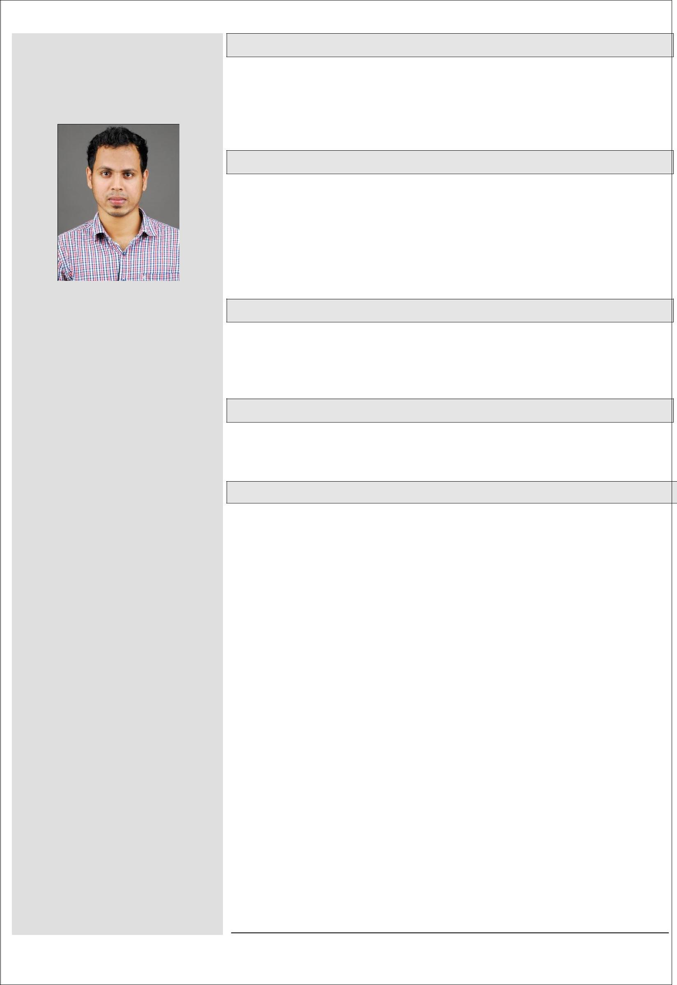

Mechanical Engineer

Looking for a position in the area of my expertise where I can bring out my skill and abilities in conjunction with the opportunities & commensurate to the organization’s goals and objectives.

Experience Overview

B.Tech in Mechanical Engineering with 5 year experience in the field of Quality Assurance/Quality Control and Construction, maintenance, fabrication and erection of components for Oil & Gas, Refinery. Experienced in Material inspection, Valve testing, Fabrication, Installation, Pressure Testing As well as HVAC system,Plumbing,Drainage and Fire fighting system

Professional Qualifications

B.Tech in Mechanical Engineering (4 Year Course) Passed out 1st Class in 2014 - State Board of Technical Education from LBS College of Engineering

– Kannur University

Certification

Certification in non-destructive testing of 'American Society of Non Destructive Testing’ – ASNT level II in RT, PT, MT and UT

Professional Experience

- PIPING ENGINEER (June 2014 to Oct 2019)
- INDIA

One of the established contractor in India for Piping Fabrication & Erection works for the Oil & Gas, Petrochemical, MEP and Power Sectors.

SHELL, ADNOC & Reliance Approved Piping Fabrication & Erection Contractor.

Reporting to the Project Manager.

Key Project

DTA PCG @ Reliance Petrochemical Industries, Jamnagar

Duties & Responsibilities:

- Interpretation of construction Drawing like ISO and P&ID and give instruction to the construction team.
- Witnessed NDT inspection like PT, MT,RT ,UT.
- Coordinating NDT activities with third party NDT company
- Ensuring implementation of QCP and ITP.
- Co-ordination with client inspector for final inspections for Hold and Witness Point inspection.
- Coordinating NDT activities with client
- Performed in-process and final inspection using NDT methods.

1

- Ensured the quality tasks are performed in accordance with applicable approved procedures.
- Conducted material inspection, layout and fit up inspection, visual inspection and witness NDT for final acceptance.
- Reviewed all test reports including NDT, Daily weld production and material record.
- Performed RF pad leak testing as per applicable QCP.
- Monitoring PWHT and review the PWHT reports and chart.
- Review the hardness report Verify the hardness limit of PWHT’ed weld joint as per the codes and standards.

- Released the inspected material for construction after construction conduct final inspection then release it for erection.

- Material receiving and inspection of Flange and fittings.
- Receiving inspection of valves
- Familiar with codes and standards like, ASME B 31.3,B 31.4,ASTM and API
- Punch list
- Hydro test
- Re-instatement
- Supervision of installation of HVAC system, Plumbing & drainage system and fire fighting system in the multi story buildings

- Planing & execution of manpower deployment, material delivery, drawings & documents availability at site for the successful execution of the Mechanical construction works at site in safety and quality manner within the time frame.

- Lead the team of supervisor, foreman and labours to execute the construction works as per the planning schedule and reporting to Construction Manager.
- Liaise with the client representative for the conducts of day to day quality related activities.
- Ensure the correct materials are utilized for the works carried out.
- Ensure fulfilment of all inspection & test requirements at all stage as per the contract requirements.

- Preparing documentation &compile test packs for all jobs to meet client requirements and as per specification.

- Coordinates with sub-contractors at site to ensure that projects are implemented as per contract and done as per schedule.

Computer Proficiency

AutoCAD (2009-15), MS Office , AutoCAD, Excel, Power Point

Hobbies

Football, Driving & Listening Music

Declaration

I do hereby declare that the information given above by me is true to the best of my knowledge.

Arjun Place: Abudhabi

Date: 30 Oct 2019

2

