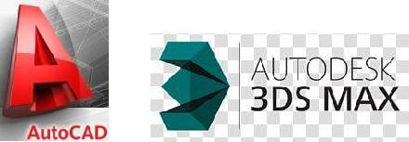
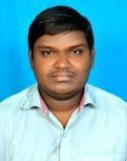

AJAY

Email : ajay-395420@2freemail.com

CARREER OBJECTIVES :

To be able to enhance my knowledge and skills in the fields of engineering. To be associated with an organization that will provide an assured career growth and maximum professional development

EDUCATION HISTORY QUALIFICATIONS & OTHER ADDITIONAL INFORMATION:

- B COM (computers) from Arunodaya degree college 2017

- M P C from prbm junior college 2012

- SSC from kerala high school 2010

DIPLOMAS:

- AUTOCAD (2d & 3d)

CAD DESK (HYDRABAD) (2019)

- 3D Max
CAD DESK (HYDRABAD) (2019)

COMPUTER SKILLS:

- auto cad 2d & 3d
- 3d max basic knowlede
- Microsoft office suite
- Windows 7,8,10
- Windows and software installation and system troubleshooting

RESPONSIBILITIES :

- Excellent working knowledge of autocad and 3dsmax
- Preparing civil drawings
- Ensuring overall data quality and intergrity
- Ability to read and comprehend engineering blueprints
- Able to exercise initiative and independent judgement
- Excellent verbal and written communication skills along with leadersip qualities
- Clear understanding of general drawings
- Excellent attention to detail

PERSONALITY TRAITS:

- High degree of confidence, positive attitude, good team spirit and hard working capability

- Easily adaptable to changing work environment

- Good communication skils for English
- Cool and confident.
- Passion to learn new Things.

- Time management

DECLARATION:

I hereby declared that all the above details are true and correct to the best of my knowledge

PERSONAL INFORMATION:
Date of Birth | : |  | 21/05/1998
Nationality | : |  | Indian
Languages Known | : |  | English, Telugu,Hindi

Place: Bar Dubai

Date: [Ajay]

