CURRICULAM VITAE
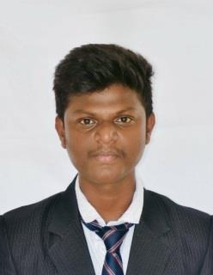

MURU
Gmail: muru-395537@gulfjobseeker.com

OBJECTIVE

Looking for a challenging and demanding position in CIVIL ENGINEER towards the growth of the organization which requires design and development expects.

ACADEMIC PROFILE

Bachelor of Engineering in Civil from parisutham institute of Technology and Science finished at 2015, Thanjavur, Tamil nadu, India.

WORK EXPERIENCE

ADHWA ALSUWAYHIRAH CONSTRUCTION, SOHAR, MUSCAT, OMAN.

- Experience in site engineer

- From July 18 to present

Project

  - Warehouse and office buildings in sultanate of Oman ministry of defense army camp, Muscat.

  - Skimming concrete bunker work in Oman aluminum cast llc

  - sohar industrial area.

  - Workshop building in rusayl institute llc ,Muscat.

JOB DESCRIBTION

- Inspect project sites to monitor progress and ensure design specifications as well as safety and sanitation standards are being met.

- Preparing cost estimations of the project.

- Execute the work as per the drawings and standards both discipline.

- Provide alternative design concepts to meet customer requirements.

- Oversee all construction, maintenance, and operations activities on project sites.

UTHAYAM DESIGNS ,INDIA

- 2.5 years’ work experience in site supervising

- From august 2015 to December 2018

Projects

  - Administration building work in Seventh day Adventist hospital Thanjavur,Tamilnadu,India.

  - Various commercial buildings.

JOB DESCRBTION
- Setting out, leveling and surveying the site.

- Checking plans, drawings and quantities for accuracy of calculations.

- Ensuring that all materials used and work performed are as per specifications.

- Supervising and counseling, junior or trainee engineers.

- Day to day management of the site including supervising and monitoring the site labor force and the work.

SKILL SUMMARY

Technical skills

- Auto cad(2D &3D), Revit, sketch up, staad pro, Photoshop and Microsoft office.

.

Management skill

- Excellent leadership abilities needed to manage an entire construction project.

- Site management

Communication skill
- Tamil,English,Malayalam,Arabic,Hindi.

PERSONAL DETAILS

Date of birth
Age

Marital status
Gender

Nationality

16.01.1994
25

Unmarried

Male

Indian

DECLARATION

I declare that the above furnished information are true and correct to the best of my knowledge and belief.

Truly yours

MURU

