PERSONAL INFORMATION:
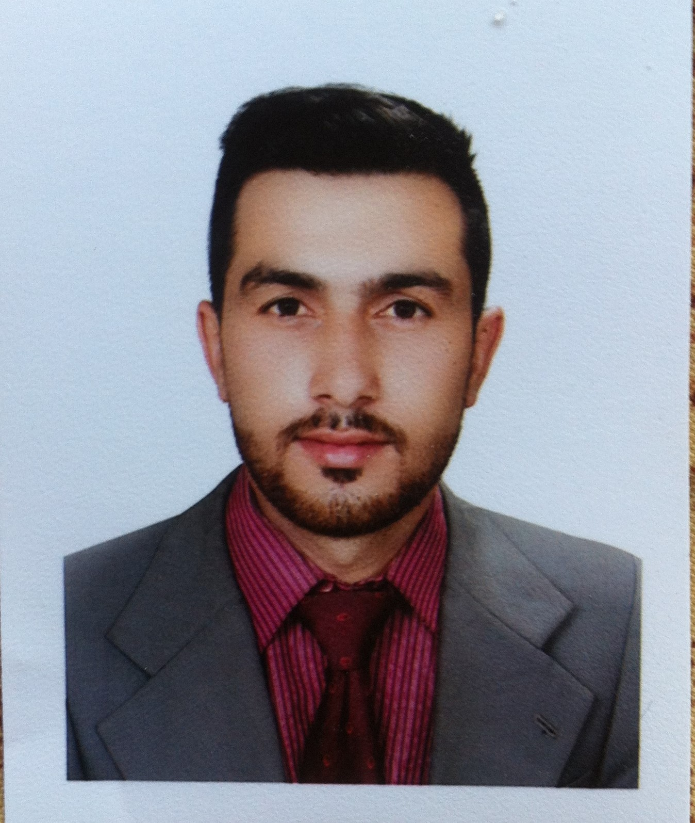

SARFARAZ

DATE OF BIRTH:06-APR-1994.
NATIONALITY:Pakistan.
EMAIL ADDRESS: sarfaraz-395544@gulfjobseeker.com

OBJECTIVE

Apply my, education and skill to attain organizational goals to the best of my abilities. I have good communication skills, good ability for team work, and having strong motivation for my profession I will prove good experiencing in this field.

RESUME SUMMARY

Subject Pre .Med

Years of Experiences: 8 Years

EDUCATIONAL BACKGROUND

- IELTS 2014.
- AEO Pakistan Islamabad.

- Mobile Software Course.
- Federal Institute of Technical Skills, Rawalpindi.

- Information Technology Diploma 2013.
- Joher Institute of Technology Islamabad.

- F.Sc (Pre. Medical) 2010-2011.
- Govt: Higher Secondary SchoolNo.3 Peshawar City.

- English Language Course 2010.
- Dawn English Language Center, Islamabad.

- Matriculation 2008-2009.
- KurramPublic High School Parachinar, Kurram Agency.

- Computer Course 2008-2009.
- Islamic Center of computer educations Parahinar.

EXPERIENCES:

- Open Testing Service Pvt. Ltd. 5th Jan-2012 to 20th Oct-2013.
- Designation:Data Entry Operator.

- GKG-SAAED Associates JV. 10th Dec-2013 to 15th Jan 2017.
- Designation:Assistant Accountant.

- Builtsworth Builders and Real Estate.20th Jan-2017 till to date.
- Designation:Manger.

EXTRA ACTIVITIES:

  
- Attended the seminar on Ministry of Labor and Manpower Govt: of Pakistan.
- Attended the seminar on the management and controls of tasks.
- Attended the seminar on effective communication skills.

COMPUTER SKILLS:

.

- Microsoft Office.
- Typing speed 40 w/m.
- Networking Essentials.

INTERPERSONAL SKILLS:

- Decision making ability.
- Good communication and Interpersonal skills.
- Good command to work in group and separately.
- Highly Flexible and able to work in a multicultural environment.

LANGUAGES:

- English.
- Urdu.
- Pashto.

REFERENCES

Will be provided on Demand

