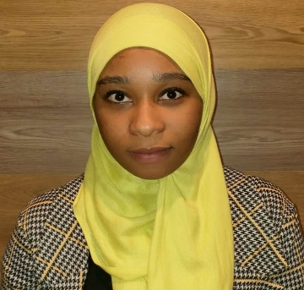
KASHI

PERSONAL INFORMATION

Date of Birth: 03/06/1997
Nationality: Kenyan
Address: Al Nahda Sharjah, UAE
Email: kashi-395549@2freemail.com
Visa Status: Employment Visa

PROFESSIONAL SUMMARY
Motivated individual with 2 years of experience in the automotive industry. Offering expertise in motor clothessales and marketing. Energetic self-starter and team builder able to navigate high-stress situations and achieve goals on time and under budget.

EDUCATION
April - October 2016
DATA NETWORKS INSTITUTE (Kenya)

CERTIFICATE
- Computer Packages (Office, Excel, Word, PowerPoint, Outlook, Internet etc.)
- QuickBooks

COAST GIRLS’ HIGH SCHOOL(Kenya)
February 2012 –October 2015
CERTIFICATE
- Secondary Education (GPA 7.5/10)

EXPERIENCE
JUNE - 2017Current
MERCHANDISE EXECUTIVE(Motor Clothes)
- Greet customers immediately, in a courteous and friendly manner.
- Organize store by returning all merchandise to its proper place and keeping floors clean.
- Recommend, select and help locate merchandise based on customer needs and desires.
- Work closely with visual display staff and department heads to decide how goods should be displayed to maximize customer interest and sales.
- Educating customers on product knowledge.
- Achieve agreed upon sales targets.
- Supply management with reports on customer needs and potential for new products.

JANUARY 2016- APRIL 2017
NAIVAS SUPERMARKET (Kenya)

MERCHANDISER /OFFICE ASSISTANT

- Ensured that the right products are available in shelves and store at large.
- Produced layout plans for stores and maintain store inventory.
- Collaborated with buyers, suppliers and distributors to negotiate prices and quantities.
- Implemented marketing strategies which resulted in 12% growth of customer base.
- Achieved monthly target.

SKILLS

- Excellent interpersonal & communication skills.
- Fluent in English
- Customer oriented
- Skilled multi-tasker
- Works well under pressure
- Cash handling

HOBBIES
Reading,Socializing, Sports and Travelling

