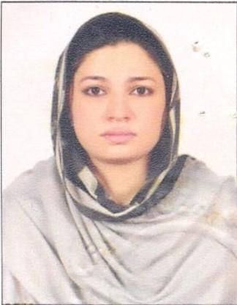

Sumbal

Dubai, U.A.E

E-Mail: sumbal-395572@gulfjobseeker.com

PHLEBOTOMIST, DHA

OBJECTIVE

Seeking for substantial responsibility where my past and varied experience would be fully utilized in a career opportunity and where making a significant contribution to the success of my employer which will gain me a career advancement opportunity.

WORK EXPERIENCE

Worked as a phlebotomist in AZIZ X-ray & CLINICAL LABORATORY w.e.f from 16-01-

2014 to 22-01-2019.

KEY SKILLS

Collection of samples like blood, pus, throat swab, and skin scrapings. Preparation of culture media, culture tubes and broths.
Sterilization and storing the culture media.

Routine examination and process of the clinical samples.

Isolation and identification of the pathogen by culturing, staining, microscopic

.

EDUCATIONAL QUALIFICATION

Diploma in medical lab technician Passed from ”Clini Care Institute of Medical Sciences”. 2012-2013.
Matriculation from board of GUJRANAWALA BOARD PUNJAB(Pakistan), IN 2007. Intermediate from GUJRANAWALA BOARD PUNJAB ( PAKISTAN) IN 2009.

COMPUTER SKILLS

Good Basic in computer Application Ms Word , MS Excel , Ms Power Point

PASSPORT DETAILS

Date of Issue | : | 04-06-2018
Date of Expiry | : | 03-06-2023
Placer of issue | : | Hafizabad, Pakistan.

PERSONAL DETAILS
Date of Birth |  | : | 04-12-1987
Nationality |  | : | Pakistan
Religion |  | : | Christianity
Gender |  | : | Female
Marital Status |  | : | Single
Language Known |  | : | English, Hindi & Punjabi.
Visa Status |  | : | Visit Visa
DECLARATION

I certify that all the details provided above are all correct according to my knowledge and belief.

Sumbal

