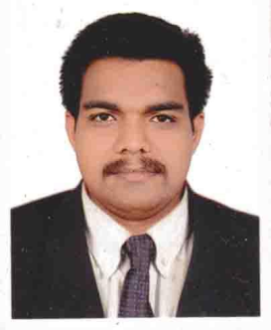
CURRICULUM VITAE

DILEEP
Email : dileep-395582@gulfjobseeker.com

OBJECTIVE:-
Seeking a challenging career in a leading corporate entity, which will help me to utilize my skills and realize my potential willing to as a key player in a creative and progressive environment.
ACCADEMIC QUALIFICATION:-
- S.S.L.C. (Secondary School Leaving Certificate) March 1996
- Pre Degree Course March 1999
- BA – (Bachelor of Arts) Malayalam(calicutuniversity) September 2002
- B.Ed – (Bachelor of Education(malayalam)MGUniversity June 2006
- (P.G) doing in Annamalaiuniversity
WORK EXPERIENCE:-
  - Two years experience in Dubai as an Assistant Store Keeper from 2004 to 2006.
  - Teaching in Govt. High School (three years experience).one year experience in private school
- TenYears experience as a shopmanager in Malaysia.
COMPUTER KNOWLEDGE:-
    - Diploma in Computer Operation
LANGUAGES KNOWN:-
    - English, Hindi, Malayalam, Malaya & Tamil.

STRONG POINTS:-
- Excellent Communication skills.
- Fast learner, ability to perform under pressure.
- Creative & move with a very positive attitude.

DRIVING LICENCE:-
- U.A.E. Heavy Driving Licence (Vehicles permitted 3, 5, 6)
- Malaysia Light Driving Licence No. B
- Indian Light Vehicles
PERSONAL PROFILE:-

Date of Birth : 26-03-1978
Gender : Male
Religion : Hindu
Nationality : Indian
Marital Status : Married
PASSPORT DETAILS:-
Date of issue : 22-03-2015
Date of expiry : 01-03-2025
HOBBIES:-
- Reading, Writing and Social Activities.

DECLARATION

I hereby declare that all the information stated above are correct and are done to the best of my knowledge.

DILEEP

