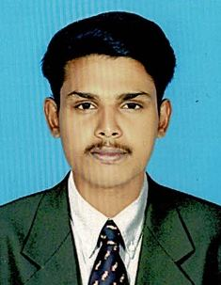
CURRICULUM VITAE

SHARUKHAN
E-mail: sharukhan-395584@2freemail.com
Sharjah, UAE

CAREER OBJECTIVE

My mission is to work to the best of my ability with a view to cater the needs for the organization / company where I am working. I do believe that I have the experience and capabilities to communicate and interest well with people of all thus ensuring their satisfaction.

ACADEMIC QUALIFICATION

- BBA (Airline and Airport Management)Certificate in the year2018

- Higher Secondary School Certificate [ Plus Two ] in the year 2015 Govt of Kerala,

- Secondary School Leaving Certificate [ S.S.L.C ] in the year 2013Govt of Kerala,

COMPUTER SKILLS

- Basic Computer Knowledge

LANGUAGE PROFICENCY:

- English, Malayalam, Tamil and working knowledge of Hindi.

SKILLS:

- Excellent Communication Skill to Present Clearly
- Good Problem Solving Ability
- Hard Working And Dedicated

Professional experience

1 year Experienced in Qatar Milaha Logistics as a Warehouse assistant

PERSONAL INFORMATION
Marital Status : Single
Nationality : Indian
Date of Birth : 30-03-1997
Religion : Muslim
Passport
Issued at : 13/10/2016
Valid till : 12/10/2026

Visa Status : VisitVisa valid until (Feb13 2020)

I hope you will allow me to present myself personally and favor me with a chance to serve you and to grow with my career with you.

I hereby declare that those above mentioned details are true to the best of my knowledge and belief.

Place :
Date :

(SHARUKHAN)

