ELVIS
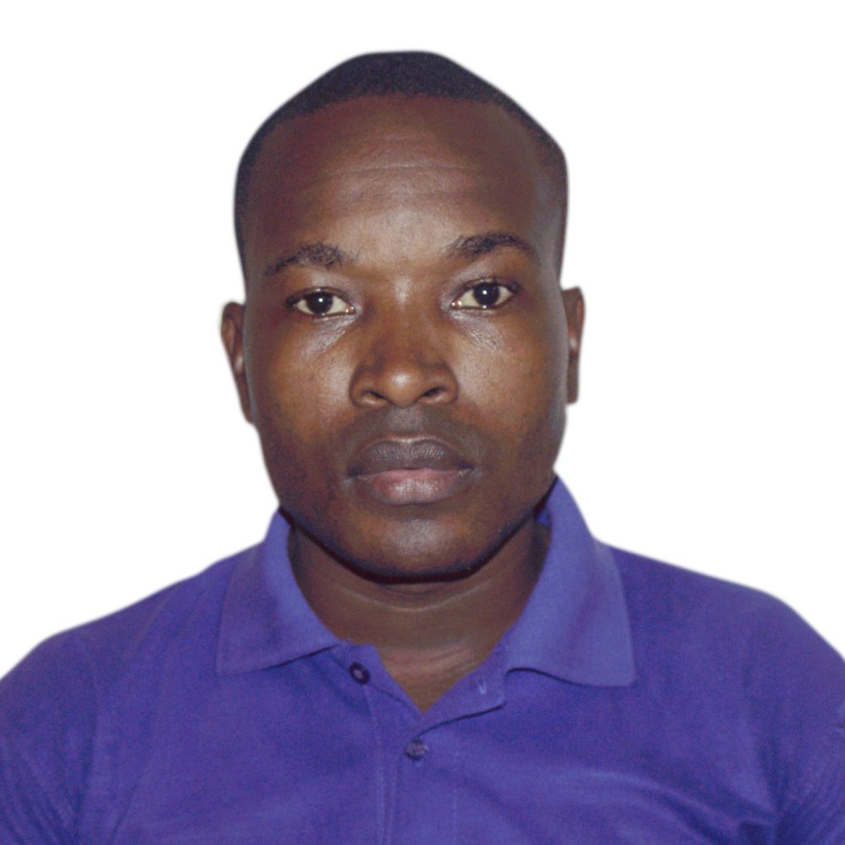
Elvis-395626@gulfjobseeker.com
Union, Dubai, UAE

Marital Status: Married
Hobbies: Reading, Traveling and Movies

EDUCATION

- 2008-2012: Bachelor in Economic Sciences, University of Dschang, Cameroon (completed 84 credits: Did not graduate).

- 2007-2008: GCE Advance Level in Accounting Series with 10 points (Business Mathematics and Statistics (B), Business Management (C), Commerce and Finance (D) and Accounting (E) from the Government Technical High School, Buea-Cameroon
- 2005-2006: GCE Ordinary Level in Business studies (Pure Mathematics (B), Business Mathematics (C), Commerce (C), Economics (C), Law and Government (C), Office Practice (B). From the Government Technical High School, Buea-Cameroon.
- 2001-2004: The Vocational Aptitude Certificate as an Accounts Clerk (Average). From the Government Technical College, Limbe-Cameroon.

- 1995-2000: The First School Leaving Certificate from the Cameroon Baptist Main primary School, Limbe-Cameroon.

SKILLS
- Languages
English: Spoken (Excellent), Written (Excellent).
French: Spoken (Good), written (Good).
- HIV AIDS Counselor. Trained by the Cameroon Baptist Convention Women Local AIDS Control Committee (BAWOLACC-June 2005).
- Computer skills in MS Word, Excel, Power point and internet.
- Can work unsupervised and multi-task. Team motivator and initiator, passionate and enthusiastic.
- Starter and mobilize.
- Basic computer network skills
- Basic Accounting and data recording abilities
- Ability to represent the organization in a foreign country and help establish their goals there.
- Perfectly Bilingual in English and French. Can write, read and speak both languages very fluently.

EXPERIENCES
Security Experience

- May 2015- September 2017: Security Guard with the C.B.C security, Cameroon. Guarding the Campus of King David High School, Douala. Making sure students are in good security condition by monitoring every corner of the school property and giving daily, weekly and monthly report to principal. Recommending important security measures to be taken by school authority and leading every security project undertaken by the school. Handling crisis and emergency situations efficiently and effectively. Effectively handling various individuals in stressful, highly sensitive and risky situation by using basic first aid training skills. Having security talks in the Morning in the school assembly and sensitizing the campus on basic security measures to be aware of. Detecting illegal activities carried out by students and visitors and handing them to appropriate quarters.

Other Experiences
- 1st December 2017-February 2019: Lead social worker with U4FF international, Australia. Task included reaching out to indigenes of remote parts of Jinja, Mbale and Mukono with HIV sensitization, girl child and child education promotion, identifying needy children with no ability to go to school and making scholarship schemes for them. Involving women in empowerment projects for economic stability, and finally establishing U4FF Uganda branches in Jinja and Mukono.
- 2013-2014: Manager of LoveWorks ICT and Cyber Café Center, Bamenda-Cameroon. My responsibilities involved; selling and providing internet and secretarial services to students of the University of Bamenda, typing and producing defense theses, research papers and assignments. Cleaning the business premises every morning and making end of day cash income balancing. Training little children during holidays in basic ICT skills.

- 2011-2012: Shop keeper at MAHIMA supermarket (Electronics department), Douala-Cameroon. Assisting in helping buyers understand the characteristics of electronic gadgets, packaging items and helping them make payments.

- 2009-2011: Trainee and intern office assistant and Cyber café and documentation attendant, Shalom Excellent Computer World, Dschang-Cameroon. Providing internet services to customers, rendering hardware and software computer services.

- July-August 2008: successful trainee and sales agent intern with the Garden of Eden Traditional medicine clinic, Buea-Cameroon. Promoting and advertizing products to different localities and bringing the products closer to the consumers.
icate
Waiterand Cleaner WorkExperien
2013-2014:WaiteratNjomopalacehotelLimbeCameroon:takingfoodanddrinkordersandservingcustomers,answeringquarrelsandmakingsureeverycustomerisservedwell. Proposing other services which the hotel offered and nicely persuading customers to request these services. Cleaning hotel premises everyday to make sure rooms are clean and bar and restaurant are fresh and clean and attractive for guests.
2015-2016:WaiterforVictoriaGuesthousehotelLimbe, Cameroon:answeringtoseniorhousekeeperandtakingorderstovisitorsintheirroomandcleaningtheroomlater, changing sheets and toiletries, disinfecting toilets and leaving room fresh and nice for the next occupant.
Agricultural Experience
- Last but not the least; I have acquired much experience in agricultural domain. Farming is our main source of livelihood and all my life I have been an active worker on our farms. My dad has poultry and goat farms since childhood till date and we also grow different tropical foods on our farms like plantains and bananas, cassava tubers which we consume directly or transform into our local foods like garri and cassava dough, groundnut and palm trees which we produce red cooking oil for sales and personal consumption. Over the years, My roles involved most of what had to do with much energy; clearing farm lands for planting, planting in different seasons, killing weeds by spraying herbicides and insecticides, carrying farm produces to motorable roads, taking goats out for feeding every morning and bringing them back in the evening, feeding chickens and giving them medication in their water and food in due season.

