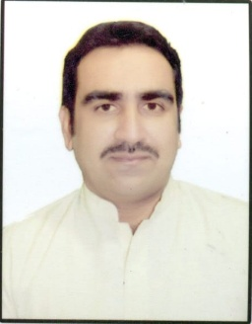
Rizwan
E.Mail : rizwan-395653@gulfjobseeker.com

Objective
Seeking a challenging opportunity in camp boss an operations, where i can apply my skills and experience to optimize use for delivering the desire results and to gain value addition from the job, enabling me to grow along with the organization and become a part of the Management ______________________________________________________________________
Experience.
- From(Aug 2011 to Aug 2013) As a Facility and Security supervisor
- From (Aug2013 to Sep 2016)As a camp Boss and operations coordinator
- From (Feb 2017 to Jan 2019)As a camp Boss, operations coordinator and Store in-charge in MJB Group of companies.

Education
1993 to 1996. High School certificate from Lahore Pakistan.
1998 to 2000. Trade of Machinist from Technical Training Centre, Lahore Pakistan.

Skills
● Leadership ● Cost control ● Microsoft excel & Word ● CCTV (Dubai Police)
● D.P.S ( Dubai Police) ● Microsoft excel/word ● Team supervision. ● Decision maker
● waste Control ● Conflict resolution ● Innovative

Personnel Detail.
● Nationality : Pakistani
● Marital Status : Married
● Religion : Muslim
● Visa Status : Visit Visa
● D.O.B : 01.11.1979

