OBJECTIVE

To grow and explore knowledge in an organization and to use my skills and perseverance for the growth of the organization, and the society around me.

PASSPORT DETAILS

Expiry date: 25/09/2026

Visa status : Visiting visa

Visa validity: 26/11/2019 to 18/02/2020

EMAIL:

ID: ajin-395658@gulfjobseeker.com

AJIN
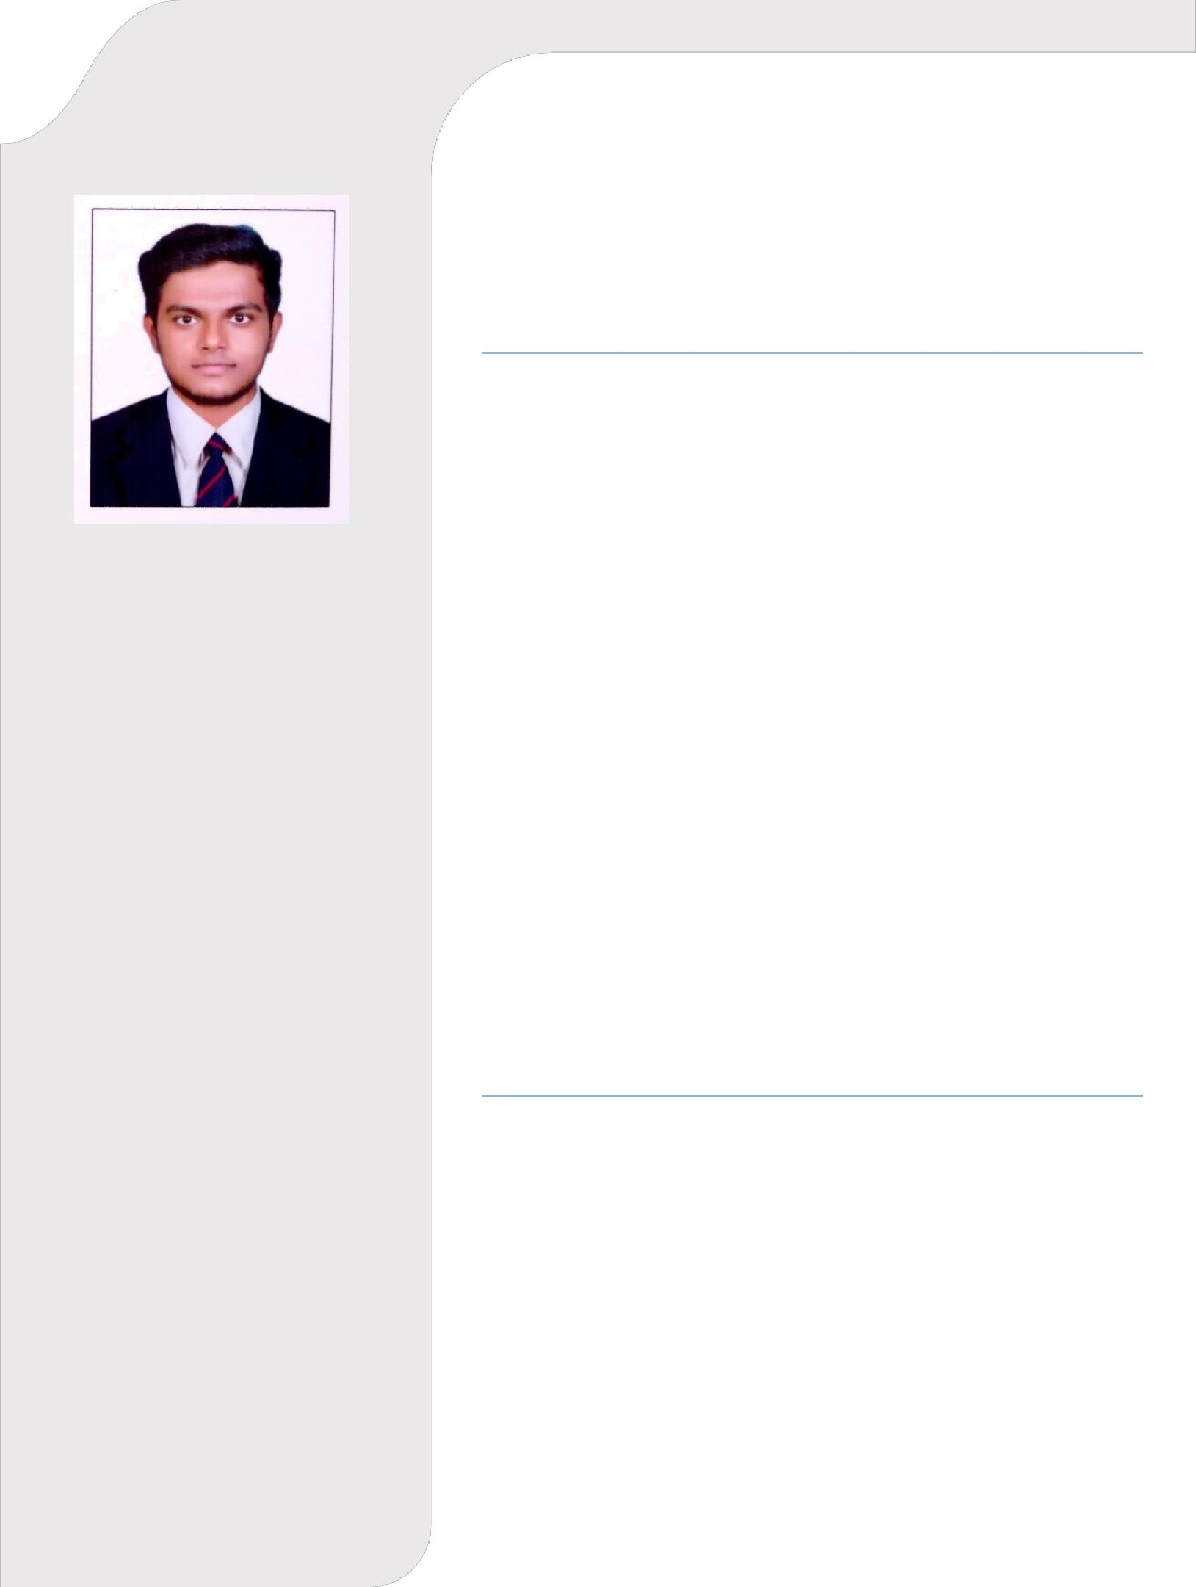
B.E (MECHANICAL ENGINEERING)

Bangalore, India

2016–2019 (3 year) – Quality Inspector

- Experienced in handling CMM machine

- Handled inspection of medical, military and Danieli products

- Interpretation of drawing dimensions, and supervising the production unit

- Inspection of procured raw materials

- Monitoring the production stages, and supervising the correction required for the process

- Document preparation for ISO Audit

- Preparing the target of production on daily basis for the employers

- Recommending the team of employers for the change in Dimensions as per product drawing

- Optimize the product requirement as per customer needs

- Representing the Company to address Customer need

EDUCATION

BLITZ ACADEMY, KOCHI
June 2016 – August 2016

- MEP System Designing(AUTOCAD 2D/3D)
- HVAC System Designing
- Plumbing
- Fire Protection System
- REVIT

ANNA UNIVERSITY, AMS ENGINEERING COLLEGE, ERODE 01/04/2012 – 01/04/2016

B.E (MECHANICAL ENGINEERING)

ANNA UNIVERSITY, CHENNAI
CGPA-7.01

Personal Details

Date of birth :07/02/1994

Sex :Male Mother Tongue :Malayalam

Nationality :Indian Marital status :Single

Technical Skills:

MS OFFICE

AUTOCAD

ARCO CAD

HOURLY ANALYSIS PROGRAM

REVIT MEP

AREA OF INTEREST

- Quality Assurance and Quality control Engineer

- Supervising of manufacturing unit

- Product Drawing and Modeling

- HVAC Estimation Engineer

- HVAC Site Engineer

- HVAC Design Engineer

- Sales supervisor

- Service advisor

PROFICIENCY IN LANGUAGE

Speak | Read | Write
English | English | English
Hindi | Hindi | Malayalam
Malayalam | Malayalam
Tamil
Kannada

DECLARATION

I, hereby declare that all the information given above are true and correct up to the best of my knowledge and I bear the responsibility of the above mentioned particulars.

Date : 27/11/2019 AJIN

