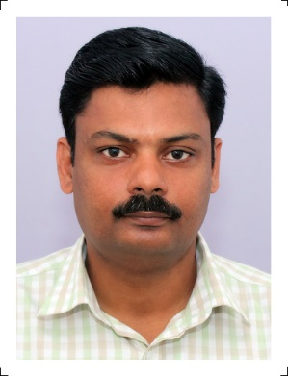
AUZWEL
STOREKEEPER / MAINTENANCE SUPERVISOR
FACILITIES MANAGER

Auzwell-395673@2freemail.com

OBJECTIVE: Intend to be part of a reputed organization where in my technical skills and knowledge can be utilized towards the growth of the organization and be able to maintain the company’s realm in terms of productivity and quality.
STRENGTHS

- 17+ years of work Experience | - Excellentcommunicationskills
- Prioritizing Tasks | - Learning Agility
- Decision Making Skills | - Honesty & Integrity
- Flexibility & Adaptability | - Ability to work hard

ACADEMIC PROFILE:

- Maintenance Engineering (AME) in Mechanical stream from Nehru College of Aeronautics and Applied Sciences, Coimbatore (Approved by DGCA India) 80% Marks. (1998-2001)
- Passed 12th under Kerala State Board with 72% Marks (1994-1996).
- Passed 10th under Kerala State Board with 82% Marks (1993-1994).

WORK EXPERIENCE: 17+ Years
10+ Years (January2008-April 2019) in Pune&Cochin - India.
Worked as Senior Maintenance Technician.

- 3+Years in INDAMER COMPANY PRIVATE Ltd at Ahmedabad - India
Worked as Senior Maintenance Technician (December2004-January2008)onSKA B-200, DAUPHIN SA 365N, HAWKER 850XP

- 3+Years in AHMEDABAD AVIATION & AERONAUTICS Ltd at Ahmedabad - India
Worked as Senior Maintenance Technician (November2001-November2004)
onCESSNA 152, CESSNA 172, ZANITH CH 2000

- Intern-ship with INDIAN AIRLINES at Base Maintenance Hangar Mumbai-India

Worked as Apprentice (6 Months) onAIRBUS-300

CAREER HIGHLIGHTS

Worked as Document Controller:
Regulatory compliance of maintenance documents. Responsible for overall aircraft flow and paperwork accountability.

Worked as Storekeeper:
Ordering, receiving, stocking and inspecting parts and equipment needed for the day-to-day tasks of aviation mechanics and maintenance works.

Worked as Aviation Maintenance Coordinator:
Manage maintenance activities according to the requirements and ensure completion of all necessary tasks in stipulated time.

- Well versed with MS Office.
- Good PC skills
- Completed Security Awareness Program as per National Civil Aviation Security Training Program.
- Completed Human Factors, Safety Management System Training & Fuel Tank Safety Training.
- Completed Familiarization course on B737-900/800/700 and ATR 72-212aircrafts.

PERSONALDETAILS:
Nationality : Indian
Date of Birth : 27-05-1978
Gender : Male
Marital Status : Married
Languages Known : English, Hindi and Malayalam

REFERENCE:
Anup P. Bhatia – HR Consultant, Gulfjobseeker.com
Mobile: 0504753686 Email: feedback@gulfjobseeker.com

