**CURRICULUM VITAE**

**Career Objective:**

To work in a challenging environment with a well-established and reputed organization where honesty, hard work positive attitude would be valued and where I would be exposed to a varied range of mechanical duties that would not only provide monetary compensation but opportunities of burning and growth.

**Personal Skills:**

* Hard working and Dedicated
* Honesty and Reliability
* Good communication and analytical skills
* Easy adaptability to situations

**Educational Qualification:**

* Certified B.Tech from **Jyothishmathi Institute of Technology and Sciences** with **54.5%** in the year of **2013**.
* Certified Intermediate From**Alphores Junior College** with **88.90%** in the year of **2008**.
* **S.S.C** from **Siddhartha High School** with **91.33%** in the year of **2006**.

**Languages:**

* English, Hindi and Telugu

**Work Experiences:**

* Worked as **Office Boy** for **factory** in **Dubai** from **2015 to2017**.
* Worked as **Office Administrator** for **TuvRehinland** in **Hyderabad, India** from **2017 to 2018**.

**Technical Skills:**

* Printer Troubleshooting
* OS Installation
* Critical Software Installation

**Work Experiences:**

I here declare that the above mentioned statement is correct & true to the best of my knowledge & belief.

**References:**

Available upon request

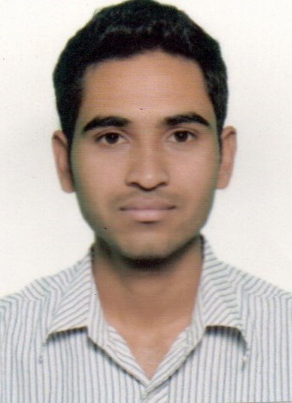

**BHASKAR**

**DUABI,UAE.**

**Email: Baskar-395693@2freemail.com**

**PersonalDetails**

**DateofBirth:08/07/1991**

**Gender:Male**

**Religion:Hindu**

**Nationality:Indian**

**CivilStatus:Single**

**VisaStatus:Visit**