TOSHI

Mechanical Engineer

PROFILE

A Filipino Mechanical Engineer with the following traits:

- Willingness to learn
- Ability to adapt to changes
- Analyze and interpret data
- Able to decide on situations
- Eager to solve problems
- Openness to ideas

- Can apply basic engineering calculations on actual situations

CONTACT

EMAIL:
Toshi-395712@gulfjobseeker.com

EDUCATION AND LICENSE
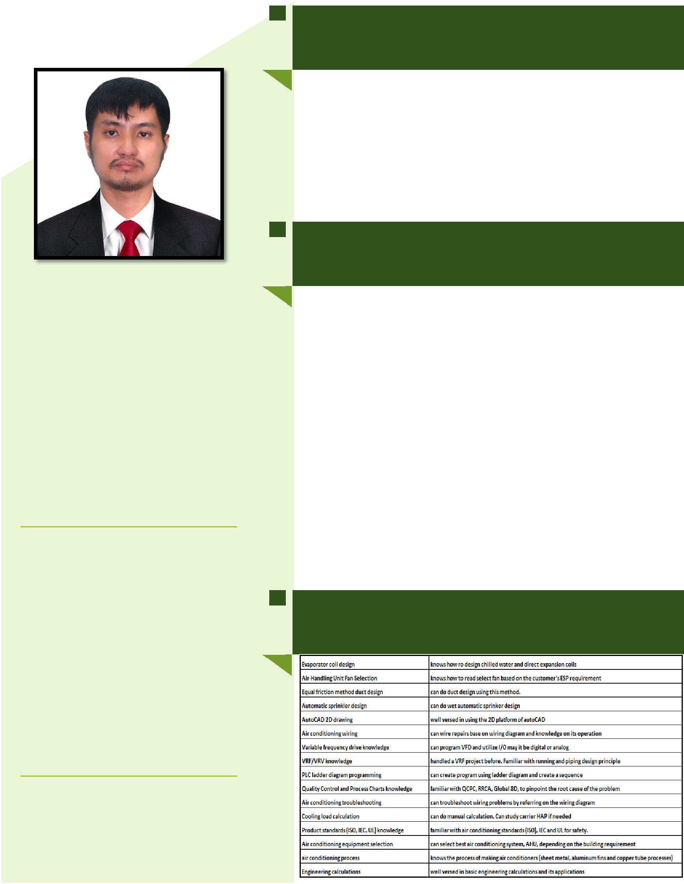
De La Salle University – Dasmariñas
2010 – 2015
- Bachelor of Science in Mechanical Engineering

  - 2015 most outstanding mechanical engineering student
  - 1st DLSU-D Shell Eco Marathon prototype design team
  - PSME quizzer representative of DLSU-D

Professional Regulations Commission of the Philippines 2015 - Present
- Registered Mechanical Engineer – 82.3% weighted ave.

WORK EXPERIENCE

Air conditioning Company [Product Engineer] August 08, 2016–November 5, 2019
- Duties and responsibilities

  - Ensure build of prototype of new developed air conditioning products.

  - Ensure development of new parts for the newly developed air conditioning model.

  - Ensure to respond to customer’s request if air conditioner will be order-to-manufacture.

  - Creation of bill of material of air conditioning products.

  - Use of simulation software to see the trend of the air conditioner’s performance.

  - Collaborate with test engineer regarding testing of air conditioner (standard to be used & troubleshooting).

  - Spearhead changes related to product, inform cross-functional departments and schedule trial run.

  - Leads the launch of new products, creates Gantt chart to see the timing of each milestone until the actual product launch.

  - Collaborate with design engineer to draw the new product based on specification of each part and size.

SKILLS

