PROFILE

Extremely motivated to constantly develop my skills and grow professionally. I am confident in my ability to come up with interesting ideas for unforgettable marketing campaigns.

CONTACT

Ranjith-395714@gulfjobseeker.com

EDUCATION

BTECH IN MECHANICAL ENGINEERING

Malabar college of Engineering and Technology

RANJITH
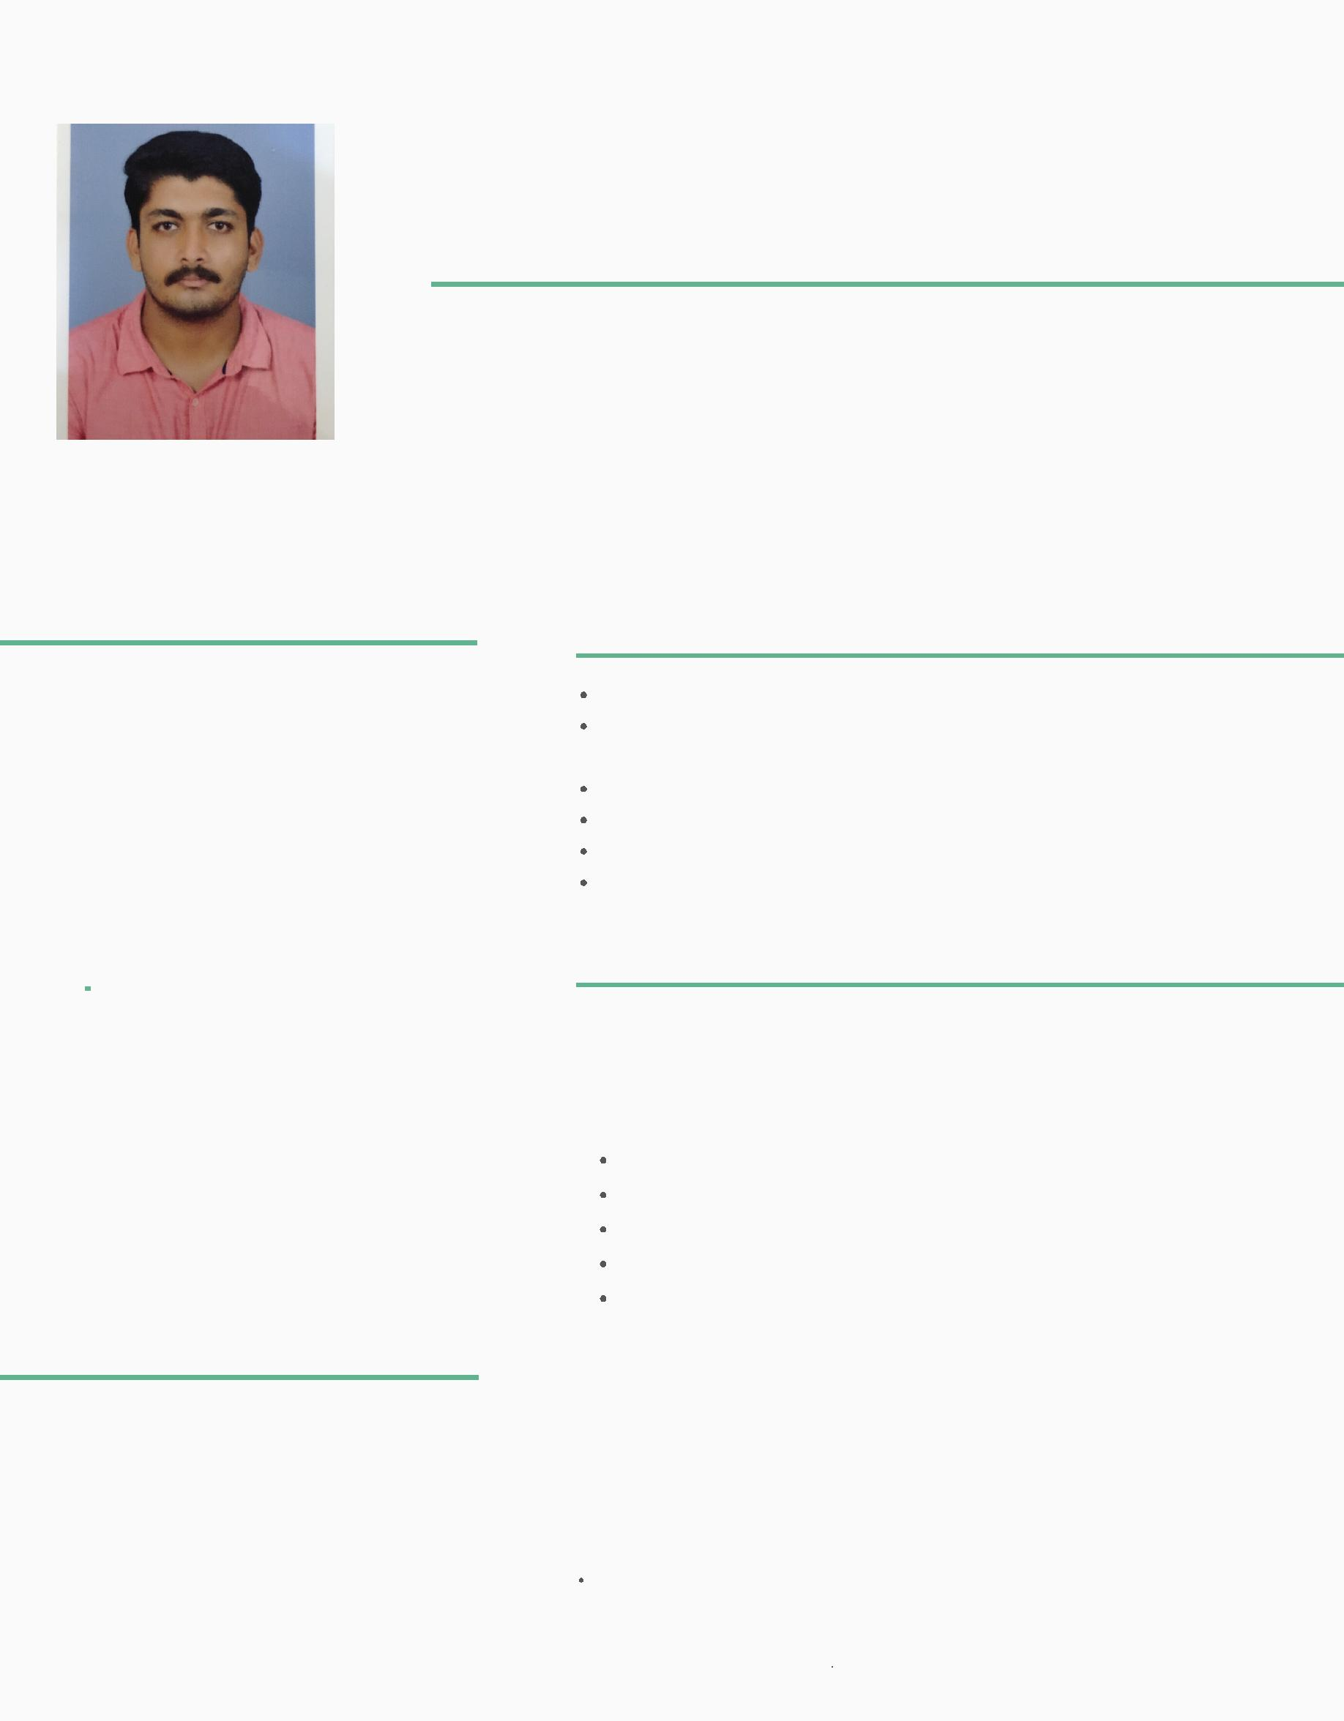

M A R K E T I N G A S S I S T A N T

SKILLS

Exceptional communication and networking skills Successful working in a team environment, as well as independently

The ability to work under pressure and multi-task

The ability to follow instructions and deliver quality results Handling MS OFFICE tools like powerpoint,excel sheets ,etc Familiar with AutoCad

WORK EXPERIENCE

3-SEP-2018 TO 19-NOV-2019

Maintained and organized numerous office files

Constantly updated the company’s contact and mailing lists

Monitored ongoing marketing campaigns

Monitored press coverage

Maintaining social media coverages and improving publicity

