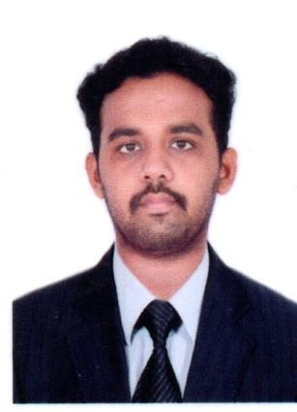
CURRICULAM VITAE

ABDHAGEER

Email | : | Abdhageer-395718@gulfjobseeker.com

VISA STATUS : Visiting Till 05/02/2020

OBJECTIVE:

To work with leading company and to use my analytical thinking to the best of my ability combined with perseverance, so as to contribute to organization’s growth and goal, as well as to attain my professional goal.

PROFESSIONAL QUALIFICATION:

- AutoCAD user with Certified.

- Certified Revit architecture user (Autodesk certified user) ACU.

- Certified in Type writing (Lower,Higher).

ACADEMIC QUALIFICATION:

Exam/Course | Institution | Board/University | Year of | Percentage/CGPA
 |  |  | passing
B.E-Civil | Arasu Engineering College,
 | Kumbakonam. | Anna University | 2014-2017 | 6.77 CGPA
Engineering
HSC | Native Higher Secondary School | State board | 2012-2013 | 65%
 | Kumbakonam.
SSLC | Native Higher Secondary School | State board | 2010-2011 | 83.6%
 | Kumbakonam.

COMPUTER PROFICIENCY:

- Working knowledge on installing OS of Windows. And familiar with MS-office.

- Installing and cracking software’s related to civil engineering.

PROFESSIONAL EXPERIENCE:

- CORE FIELD EXPERIENCE: SITE ENGINEER-Kumbakonam (Aug2017-Jun2019).
- NON-CORE FIELD EXPERIENCE: Online Data Entry in Job Portal,Kumbakonam (2015-2016).

AREA OF INTREST:

- Sports (Cricket,Carrom,Shuttle).
- Internet Surfing.
- Gathering information and Learning of recent software’s on civil engineering etc.,

SKILLS:

- Good Communication Skills (Tamil, English).
- Total station surveying ability.
- Easily negotiate with other people.
- Familiar in AutoCAD (2D) drawing using software.
- Can work effectively in team, as well as individually.

ROLES & RESPONSIBILTIES:

- Check plans, drawings &quantities for accuracy of calculation.
- Day to day management of site & monitoring the site labors.
- Preparation of reports & schedules.
- Control site wastage minimization and managements.

- Prepare estimation & record site observation.
- Ensuring a site safety.
- Pleasant environment for our labor at all time.

PROJECT DONE:

MAJOR PROJECT: Behavior of hybrid- GFRP- concrete-GI- double skin tubular column.
MINOR PROJECT: Design and analysis of bio-climatic building using STAAD.pro v8i.

PERSONAL INFORMATON:

Marital Status:

Single

Sex:

Male

Date of Birth:

5th September 1996

Language Known:

English & Tamil

Nationality:

Indian.

Strength:

Positive attitude, Confident, Hardworking, Punctuality, Good Listener & Quick Learner.

DECLARATION:

I hereby inform you that all the statement made above is true the best of my knowledge and belief.

DATE :

PLACE :

(ABDHAGEER)

