C

V

CURRICULUM VITAE

MAREENA
Sharjah.
Email: mareena-395730@gulfjobseeker.com

Position: Office Administrative

OBJECTIVE
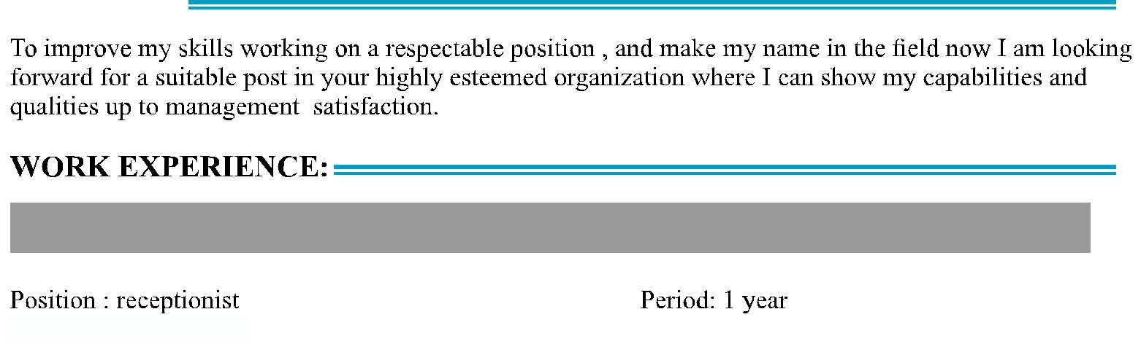

Negombo, Sri Lanka

Office Adiminitrative

Negombo, Sri Lanka

EDUCATION:

- Passed G.C.E Ordinary Level (2010) - Loyala Collage,Negombo,Sri Lanka

- Passed G.C.E Advance Level (2012) - Kochchikade Maha Viddayalaya, Sri Lanka
- I have done 4 month English Course at Betany English School, Sri Lanka
- I have done 1 Year Computer Course at Esoft Computer Studies (PVT) Ltd, Sri Lanka ↑Iunderwent a 1 year Graphic Designing Course at Wijaya Graphics (PVT) Ltd, Sri Lanka

LAGUAGAE:

↑English

QUALIFICATION:

- I Fluent in computer knowledge like CorelDraw

- I have more computer knowledge programming (Ms Office, Hardware, Type Setting, Planing,)
- I have experience for wise data entry, data analysing (Document Controller)
- Also taking reports for monthly salary details (Pay Roll)
- Object oriented and honest
- A active person at work time
- Friendly and pleasing others
- I am punctual and also very well dressed

C

V

PERSONAL DATA:

- Date of Birth - 19-10-1994

- Marital Status - Single

↑ Nationality - Sri Lankan

DECLARATION:

I sincerely hope that y application will receive your kind attention and I am most anxious that an opportunity for an interview is given to me at your earliest convenience

Yours,

Faithful,
Mareena

