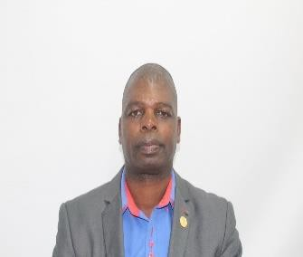
CURRICULUM VITAE:

Primary school Teacher:
Intermediate Phase.

CAREER OBJECTIVES
As a qualified teacher from the University of Rhodes South Africa, with more than 20 years in the education fraternity. I would like to be part of an organisation that values teamwork and encouraging diversity of thinking with shared diversity towards achieving organisational objectives. To perform to the very best of my abilities as an individual and to the very best aligned to the core values of any organization I am part of. I intend to use all the skills I have acquired to add value to any company which happen to hire me and at the same time strive to improve and diversify my current skills. I aim to be part of an organization that gives me an opportunity to grow and develop regarding my career.
PERSONAL DETAILS

Gender: Male
DOB: 02 August 1967
Nationality: Zimbabwean
Marital Status: Married
Languages: English, Shona and Zulu
Name: Richard
E-mail: richard-395789@gulfjobseeker.com
Criminal Record: None
Health: Excellent
Visa Type: Long Term Visiting Visa

Experience: 11 years in Department of Education
19 years in Ministry of Education
PROFESSIONAL ACHIEVEMENTS AND QUALIFICATIONS

      - Institution: Rhodes University South Africa. Qualification: Bed Mathematics
Year: 2018
      - Institution: University of Zimbabwe Qualification: Diploma in Education Year: 1988

WORKING EXPERIENCE

Intermediate Teacher 11 years South African Schools.
Company: College

Position: Intermediate Mathematics & Natural Science Educator (Grade 5)

Period: January 2013 to date

Company: Education Centre

Position: Teacher (Grade 4 – 9)

Subjects Taught: Mathematics

English

Period: March (2008) to December (2012)

Company: Government in Zimbabwe

Position: Teacher

Duties: Teaching an intermediate class

Mathematics, English, Social Science and Natural Science. Coaching Soccer, Rugby, Athletics and Base Ball.
Remedial Teaching.

Any other duties assigned by the school principal.

Period: January 1989 to January 2008.

HIGH SCHOOL EDUCATION

Highest level passed: GCE Ordinary Level Certificate Country: Zimbabwe
OTHER QUALIFICATIONS

      - Base Ball coaching (2000)
      - Basic Home Nursing (Red Cross Zimbabwe)
      - Rugby Coaching.
      - Security Training
      - Zimbabwe Driving Licence

