JOSMY
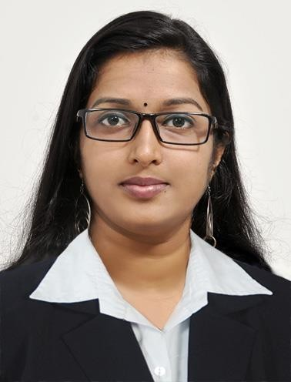

Email Id :
josmy-385806@gulfjobseeker.com

Visa Status: Visit Visa

Personal Information

Sex : Female

Nationality : Indian Marital Status : Single Date of Birth : 13.06.1993

LANGUAGES
- English
- Hindi
- Malayalam

Area Interests Accounts Admin
Billing HR

Career Objective

- To provide value added and quality service which will help to promote and contribute positively to the progress and reputation of the organization.
- To work towards fulfillment of objectives of the organization and also to achieve individual growth.

Assets

- Dedicated worker
- Willingness to undertake challenging responsibilities.
Academic Profile

Course / Degree | Board | Year
M.Sc Statistics | MG University | 2017
B.Sc  Mathematics | MG University | 2014
+2 | Science(Kerala) | 2011
SSLC | CBSE | 2009

Experience

Position | Years
Junior Assistant | 23 July 2018- 9 Oct 2019

Certification Course

- STATISTICAL DATA ANALYSIS – Organised by Tropical Institute of Ecological science

- MS Office – NATIONAL CERIFICATE IN MODULAR EMPLOYABLE SKILLS

Junior Assistant (23 July 2018 – 9 October 2019)

- Accepting cash or checks for deposit
- Processing cash withdrawals
- Assisting customers with routine tasks such as ordering checks or bank cards
- Maintaining detailed records of all transactions in accordance with the bank’s policies
- Adhering to branch procedures for all transactions
- Verifying customer identification
- Validating and cashing checks
- Receiving and processing loan and mortgage payments
- Balancing all cash and checks in cash drawer at the end of each shift
- Resolving issues and concerns with customer accounts to the best of one’s ability
- Referring customers to other bank personnel as needed to resolve problems
- Opening new bank accounts
- Answering customer questions, explaining promotions, and suggesting appropriate accounts or opportunities that suit the customer’s financial profile and current needs
- Generating receipts for customer transactions
- Cross-selling bank products when appropriate
- Maintaining confidentiality with all transactions
- Keeping stations properly supplied with pens, forms, and other necessary supplies
- Removing accounts for dormancy in compliance with branch procedures
- Closing accounts for customers as needed
- Keeping teller drawer within specified limits while buying and selling currency from the vault

Skill Set

  - Customer Service
  - SPSS
  - Report Generation
  - Data updating
  - MS Office
  - C++,SQL

Declaration
I hereby declare that the above particulars furnished by me are true to the best of my knowledge and belief. I assure you, if I am given a chance, I will execute my work to the fullest satisfaction of my superiors.

Place:

Date Josmy

