SHAHUL
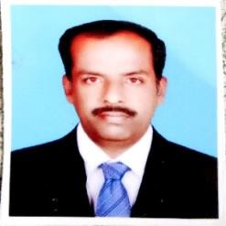

Email : shahul-395850@gulfjobseeker.com

Objective:

Obtain a position in an esteemed organization where I can contribute my experience as a Driver, Where my year of experience and hard work can add value.

Work experience

Worked as a personal driver in Kuwait from 2001 - 2004

Company : Group of Companies, Dubai, U.A.E

: Jan – 2006 till Dec – 2011

Position : Driver, Office assistant.

Job responsibilities : Executive driver , Picking up company guest, Traffic Fine checking & Paying for all company vehicles, banking related works, Utility bill Payment.
Company : Freight forwarding company in Dubai, U.A.E.

: May – 2015 till May – 2018

Position : Driver, Office assistant.

Job responsibilities : Executive driver, Picking up company staffs , Transporting ATM machines, Utility bill payments, Head of the driver staffs, Import and export clearance in Airport. Also worked as a Driver at Kovai lubricants in India from 2018 - 2019

Skills

- Having Valid UAE ( Level 3 & 5 ) Driving License.
- Excellent Knowledge of All U.A.E roads.
- Trained to drive safely
- Good customer service skills
- punctual in work.
- Detailed and organized hard working

Language known : Arabic , Hindi, English, Malayalam and Tamil.

Education : SSLC ( SECONDARY SCHOOL LEAVING CERTIFICATE),

Tamilnadu, India.

Personal detail :

Nationality : Indian

Date of birth : 17 Jul 1974

Marital Status : Married

Declaration :

I hereby declare that the above information given in my Curriculum vitae is true and correct to the best of my Knowledge and understanding.

SHAHUL

