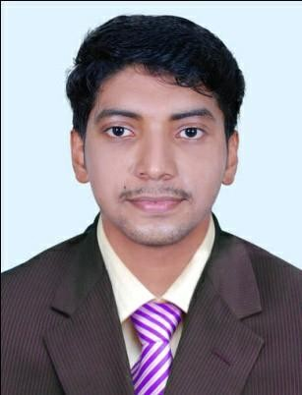
ABDUL
Kerala, India
Abdul-395856@gulfjobseeker.com
PROFESSIONAL EXPERIENCE

5 years of teaching experience in india

ACADEMIC PROFILE

- Master of engineering in power systems
- Bachelor of Technology (Electrical and Electronics Engineering)
PROFESSIONAL SUMMARY

- Engineering college
Assistant Professor. June 2016 to present.
- College of Engineering and IT Lecturer Feb 2012-June 2014
- Operator Assistant Engineer February 2013 to present (Part Time)

Assistant Professor in Electrical and Electronics Department- National Service Scheme Programme Coordinator
Engineering College
June 2016 to present
- Working Assistant Professor in the department of Electrical & Electronics
- Teaching theory as well as practical subjects to graduates and under graduates students in Electrical & Electronics Department
- Program co-ordinator of all the programs conducted by the college
- Department co-ordinator of Entrepreneurship Development cell
- Handling various theoretical and practical(Power system Lab, cad, Matlab, E-Tap etc.) electrical and electronics subjects especially power system based subjects
- Conducting various social works under NSS cell

College of Engineering and IT

Lecturer
February 2012 – June 2014.

- Lecturer in electrical and electronics department
- Attendeducational events andother fairs toexplainaboutcoursetoprospectus students
- Helping and mentoring students to identify the right career.

Operator Assistant Engineer February 2013 To present

- Supervise maintenance works, breakdown and construction works of 110kv substation.
- Arrange and ensure the essential tools and materials required for construction, breakdown and maintenance works are kept in readiness.
- Ensure the correctness of the operations carried out by the subordinates.
- Responsible for Stage wise planning, coordination, operations, execution and supervision of works of substation.
- Arrangeto preparerequisitions and procurematerials fromstores for worksin particular section..
- Analyze the load energy at various hours and tabulate it.

COMPUTER LITERACY
- MS Excel, Word, Power Point, Internet& Windows
- Drawing Tools- Auto CAD,CNCCADD,E-TAP,MATLAB
LANGUAGES
- English, Malayalam, Hindi and Arabic (Reading and Writing)
PUBLISHED PAPERS AND PROJECTS
- Publishedapaper‘’Over currentand Earthfault Relay Coordinationfor Microgrids with Modern Numerical Relay Features’’ in an International Journal of Engineering Research and General Sciencein2016
- Completed a project on Automatic power factor improvement in 2011.

PERSONAL INFORMATION
- Marital Status : Married
- Date of Birth : 16th January 1989
- Visa Status : Visit Visa

REFERENCES
- Will be provided on request.

2

