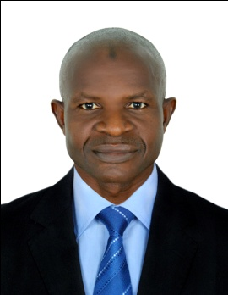
CURICCULAM VITAE
RASHEED
Email: rasheed-395958@gulfjobseeker.com
Sharjah – U.A.E

Career Biography & Objective

Seeking a creative and challenging position where my background experience and interpersonal skills can be developed & used in a way that yields benefits to the organization.

Skills
- Well-organized
- High communication skills.
- Accurate in everything
- Work under stress
- Self confidential
Experience
GENERAL HELPER
In LAGOS , NIGERIA
2 Year( 2015-2017)
Duties:
  - Organizing merchandise, weighting and measuring products.
  - Coordinating with customers details of their shipment.
  - Managed the transport of outgoing and incoming load and cargo shipments from aircraft and trains
  - Confirmed orders with vendors and customers ensuring cargo and freight delivery to loading platforms
  - Maintained shelf stocking formulations and audit of transport documents

Personal Information:

- Date of birth : 13/04/1974
- Marital Status : Married.
- Nationality : Nigeria.
- Visa Status : Visit Visa ( Till : Feb,28-2020)
- Language Known : English

Education:

O- Level
Declaration
Hera I certify that the above mentioned statements are true in my knowledge & belief.

