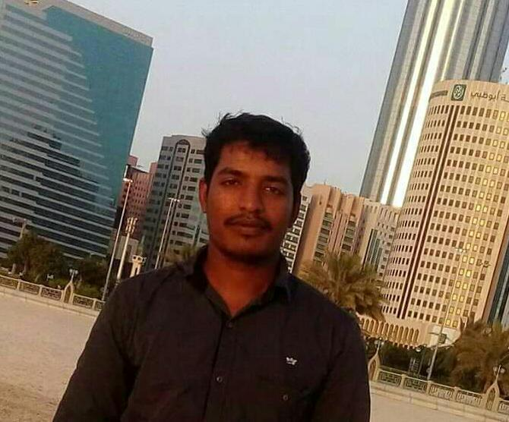  PERSONAL DETAILS:  Name : SARAVANAN  Email: saravanan-396010@2freemail.com  PASSPORT DETAILS :  Date of Expiry :24th July 2023  EMPLOYMENT VISA  EXPIRY: 2020 JAN 22  LANGUAGES KNOWN :  English, Hindi, Tamil and Malayalam  UAE address  Abu Dhabi  PERSONAL DATA :  Date of Birth: 03rd June 1991  Marital Status : Married  SKILLS :  - Outstanding communication skills.  - Ability to work independently.  Excellent knowledge in  MS OFFICE  MY STRENGTHS:  - Willingness to learn.  - Ability to learn quickly..  - Sincerity and hard working  - Basic Mechanical and Electrical Equipments.  TECHNICAL SKILLS:  - AutoCAD  DECLARATION:  I hereby declare that the above stated information are true and correct to the Best of my knowledge and belief.  Yours Sincerely  ( SARAVANAN)  Place :ABUDHABI | CURRICULUM VITAE  OBJECTIVE :  To seek a challenging career in an industry that provides a channel for Enhancement of my knowledge & strength to reach the organization goals  as well to have an upward personal career growth.  EDUCATIONAL QUALIFICATION  Academic :  Diploma in Computer Application (2008) and  Mechanical Engineering in ANNA UNIVERSITY 2012 -UAE attested)  DRIVING LICENSE DETAILS:  TYPE : UAE DRIVING LICENSE LMV (MANUAL)  PROFFESSIONAL EXPERIENCE: 6 YEARS UAE DUBAI - 4 YEARS  INDIA – 2 YEARS  - FM MEP SUPERVISOR  ( Facilities Management company in UAE (dec2017 to now)  - MEP technician  (Construction Machinery company in UAE Nov 2014 – Jan 2017)  - Mechanical Technician  ( in Chennai INDIA  (Jun 2012- to July 2014)  PROJECTS WORKED IN DUBAI  - Fairmont Hotel Project,Abudhabi,UAE(sub contract under ARABTEC).  - Mussaffah Garden Project,Abudhabi,UAE(sub contract under PIVOT).  - Al RAYYANA project under ALDAR  ROLE HANDLED  - FM CONCEPT EVOLUTION FSI software works  - Managed daily work load and priorities of 15 to 25 Facility technicians and contractors involved in HVAC,Electrical and Plumbing and multiple shifts  Prepared and processed the PPM of INTERNAL AND SUB CONTRACTOR(monthly ,quqterly and yearly)  - Ensure efficient delivery and services of FCU, FAHU, boosterfilterationpump,generator maintenance ;LV ,HV room maintenance And all kind of apartment works handled  - M  - Analyzes and resolves trouble shoot problems or assist workers in solving work problem  - Guagecalibration,third party safety certificate arrangements and keep records  - Work done as per the safety standards and follow construction safety rules and regulations  - Supervise all machineries And Activity of technicians  - Provide and Make site inspection reports to the clients  - Report the condition of the unit during the warranty period.  - Initiates and suggests plan tomotivate workers to achieve work goals

