Kavita (Senior Accountant)  E-mail: kavita-396114@2freemail.com |  | 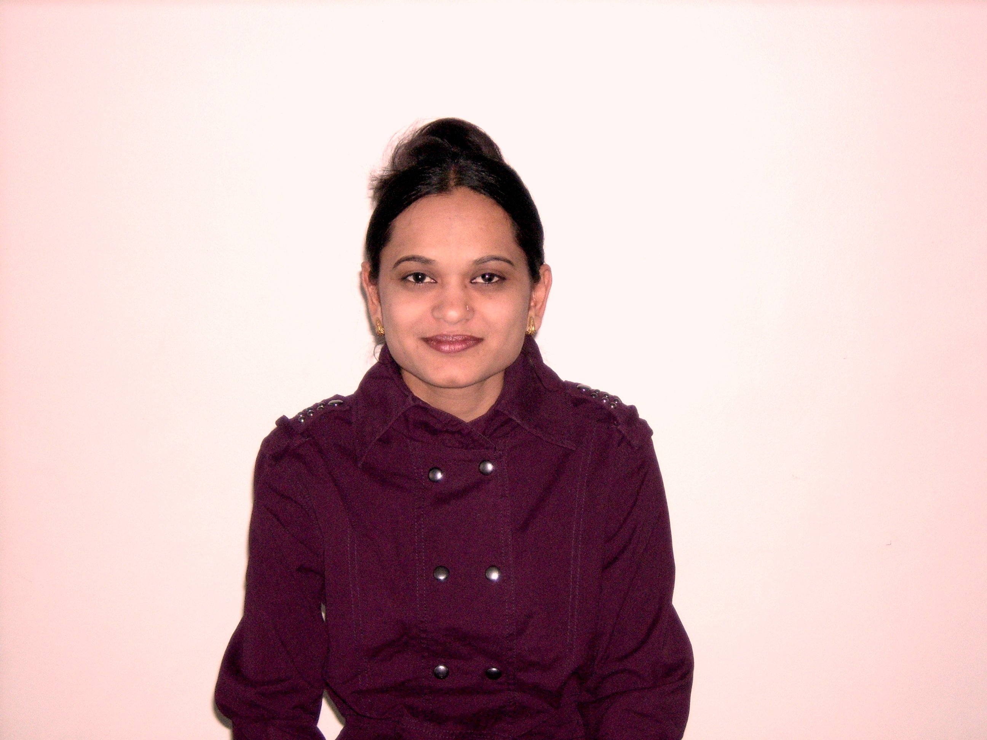
Objective | To associate with an organization which prosper dynamically and give me  an opportunity to prove my ability and skills in all aspect in the development and prosperity of the organization.

Achievements and professional strengths:

- Developed extensive written, verbal and latest computer skills.
- Interpersonal ability to organize and implement work related activities.
- Capable of adopting new environment and group work quickly.
- Effective co-ordination skills.
- Ability to work under pressure

Experience

GENERAL TRADING CO in Dubai, U.A.E August 2009 till date

Responsibilities: -

Accountant
- Processing employee’s salary.
- Preparation of vouchers, handling petty cash, data entry.
- Documentation/review of various accounting and internal control system.
- Preparation of supplier’s correspondence letters, memos & schedules.
- Draw management’s attention or recognise operations which are unprofitable.
- Handling the entire accounts related works & transaction up to balance sheet &
finalisation including general admin related works.
- Keeping Managing Directors personal account.
- Handle cash book, general ledger, personal ledger, journal register, L/C transactions,
reconciliation of bank statement and other accounts.
- Prepare and process monthly payroll and expense reimbursements.

GROUP OF COMPANIES in Dubai, U.A.E Feb 2007 till July 2009

Responsibilities: -

Accountant
- Processing bank employee’s salary, visa charges & credit supplier payments.
- Managing invoices of salaries for other banks mainly Barclays, ADCB, Doha bank,
NBO, NBQ, Habib bank, UBL, Dubai bank, Emirates bank, HDFC, Mashreq bank,
City bank, HSBC.
- Preparation of vouchers, handling petty cash, data entry.
- Documentation/review of various accounting and internal control system.
- Preparation of bank correspondence letters, memos & schedules.
- Draw management’s attention or recognise operations which are unprofitable.
- Handling the entire accounts related works & transaction up to balance sheet &
finalisation including general admin related works.
- Keeping Managing Directors personal account.
- Handle cash book, general ledger, personal ledger, journal register, L/C transactions,
reconciliation of bank statement and other accounts.
- Prepare and process monthly payroll and expense reimbursements.

July 2006 till Jan 2007
(A unit of ICA Infotech Pvt. Ltd.) – Surat, Gujarat-INDIA

Responsibilities: -

Accountant
- Control and administration of all documents.
- Attend payment enquiries, maintain books of accounts, in charge of local purchases
and payroll functions.
- Maintaining of bank book, cash book & petty cash.
- Preparing financial statements based on Auditors report.
- Preparing forms, manuals for accounting book keeping personnel, direct their work
activities.

Rajkot, Gujarat-INDIA June 2004 till June 2006

Responsibilities: -

Accountant
- Prepare students & staff salaries.
- Data entry and review of voutchers.
- Prepare financial statement for submission to the Banks/Financial Institutions.
- Assisting in handling all document work for income tax.
- Prepare books stock summary according to the requirement, weekly, monthly & annually.
- Reconciliation statements & final accounts such as Profit & Loss account and balance sheet, generate different reports, assist auditors and report to the management.

PROFESSIONAL EXPERIENCE: -

- Almost 15 years of my extensive experience in the field of accounting those
13 years in Dubai.
- Proficiency in independently handling all the accounting functions
like closing books of every month end, bank reconciliation, customers’ accounts.
- Experience in day today administration.
- Preparing payments payable & receivable.
- Working experience in fully computerized environment by using Tally, Peachtree & quick book.
- Experience in handling of Directors & overseas Managers personnel accounts.
- Checking invoice with receiving confirmation.

Education background

Bachelor of Commerce  (Sm.R.P.Bhalodia Arts, Commerce College) Rajkot-Gujarat, INDIA. | 2000
Certificate in Computer Software  (Aptech computer education) Rajkot-Gujarat, INDIA. | 1999
Master Degree course of THE REIKI  (The REIKI institute) Rajkot-Gujarat, INDIA. | 2006

Computer Skills

- Accounting Package – Tally 7.2, Tally 8.1, Peach tree & Quick book.
- MS Office (Word, Excel & PowerPoint), Internet and E-mail applications

Language

English, Hindi & Gujarati.

Personal Details

Nationality : Indian
Date of Birth : 5th December 1979
Marital Status : Married
Visa Status : Husbands visa

