ABHIRAM

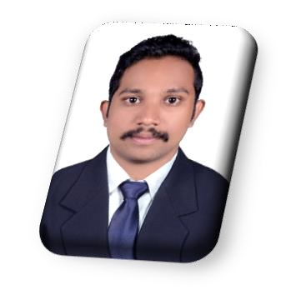Career Objective

CONTACT
E mail : abhiram-396205@2freemail.com

EDUCATION
Bachelor of Arts Degree Kerala University
2017-2019

Higher Secondary 2013-2015 Board of Higher Secondary Kerala

SSLC 2012-2013
Board of Examination Kerala

COMPUTER KNOWLEDGE
MS Word MS Excel
MS Powerpoint
Seeking for a responsible and challenging opportunity that would utilize and enhance my skills, where I can actively devote my abilities through dedicated hard work & the resources of the company to achieve combined growth.

Experience
Worked as a Receptionist with Office Administration in a Job Consultancy, Thiruvananthapuram, Kerala (April - Dec 2019)

Personal Details
Date of Birth : 12-12-1996
Nationality : Indian
Sex : Male
Languages known : English, Malayalam, Tamil, Hindi Marital Status : Unmarried

VISA STATUS

VISA STATUS : Visit visa
Expiry of Visa : March 10, 2020

Declaration
I hereby declare that the above mentioned information is true to the best of my knowledge and belief.

ABHIRAM

