Osman CURRICULUM VITAE

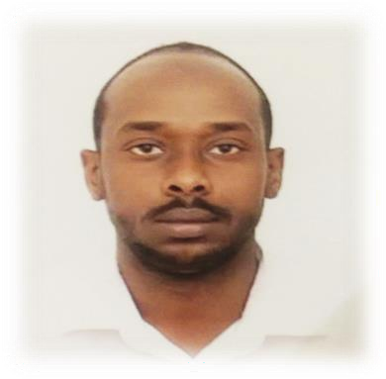
P E R S O N A L D E T A I L S :

Name: Osman
Nationality: Sudanese
Date of Birth: 18-August-1993
Marital Status: Single
E-mail: osman-396271@2freemail.com
Driving License: Valid Sudanese driving license Visa Status: Valid UAE Visit Visa.

O B J E C T I V E :

To obtain a position in Air conditioning and Refrigeration and Building Management to utilize both my educational background and professional experience to contribute effectively to the organization's vision, mission and objectives.

E D U C A T I O N

February 2018 Master degree in Refrigeration and Air Conditioning, Sudan Academy of Science October 2014 Bachelor (Hons) of Mechanical Engineering (General), Kurdofan University

W O R K E X P E R I E N CE

Employer: Breast Care Center in Sudan Job title: Building and Facilities Manager.

Duration: From 1 January 2019 until 30 October.
- Plan and coordinate all new installations and refurbishments.
- planning the work and efficiently organizing the site facilities in order to provide high quality services.
- Inspect building’s structures to determine the need for repairs or replace.
- resolving any unexpected technical difficulties and other problems that may arise.
- Supervise technician staff facilities.
- Handle insurance plan and service contracts with other companies.
- Review utilities consumptions and strive to minimize the cost.
- Estimating annual budgets and material stocks.
- Perform analysis and forecasting based on daily reports.

Employer: Maintenance and Electronic Devices company in Sudan

Job title: HVAC Field Service Engineer.
Duration: From 02 November 2017 until 22 June 2018.
- Schedules, directs and provides technical support for technicians to meet service demands and customers’ expectations.
- Supervises technicians to perform actively functions of equipment repair, installation, operation and other duties.
1 | P a g e

Osman CURRICULUM VITAE

- Reviews work orders, invoices and time reports.
- Specifies and make sure that required parts are ordered in time to ensure work deadlines are met.

Employer: Engineering company in Sudan

Job title: HVAC Projects and Design Engineer.
Duration: From 05 February 2016 to 10 May 2017.
- Day-to-day management of the site, including supervising and monitoring the site.
- ensuring that all materials used and work performed are as per specification.
- planning the work and efficiently organizing the site facilities in order to meet agreed deadlines.
- overseeing quality control and health and safety matters on site.
- preparing reports as required.
- resolving any unexpected technical difficulties and other problems that may arise.
- Creating basic designs, calculations, duct sizing, Pipe sizing and pump selection.
- designing new or replacing heating, cooling, and refrigeration systems specific to the customer's needs and to building specifications
- Calculating thermal loads and choosing the appropriate system and providing Design Drawings.
- Working with a team of engineers to deliver the plans.

T e c h n i c a l C o u r s e s :

  - Heating Ventilation and Air Conditioning (HVAC).
  - AutoCAD.
  - OSHA.
  - Fire Fighting & Fire Alarm System.
  - Programmable Logic Controller (PLC).

V oc a t i o n a l C ou r s e s :

- General Electricity and Classic Control:
- Air-Conditioning and Refrigeration Maintenance:

S K I L L S A N D C O M P E T E N C I E S :
•Excellent communication skills in both Arabic and English.
•Excellent IT skills including MS-Office package.
•Interpersonal and effective communication skills.
•Confident and have an inspiring personality, Able to work under Stress.
•Self-dependent, Co-operative, helpful, good listener and willing to make good relations with others in places I attend.
•Fast learner, able to identify main issues quickly and deal with them efficiently.
- All references to be provided upon request.

2 | P a g e

