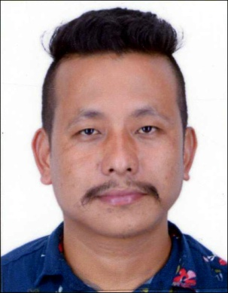
CURRICULAM VITAE
SUNIL
Sharjah -United Arab Emirates
Email: sunil-396298@2freemail.com
Objective
Seeking a challenging and career oriented Position in Administration & Marketing
Education Qualification:
Higher secondary from West Bengal Education Board.
Work Experience:
TELE COMMUNICATION company in Sikkim
Period : 03/03-2016 – 2019
SALES PROMOTER / TEAM LEADER
Responsibilities:
- Responsible for coordinating with the existing dealers of the company.
- Updating dealers about the change in product price and new product launch.
- Meeting the existing customers.
- Meeting the new target customers and converting them into customers.
- Solving the problem and queries of existing dealers and customers.
- Searching for new dealers.
- Giving all the details of the company to the upcoming dealers and explaining them policies for the dealership.
- Organizing events at the dealers place to attract more customers.
- Meeting dealers on daily basis and helping them in finding customers.
- Making daily call reports and sending them to the seniors.
- Attending meetings and monthly closing at district office.
in Chennai
Period : 18/03/2014 to 30/03/2016
PHYSIO THERAPY / HAIR DRESSER
Responsibilities:
- Maintaining a clean and tidy salon
- Washing and conditioning clients' hair
- Reception duties
- Stock rotation and ordering supplies
- Washing and conditioning hair
- Perming techniques
- Cutting and styling
- Colouring hair
- Greeted customers with a calm and attentive manner and escorted them to treatment rooms
- Stocked the front desk with clean spa towels and collected used linen after treatments
- Replenished drinking water on an hourly basis and carefully set up treatment rooms before each appointment

Personal Details:
Date of Birth : 01/06/1992
Nationality : Indian
Marital Status : Single
Sex : Male
Visa status : Visit Visa
Languages:
Hindi : Mother Tongue
English : Good
Nepali : Good
Other Skills:
Possess excellent telephonic, problem solving and customer service skills
Excellent listening, multitasking and organizational skills.
Customer oriented with excellent communication skills.
Ability to interpret information in a clear and accurate manner.
Skilled in handling and maintaining office equipment and systems
Pleasing personality.
Additional Information
am willing to learn and confident of mastering any subject that is to be learned as a part of the job and I wish to transfer my life and looking forward a challenging ,intellectually and demanding career.
I hereby declare that the above information is true to the best of my knowledge and belief.
SUNIL

