Name : Harjit

RESUME

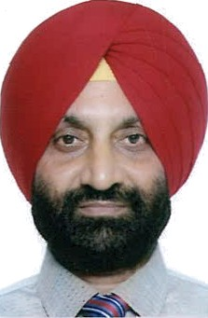
Date of Birth : 20-01-1968
Qualification : B. Sc. , B.Ed.
PG Diploma in Marketing Management (Semester 1}

E mail : harjit-396532@2freemail.com
Marital Status : Married (wife Post graduate in Sociology & working as a Govt. teacher) Children : Two; Daughter nineteen years old; student of B.Sc. — Hotel Management in
Lovely Professional University & Son sixteen years old; student of tenth class in Cambridge International school.
Brief In†roduc†ion of my academic and professional career is as follows I completed my graduation in science during 1988 by securing 80% marks and stood at the fourth position in the university. I did B.Ed. during April 1989 and after that I joined Post Graduate Diploma in Marketing Management. I was selected as a Medical Representative during my study of first semester {i.e. year 1989} pertaining to Post Graduate Diploma in Marketing Management. In the Pharma industry I was suitably recognized due to my achievements of targets. I worked at the senior levels also & ultimately I resigned as District Manager during 2002 after working for approximately thirteen years.

Within few months I started my own marketing company in 2002 by having my own brand names and occupied a place of marked prominence in Pharma industry by doing ethical marketing approximately for ten years only because I was compelled to wind up m*y business during the year 2012 due to DPCO policy adopted by the Indian government.

After this, I started IELTS coaching center but couldn’t get the desired taste of life because marketing personals can’t sit without exploring. While going through my past track and capabilities, I am sure enough that pharma marketing is the only industry for me where I can successfully explore my marketing strategies because I do have a inclination to design effective and result oriented marketing policy and have a competency to get it implemented from the subordinates. After considering so many aspects of life, I have decided to work in a good pharmaceutical company of Dubai.

In case above particulars of mine suit you then just call me for interview. Yours truly,

Harjit Dated :

