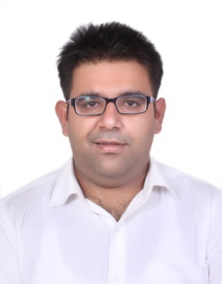
OVERVIEW:
A creative and enthusiastic individual, with strong communication skills, marketing and selling experience, always yearning to understand the customer, and building and sustaining relationships. Recognized as a high performing salesman. Avid actor in plays.

PROFESSIONAL EXPERIENCE:
Industry: Label manufacturing of clothing
Project Manager (January 2017- Current)
- Dealing with Overseas clients on mails regarding the labels.
- Providing rates of labels to clients.
- Constant follow up with our production team for the labels to be manufactured

Freight Mantra Pvt. Ltd. Gurgaon, India
Senior Shipping Consultant (Inside Sales) (September 2015 – November 2016)
- We have an online portal with a name of “ShippingExchnage.com”
- We help the Importers/Exporters to get best rates.
- My Work is to close the Deals.
- Putting mails to the Shipping Lines for Rates
- Arranging Meetings with Shipping Lines to get them on board.

American Express, Gurgaon, India
Sales Manager (September 2014 –September 2015)
- Working on selected leads from the sales funnel –scheduled meetings with clients and presented B2B cards’ products to clients, and ensuring due diligence is undertaken to close deal
- Recognized as Consistent Performer in successive months (November and December 2014)

Nest Keys Infratech Pvt. Ltd. New Delhi, India
Sales Executive (May 2014 – September 2014)
- Start-up firm with ten employees, focusing on needs-based property solutions
- Built sales funnel – researched, cold calling, generatedleads
- Built customer base – scheduled and met with clients, followed up with clients for due diligence activities

HCL Infosys, New Delhi, India
Marketing Executive Internship (June 2012 – August 2012)
- Internship: Overachieved sales targets – sold 40 Laptops and 100 LED Screens at Amity International School, New Delhi, India

EDUCATION:
IIPM, New Delhi, India
MBA, specialization inMarketing (August 2012 – December 2014)
- Thesis: Marketing Research in Healthcare in New Delhi, India
- Research focused on customer experience of patient, treatment experience of patient and equipment, and analysis of technology used (compared to market trends and competitor analysis)
- Conducted face to face interviews with Doctors of large hospitals and Doctors running their own Nursing Home
- Summer Project: Comparative Analysis of Reebok v/s Nike in New Delhi, India
- Analyzed and reported on brands worn by target group (18-25yrs, Males, New Delhi)
- Conducted a questionnaire survey of individuals wearing both brands

GNDU, Amritsar, India
Bachelors in Business Administration (July 2008– June 2011)

St. Xavier School, New Delhi, India(July 1996 – June 2008)
Schooling from Grade 1 – 12 (focus on Commerce in Grades 11& 12)

EXTRACURRICULARS:
- Part of organizing committee for AmazeStudent Cultural Festival in IIPM (October 2012, New Delhi, India)
- Awarded 2ndplace in OasisIntra College Play competition in JIMS (November 2008, New Delhi, India)
- Following sports, listening to music, reading novels, traveling and playing the guitar.

