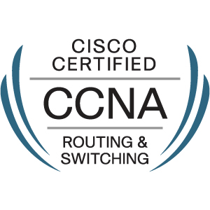
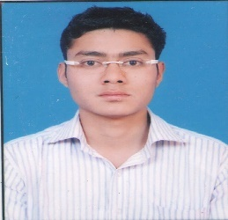
RESUME

DHRUVPAL
Email: dhruvpal-396723@2freemail.com
Date of Birth: 14/02/1992

NETWORK& HARDWARE ENGINEER
Seeking a challenging and rewarding opportunity with an organization of repute which recognizes / utilizes my true potential while nurturing analytical and technical skills

PROFILE
- Experience in managing entire spectrum of functions related to Network Management, System Administration and Hardware Support including Implementing Switching and Routing solutions.
- Conduct research, designing, develop, test, and supervise the installation of all computer hardware.
- Also worked with system motherboard in installing chips, circuit boards and entire system repairing.
- Attention to detail with capability to switch to allied or varied technologies depending on project requirements.
- Focused and hardworking professional equipped with thorough knowledge and technical understanding coupled with an analytic bent of mind and confident to take challenging assignments.

INDUSTRIAL TRAINING
INDUS TOWERS LIMITED (Cyber city, Gurgaon) 1st June 2012 to 10 July 2012

Ihave completed industrial training at INDUS TOWERS LIMITED, Cyber city, Gurgaon.
At there I worked in all department Front office, TOC (Tower Operating Centre), Information Technology Department and learned how to operate the equipment of respective department.

PROFESSIONAL EXPERIENCE
IT Infrastructure (Under project of AIR INDIA) Working from 1 june 2017 to till date

Network Engineer
- Responsible for configuration, installation & troubleshooting of LAN and WAN
- Experience of Media convertor, LIU installation through Fiber Optic. Etc.Network Printers, Scanners.
- Managed computer installations along with all related accessories and networking to ensure hassle free functioning of systems. Updated users on maintenance tips for prolonged service life of machines.
- Handled installation & maintenance of Operating Systems, Application Software, Assembling, Virus Protection.
- Managed entire computer hardware/ networking operations with an eye for viability of business enterprise.
- Scrutinized user needs and recommended appropriate hardware, software for the system.
- Very good knowledge of LAN and Desktop problems.Optical fibre solutions & splicing.

EDUCATIONAL & PROFESSIONAL CREDENTIALS

CCNA CERTIFIED IN ROUTING AND SWITCHING

Three Years Diploma in Electronics and Communication engineering
High school from CBSE Delhi in 2008.
INTERMEDIATE(+2) FROM NIOS BOARD
Area of Interest: Routing, Switching, Hardware issues

Languages Known: English, Hindi
Nationality: Indian

Date:
Place: (Dhruvpal)

