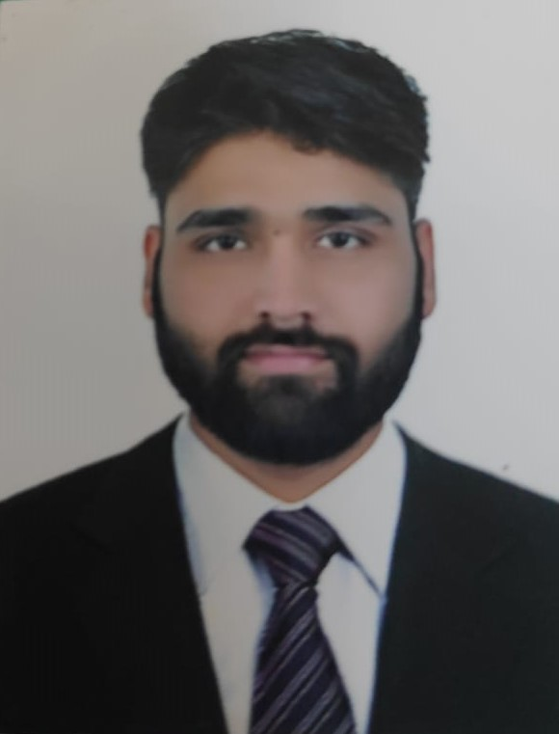RESUME
Chetan
Email: chetan-396724@gulfjobseeker.com
Date of Birth:1/04/1995

IT COMMUNICATION AND DIGITAL MARKETING

Seeking a challenging and rewarding opportunity with an organization of repute which recognizes / utilizes my true potential while nurturing analytical and technical skills

PROFILE
- Experience in managing entire spectrum of functions related to telephone Management, System Administration and Hardware Support including Implementing solutions.
- Attention to detail with capability to switch to allied or varied technologies depending on project requirements.
- Focused and hardworking professional equipped with thorough knowledge and technical understanding coupled with an analytic bent of mind and confident to take challenging assignments.

INDUSTRIAL TRAINING
Gauitam solar pvt ltd (okhla industrial area) 1st June 2013to 10 July 2014

Ihave completed industrial training atgautam solar pvt ltd
At there I worked in electronics department and learned how to operate the equipment of respective department.

PROFESSIONAL EXPERIENCE
Unique services pvt ltd.(Under project of AIR INDIA) Working from 8 june 2015to8 nov 2015
- Telephone technician
- Responsible for configuration, installation & troubleshooting of telephone instrument and the whole network of air india

Working from 10 dec 2015 to 28 dec 2018

- Managing studio personnel (including sound engineers,staff members and artists).
- Scheduling recording sessions.
- Handling employee grievances.
- Plan and coordinate meetings with clients.

EDUCATIONAL & PROFESSIONAL CREDENTIALS

- Diploma in Electronics and Communication engineering from Aditya institute Of Technology, New Delhi. It is affliated to Board of Technical Education(New Delhi).
- INTERMEDIATE(+2) FROM NIOS BOARD
- BBA from Amity University ,Dubai from jan 2019 to jan 2021(pursuing)

- High school from CBSE Delhi in 2011.

- Area of Interest:Digital marketing and communication feild

Languages Known:English, Hindi

Date: (Chetan )

