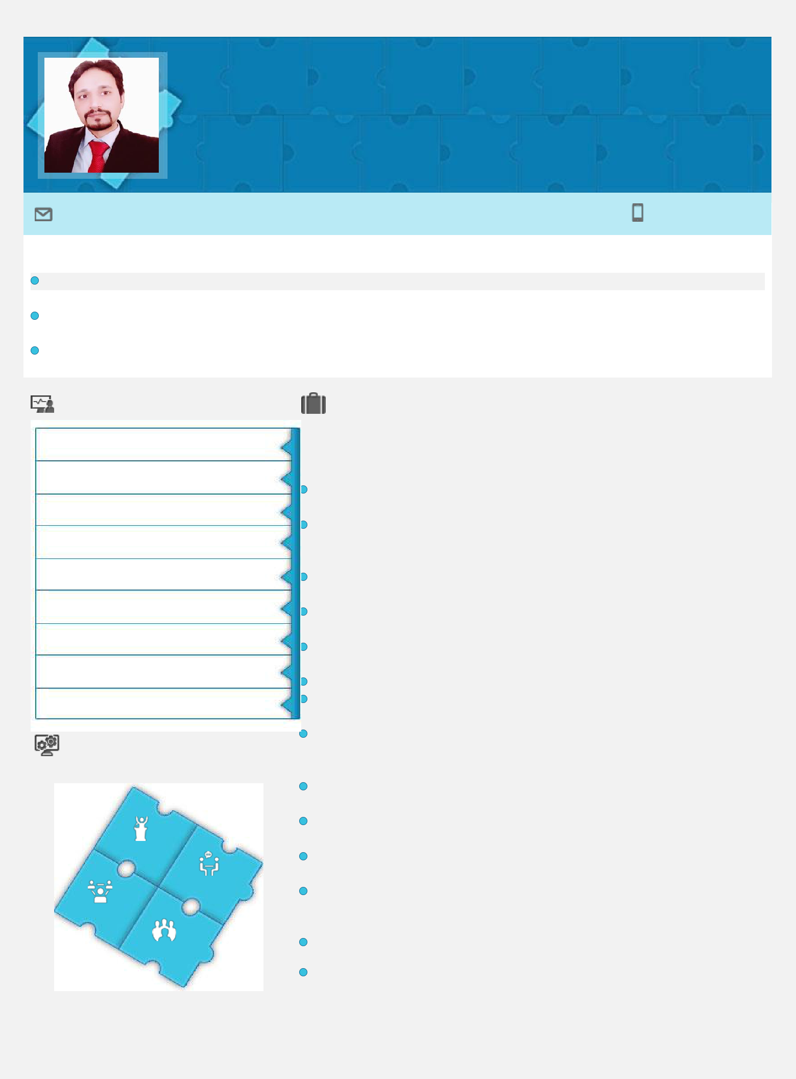
Ahmed M.BA, CMA(Continue)

Accountant

Payable & Receivable | Accounting & Reporting

 | Location Preference: | GCC Countries
 | Ahmed-396736@gulfjobseeker.com

Profile Summary

Accounting & finance professional offering 6 years of rich experience in Accounts Payables & Receivables, Financial Analysis & Internal Controls

Proficient in Managing & working with book keeping, compiling financial reports, Financial analysis and internal financial controls and costing

Experience of leading more than 3 subordinates to manage and direct reconciliation of ledgers, accruals and prepayments settlement of suppliers and generate payment runs.

 | Core Competencies |  | Organizational Experience
 | Financial Analysis |  | Nov'17- Jan’20
 |  |  | as Assistant Manager Accounts
 | Costing, Budgeting & Forecasting |  | Key Responsibility Areas:
 |  |  | Spearheading the payables, payments of operational, direct & indirect expenses
 | Payroll Processing |  | and reporting of such expenses
 |  |  | Drafting & finalizing the monthly, quarterly, half-year and annual income
 | MIS Reporting |  | statement and presenting to management to identify the risks and
 | Account Payables & Receivables |  | opportunities
 |  |  | Directing a team of 3 Subordinates; managing the Subcontractors & Suppliers
 | Internal Control |  | Payments and following with them for any query
 |  |  | Reporting to management for actual cash flow & and projected cash
 | Project Management |  | requirement to meet the operational cash needs
 |  |  | Administering the bank reconciliations & cash flow report to ensure precision
 | Team Development & Leadership |  | of the transactions
 |  |  | Drafting fixed-assets schedule and maintaining & updating fixed asset register
 | System Development |  | Collaborating with internal auditors recommending on financials & internal
 |  |  | controls
 | Soft Skills |  | Assisting in the development of annual and long-range plans that linked
 |  |  | business strategies to operational plans and the expected range of financial
 |  |  | results
 |  |  | Assessing existing system deficiencies in accounting procedure to rectify them
 |  |  | with the help of development team.
 |  |  | Coordinate the month end closing process to ensure all corporate deadlines are
 | Motivator |  | met and information is presented in accordance with policy and procedures
 |  |  | Supervising the junior staff for day to day accounting issues like data entry,
 | Communicator |  | bank reconciliation debtors’ and suppliers’ ledger etc.
 |  |  | Any other task assigned by management.
 | Team Leader
 |  |  | Highlights:
 | Collaborator |  | Monitored all purchase and expense accruals that had aged more than 120 days
 |  |  | Automated the preparation of 6 reports using MS Office Skills that had
 |  |  | previously required 12 hours of effort per week

Career Timeline |  | Previous Experience
 |  | May’14 – Oct’17
 |  | AZ Apparel(Pvt) Ltd, Pakistan
 |  | as Assistant Manager Accounts
 |  | Highlights:
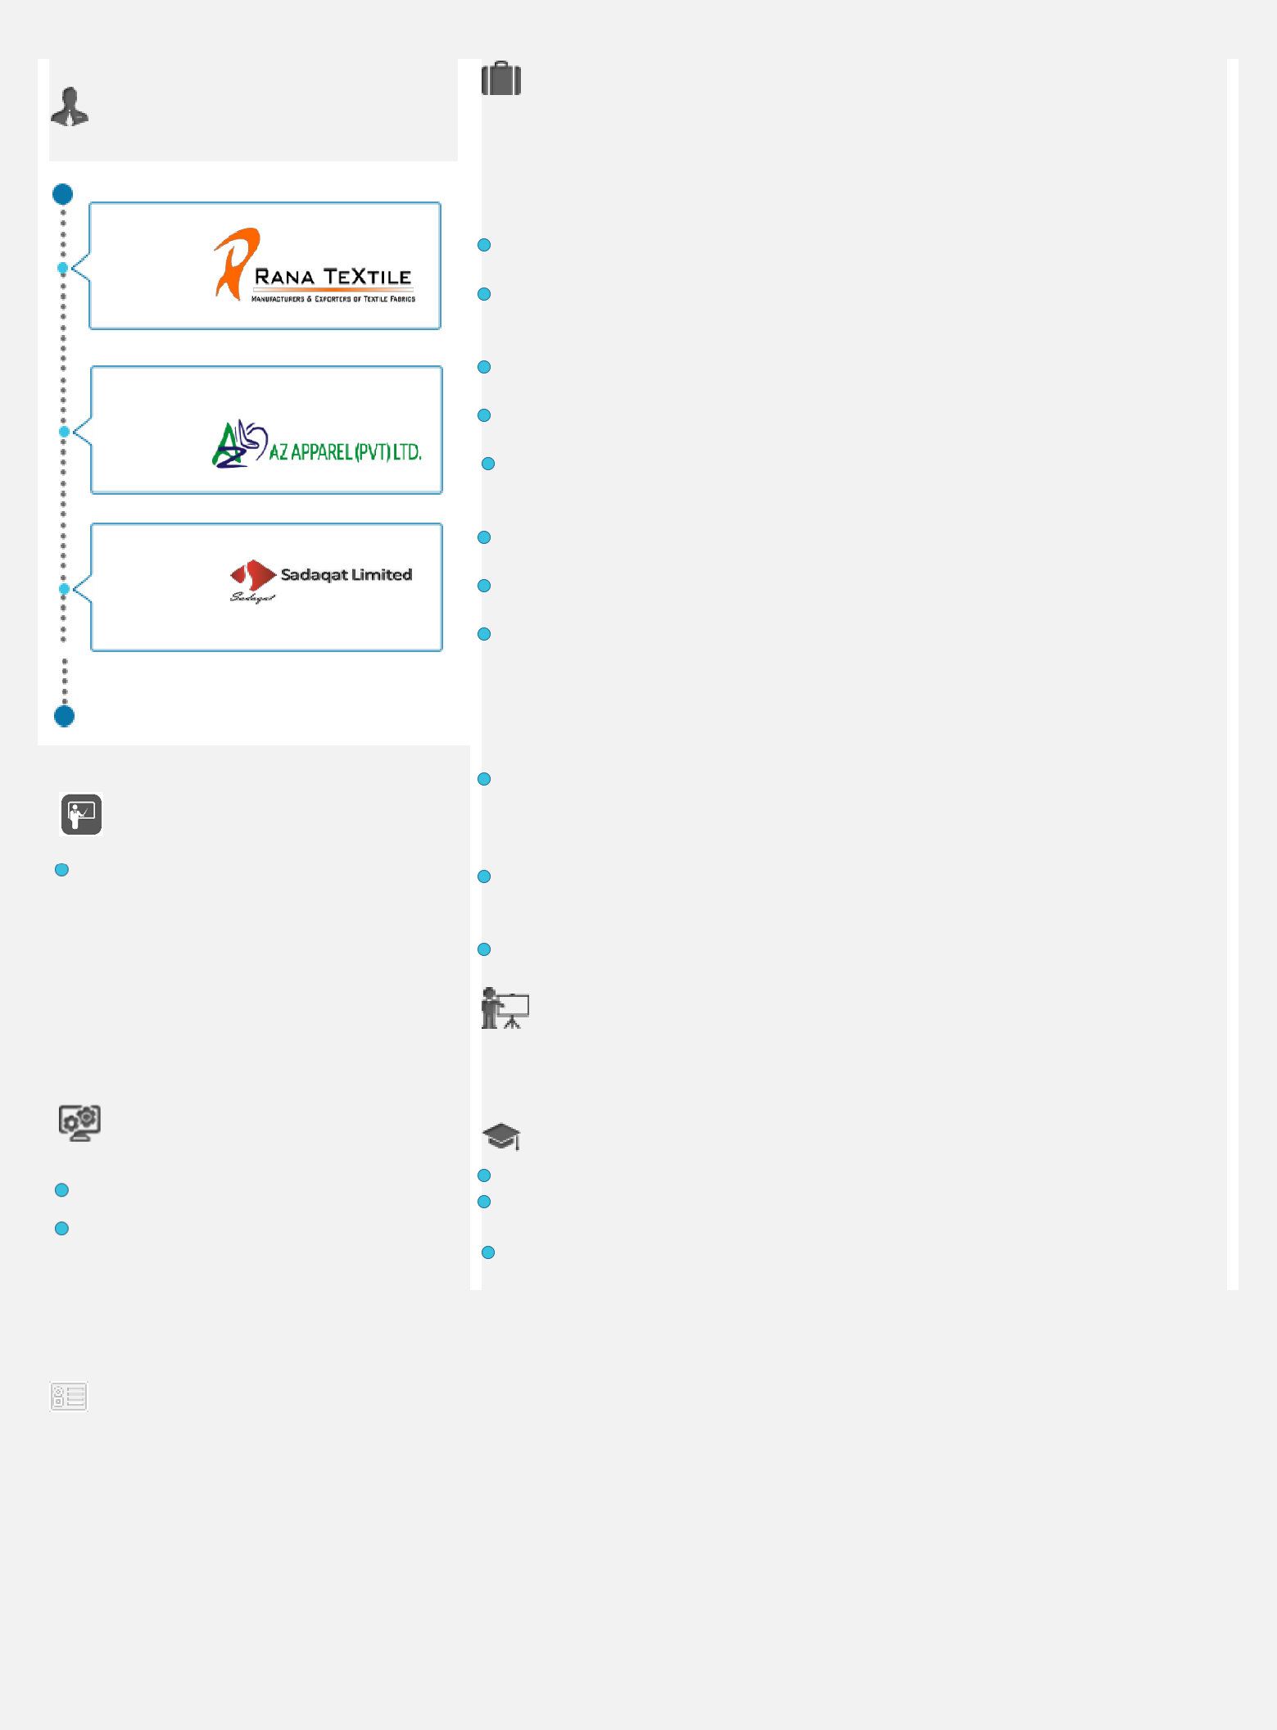
 | Nov'17- Jan-20 |  |  |  | Handled day to day accounting from data entry to preparation of Profit & Loss
 |  |  |  |  | accounts and related reports for management on monthly basis.
 |  |  |  |  | Prepare Monthly financial reports, reconciled complex fixed assets registers and
 |  |  |  |  | accounts and provide reports to management regarding significant expenditure
 |  |  |  |  | fluctuations.
 |  |  |  |  | Coordinate with internal auditors to ensure all accounting procedures are in
 | May’14 – Oct’17 |  |  |  | place as per management approval and policies of company.
 |  |  |  |  | Drove the matters for Payables, Payments of Operational, Direct & Indirect
 |  |  |  |  | Expenses and Reporting of such Expenses
 |  |  |  |  | Implement financial systems (e.g., Oracle), develop functional specifications for
 |  |  |  |  | approved enhancements, document changes and updates to the system, and
 |  |  |  |  | resolve the technical problems.
 | Jul'13– May'14 |  |  |  | Evaluated transactions to compliance with the Financial Policies, Procedures of
 |  |  |  |  | the Company and appropriate capital budget approvals
 |  |  |  |  | Prepared payment and payable summaries to compare forecasts, budgets &
 |  |  |  |  | analytical procedures
 |  |  |  |  | Supervise the junior staff for day to day accounting issues like data entry, bank
 |  |  |  |  | reconciliations suppliers’ and debtors’ ledgers etc.
 |  |  |  |  | Jul'13– May'14
 |  |  |  |  | Sadaqat Limited, Pakistan as Accounts Officer
 |  |  |  |  | Highlights:
 |  |  |  |  | Managed the Book keeping functions including diversified Accounts Payable &
 | Trainings Attended |  |  |  | Receivable, Aging Analysis, Expense Control Procedures for Bank Account
 |  |  |  |  | Reconciliations, Disbursements, Finance Charges, Billing, Invoicing; &
 | Training in ERP Oracle Financials R-12 |  |  |  | performed the General Ledgers daily
 |  |  |  |  | Supported the department in Quarterly & Final Audit, coordinated with the
 | in 2017 |  |  |  | Auditors to respond to queries (if any) and drafted briefs & reports to aid
 | o Oracle Financials Apps E-Business |  |  |  | workings for special projects
 | Suite R-12, Accounts Payable
 |  |  |  |  | Formulated Payroll - HO & Factory Employees for subsequent entry in GL
 | o Oracle Financials Apps E-Business
 | Suite R-12, Accounts Receivables
 | o Oracle Financials Apps E-Business |  |  |  | Internship
 | Suite R-12, | Internal Audit
 |  |  |  |  | Jun'10 – Aug'10
 | (overview)
 |  |  |  |  | National bank of Pakistan as Intern
 | IT Skills |  |  |  | Academic Details
 | MS Office: Word, Excel & PowerPoint, |  |  |  | Continue: | CMA
 |  |  |  |  | 2010: | M.BA from National University of Modern Languages
 | Oracle 7, Oracle financial R-12 |  |  |  | Islamabad, Pakistan
 |  |  |  |  | 2008: | Graduation in Commerce (B.Com.) from The University of
 |  |  |  |  | Punjab, Lahore
 | Personal Details
 | Nationality: | Pakistani
 | Date of Birth: | 24th November 1988
 | Visa Status: | Visit
 | Current Location: | Abu Dhabi |  |  | Languages Known: |  | English & Urdu
 | Marital Status: | Married |  |  | Availability: |  | Immediate

