UMAIR

QC MECHANICAL ENGINEER

(MEP)

GET & TOUCH:

- Umair-396747@gulfjobseeker.com

United Arab Emirate

PERSONAL PROFILE

Date of Birth : 10 April 1991

Nationality : Pakistani

Religion : ISLAM

Marital Status: Single

Language : English, Arabic,

Urdu, China

CAREER OBJECTIVE :-
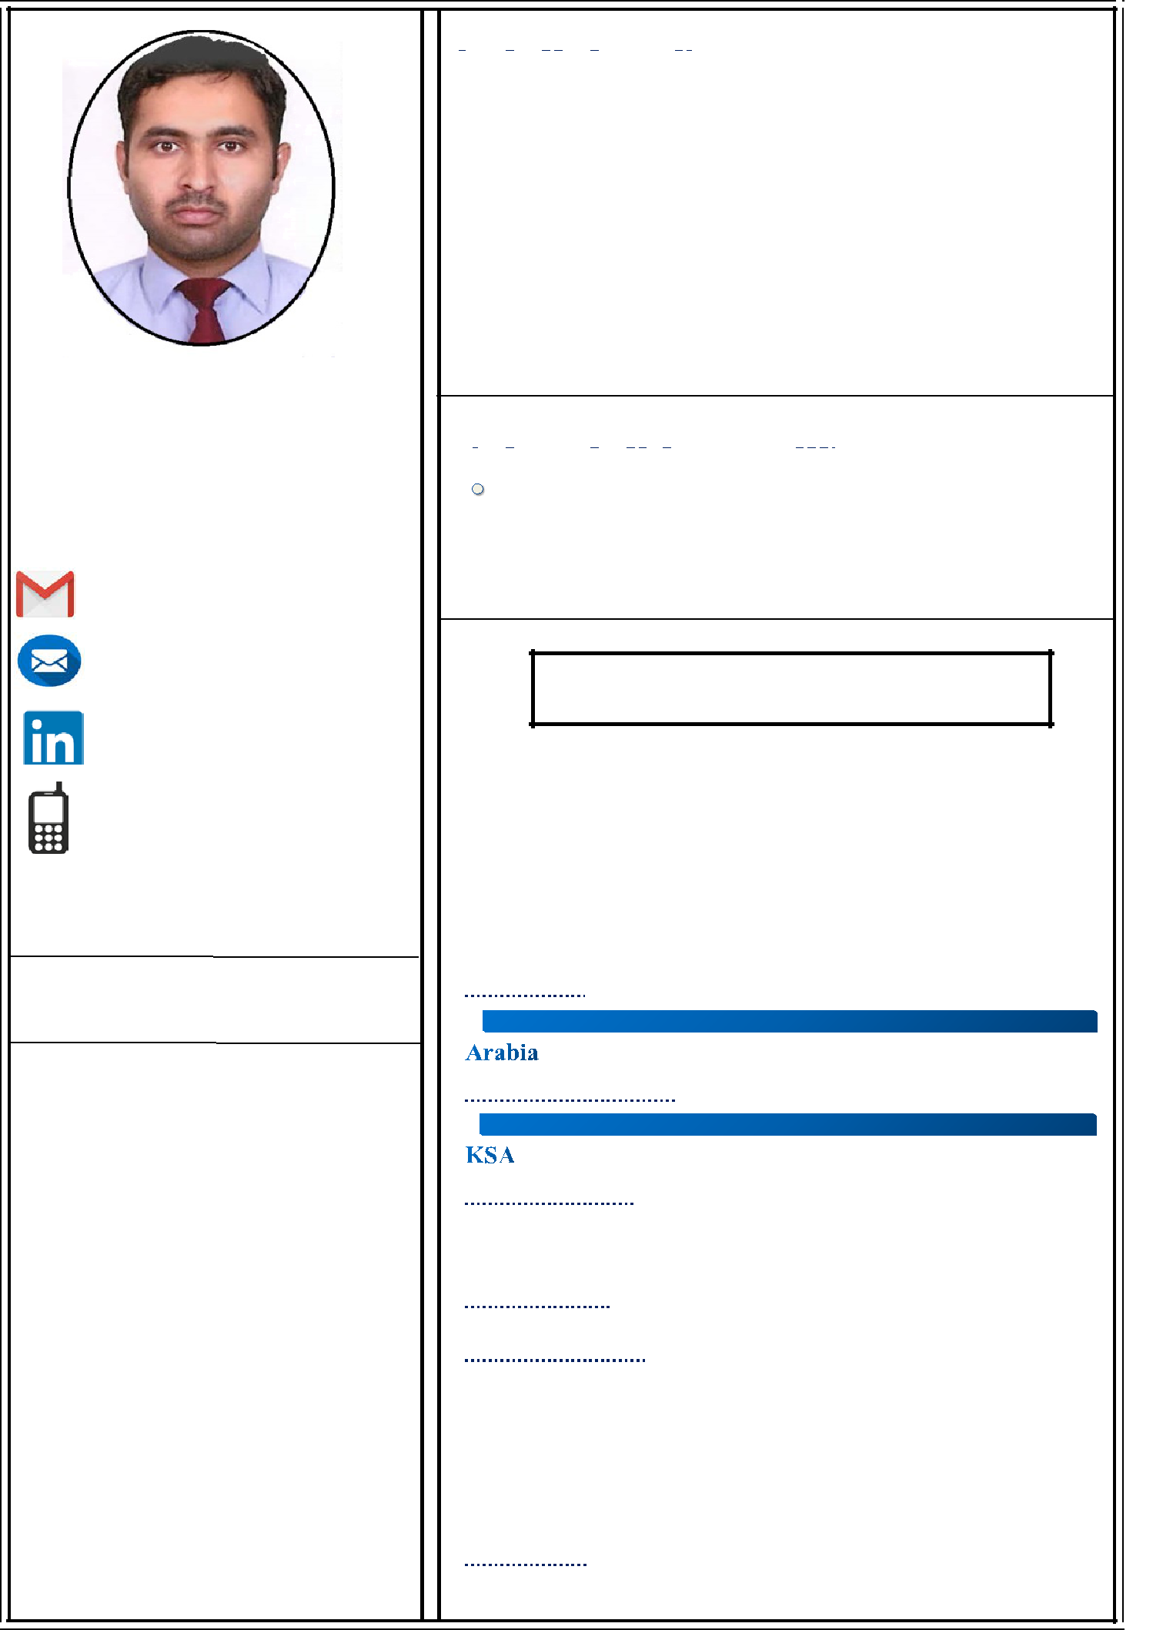

To pursue a highly challenging career in the field of QC Mechanical, where I can apply my knowledge and acquire new skills. I foresee myself to be part of top-notch respectively team of professional with sincerity, creativity and dedication. To display worthiness, caliber, and competence potential and join a progressive, forward-looking Multi-Disciplinary organization dealing especially in Mechanical, HVAC, Plumbing and Fire Fighting Designing Super visionary services which provides me advancements, continuity & growth in MEP carrier anywhere in the world.

Educational Qualification:-

Diploma of Associated Engineering (Mechanical), Government College of Technology Nowshera, KPK.

- Matric SSC from Government High School Azakhel Bala.Nowshera, KPK. PAKISTAN

Working Experience: 8 Years

Saudi Arabia: July 2013 To November 2019

Pakistan: 2011 To 2012
(1)

Second Project in Saudi Arabia: 6 Years

Company:-

Owner Company:-

Project Name:-

Designation: - Site Mechanical Engineer

Scope of Work:-

17 Multi Story Buildings, Main Distribution & Domestic Water Pipeline, Water Treatment Plant, Sewerage Treatment plant, HVAC, Car Parking, Communication Room, Medium & Low Voltage Line, Switch Gear.

Duration: 4 Years (5 December 2015 to 15 Dec 2019)

Duties & Job Responsibilities:

- Get all IFC drawings project specification, project plan chart/sheet etc from project Manager.

- Help the draughtsman in preparing Shop the Drawing.

- Submit the Shop drawing to Consultant for review and approval.

- Ensure shop drawing for all discipline should get approval.

- Ensure all the materials are available and approval from consultant and Quality Controller (QC).

- Ensure sufficient Hand Tool, Power Tool, Electric Supply, Ladder, Scaffolding and all materials are available for installation.

- Co-ordinate among all discipline and ensures Site Clearance from Civil engineer.

- Arrange the sufficient manpower such as supervisor foreman, Duct fitter, Pipe fitter, Electrician, assistants technician etc.

- Ensure all people attended safety orientation and having proper PPE’s prior start installation activities at Site.

- Provide approved MEP (HVAC, Plumbing, Electrical, Fire fitting, Fire Alarm, Telephone, and Data) shop drawings and also coordination drawing to site supervisor, Foreman and inform them to shift required approved material from ware house to Site and arrange required material in advance to avoid progress delay.

- Closely monitor Site activities to ensure quality of work is in compliance with approved shop drawing and specification and get daily progress report from Site Supervision, Foreman and Update to project.
- Preparing relevant documents to conduct inspection for completed installation activities (work inspection request), material request for information (RFI), Shop Drawing submittal, material submittal testing and commissioning repot etc.

- Active environment in weekly meetings with the project management to resolve the Site related issues.

- Assist the testing and commissioning team at all stages of all requirements.

- Assist the Project manager during preparation of final test reports, as built drawings operation and maintenance manual and Handing over the project client.

Key Skill

- Quality Control

- Site Supervision,

- Auto CAD,

- Revit,

- Ms office,

- Plumbing

- Firefighting

- HVAC

- Fabrication

- Pipline

(2)

First Project in Saudi Arabia: 2

Company:-

Beijing Construction Engineering Group Company. Saudi

Arabia

Owner Company:-

ARAMCO & King Fahad University of Petroleum & Mineral.

KSA

Project Name:-

Information Technology Center (ITC) Building King Fahad University of Petroleum & Mineral (KFUPM). Dhahran

Designation: -

Assistant MEP Engineer & MEP Draughtsman

Scope of Work:-

One Building Information Technology Center (ITC), Chiller Plant & Chiller Pipe Installation, Pump Room & Firefighting pipe installation, PVC Fitting, Mechanical equipment installation, Drinking Water line, Telephone & Data

Duration: 2 Years (June 2013 to November 2015)

Duties & Job Responsibilities:

- Preparing shop drawings and as-built drawings for all disciplines like, Mechanical (HVAC, Plumbing & firefighting), Electrical (Power, Light, Telephone, Intercom, SMATV, Lightning protection & CCTV System.

- Preparing presentation drawings for tendering as well as for the project co-ordination for the site.

- Collecting information from the site and implementing in the as-built drawing. Handling project drawings with the concern engineering staff.
- Provide functional support to the design Architect/ Engineers on the assigned task project.

- Performs other duties as directed by management, Collaborate with design staff by establishing methods of closer communication and coordination.
- Preparation of HVAC, Water Supply, Fire-Fighting, Electrical Layout Plans as per the IFC drawings.

- Providing Levels B.O.D’S, B.O.P’, B.O.T & C.O.P’S to the HVAC, Water Supply, and Fire Fighting invert levels for Ducts and Pipes.
- Preparation of Riser diagram for (VENTILATION,CHW/HW,WS,,FF)

- Preparation section for HVAC Electrical & FF Section drawings.

- Preparation of Builder’s work (Slab, Wall Openings and Beam Sleeves).

- Preparation of Sheets, Shop Drawings Etc.

- Preparation of Plant Room, Pump Room & Mechanical Room.

- Coordination Between all Services.

 |  | (3)
 |  | Project in Pakistan: 2 Years
Company | : | Carkon Engineering & Construction Company. Pakistan
Owner Company | : | Peshawar Development Authority. Peshawar
Project Name | : | Regi Housing Society Project
Designation | : | Piping Installation Supervisor
Scope of Work | : | Drainage, Domestic Water Supply Pipeline, Tube Well
Duration | : | 2 years (01 June 2011 to 30 December 2012)

Duties & Job Responsibilities:

- Site Supervisor work two years in the Drinking and Drainage Water pipeline project for residential Building on one thousand square meter area.

- Daily report to engineer and upper staff.

- Supervised 100 labors

Assets:-

- I am an optimistic person and meticulous about my work

- I am result oriented person who can work in a team and motivate people

- I have an aptitude to learn and can give 100% effort towards my work.

DECLARATION: -

I hereby declare that the above information specified is true to the best of my knowledge and belief I shall be highly grateful if you could provide me with an opportunity to do work in your esteemed organization. I look forward for favorable response.

Yours Truly

-----------------------------

Umair

Reference will gladly be furnished when required

