Sadaam

Saddam-396757@gulfjobseeker.com

Sales & Marketing | Retail Sales and Operations| Business Development
Versatile, high-energy professional, successful in achieving business growth objectives, targeting challenging assignments with a reputed organization

Executive Profile
- A result-oriented professional with 9+years of experience inSales, Business Development, Retail Sales/Operations and Channel Managementwith key focus on accomplishing top and bottom-line profitability
- Skilled in formulating strategies to achieve market expansion & growth, by aligning to market requirements; understanding market potential and opportunities
- Highly skilled in building relationships with clients and delivering customer requirements; achieving targets and effective demand generation initiatives delivering required efforts for business growth and expansion
- Proven success in managing the channels; prospecting & appointing channel partners in sync with market penetration levels; delivering training to sales team, distributors, dealers, POS and their staff
- Impressive success in repeatedly meeting & exceeding assigned sales targets and expanding market-place presence through on- ground business strategies and through acquisition, deepening & retention of account base
- Expertise in working closely with new and existing channel partners to establish relationships that drive new business, retain existing customers; skilled in consistently driving channel revenue growth

Education & Credentials
- MBA in Marketting from Millennium Institute Of Management in 2013
- BBA from Maulana Azad College, Aurangabad in 2011

Career Timeline
Key Impact Areas
Planning & Leadership
Sales & Marketing
Business Development
Customer Acquisition
Product Launch & Promotion
ROI / AOP Planning Channel/ Retail Management
Team Management

Soft Skills
Communicator
Innovator
Collaborator
Thinker

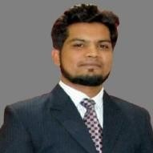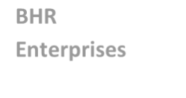
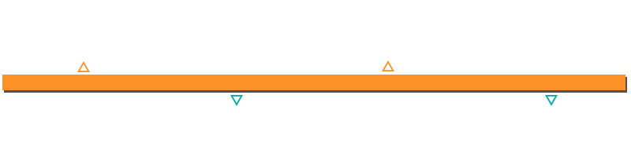
BHR
Enterprises
Jan’13 to Sept’14 Sept’14 to Oct’15 Oct’15 to Nov’18 Since Feb’19

Professional Experience

Since Feb’19 as ABM

Key Result Areas:
- Responsible for handling and appointment channel partner (Hoteliers) in Aurangabad,Jalna and Jalgaon.
- Daily 4 Partner visit for maintaining healthy and long term relationship. Hunting for new hotels in territory for adding new rooms every month. Training and recruitment of staff at hotel.
- Responsible for P&L driven decisions for assigned territory. Cross functional approach theough coordination with multiple teams in intra and inter geographies.
- Tracking and maintaining performance of hotel occupancy,pricing,visibility. Responsible for handling and briefing reconcilation of hotel to the partner.
- Competitor tracking and forwarding the same to the upper level.
- Responsible for genrating and increasing revenue of company.

Since Oct’15 to Nov’18 with IDEA Cellular Ltd., Aurangabad as Territory Sales Manager Key Result Areas:
- Managed 10 Distributors and its manpowerin assigned territory. Responsible for appointment and reporting of promoters.
- Implementing competitive strategies for generating sales, developing as well as expanding market share towards the achievement of revenue & profitability targets
- Building distribution network with financially strong and reliable dealers; planning, & setting sales targets for distributors and monitoring achievement of same; developed channel business cases and setting up channel operating standards & business plan
- Performing monthly sales forecasting and competitive analysis to determine accurate performance levels and need for growth into current & additional vertical markets & product categories

Highlights:
- Appointed 3 well performing distributors and started 2 new small markets in the territory. Launched producs in the territory which gave a boost in revenue and number of customers.
- Secured a poaition of number 2nd in M&G for digistorm and 1stin 4g Sim upgrade activity in zone.
- Expanded channel business by sourcing new partners and maintained efficient business relationships with existing partners.

Previous Experience

Sept’14 to Oct’15 with Aspiring Minds Assessment Pvt. Ltd., as Manager – Campus Sales Highlights:
- Executed planning & forecasting of sales activities; travelled in the assigned region/territory of North Maharashtra
- Proven success in acquiring new accounts and retaining existing accounts; increased the costomer base
- Performed negotiation with the clients on product, payment, delivery, standards; ensured availability & visibility of brand in assigned territory

Jan’13 to Sept’14 with BHR Enterprises, Aurangabad as Sales Officer Highlights:
- Ensured achieving targets.
- Maintained key relationship with the retail outlet for long-term business and appointed new retail outlet for expansion.

July’09 to Dec’12 with franchise Reliance Comm., Aurangabad as Team Leader

Projects Executed
Project Title: Yellow Belt - Data Revenue Increment Via 4g Sim-up For Aurangabad Zone
Duration: 5 Months
Role: Team Leader
Description: Six Sigma Yellow Belt Project for revenue increment via 4G SIM upgradation using DMAIC process

Project Title:Yellow Belt - To Improve Idea Money Performance at MI and IP
Duration: 5 Months
Role:Team Member
Description:Sigma Yellow Belt Project for Improving and boosting performance of Idea money at MI and IP using DMAIC process

Personal Details
Date of Birth: 4th April 1990

Languages Known: English, Hindi and Marathi

