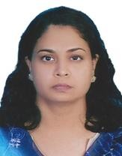
Usha
Architect, Urban Designer and LEED Green Associate with an experience of 25 years and capable of extending support to Design Director

Usha-396765@gulfjobseeker.com

, ,

H N
Architect

Muscat
August-2007 - Currently

Projects
- Arrival Pavilion
- Majlis Oman (Parliament Building)
- Royal Guard Oman Barracks
- Helipad and Accommodation for Royal Flight
- Al Ajyal College
- New Development
- Security Unit
- Six VIP villas
- Office Building for Royal Court Affairs

- Conceptual Design
- Architectural Design Development
- Architectural Detailed Design
- Coordination for Construction Drawings
- Tender Packages Preparation
- Answering Tender Queries
- Technical Evaluation of Tenders
- Construction Coordination
- Answering Requests for Information
- Checking Shop drawings
- AutoCAD
- Microsoft Office

Nature of Work
  - Detailed design development with necessary input from Structural/Interior/MEP/Landscape/Acoustic Consultants
  - Coordinating design details before issue for construction
  - Preparation of tender packages
  - Replying to tender queries and Requests for Information from the Contractor
  - Checking and approving shop drawings of various disciplines including joinery, gypsum, tiles, stone finishes
  - Site visits to ensure proper execution, assess progress of work and to give solutions to site issues

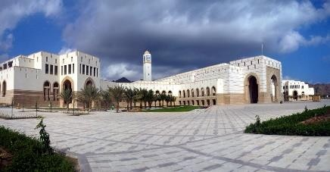Projects
Architect
Huckle and Partners
Muscat
August-2006 – August 2007
Kindly note that drawings done at Royal Court Affairs have not been included due to security reasons.
However, projects can be discussed during interview. Project costs vary from OMR 10- 160m/USD26-416m.

    - Permanent Accommodation for Contractors at Fahud & Nimr (R.O.5 million/USD 13m)
    - Permanent Accommodation for Contractors at Mukhaizna
    - 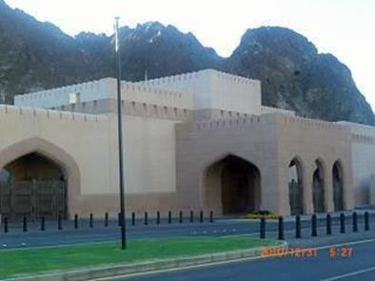Competition design for Office Building for Ministry of Manpower
    - Dining Hall for PDO School at Ras Al Hamra
    - Outdoor play area for PDO School at Ras Al Hamra
    - Office Building for Shell Development in Oman
    - Refurbishment to PDO Club at Mina Al Fahal
    - Office Building for Shell in Oman

Nature of Work
    - Preparation of presentation drawings
    - Detailed design development inclusive of joinery, windows, tiling, false ceiling, landscape
    - Preparation of control sheets as per project requirement
    - Preparation of tender packages according to specific requirement of the project
    - Coordination with suppliers for information related to design development

Architect
Rana Engineering Consultants

Muscat
August-2004 – July 2006

Projects

- Office Building for H.H. The Minister for National Heritage & Culture (R.O. 600,000/USD 1.5m)
- Refurbishment of Embassy of the State of Kuwait, Oman (R.O.1.5 million/USD 3.9m)
- Villa for Mr. Rishi Khimji (R.O.200,000/USD 5.2m)
- Five villas development at Qurm for Mr. Ajit Khimji
- Commercial-Residential Development at Bausher
- 32 Villas Complex at Sohar

Nature of Work

- Conceptual design after liaising with structural/service/quantity survey consultants
- Preparation of presentation drawings
- Detailed design development inclusive of joinery, windows, tiling, false ceiling, landscape
- Preparation of control sheets as per project requirement
- Preparation of tender packages according to specific requirement of the project
- Coordination with suppliers for information related to design development

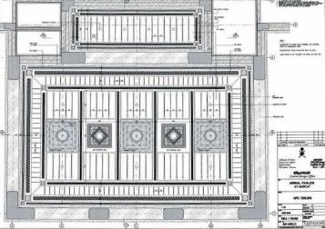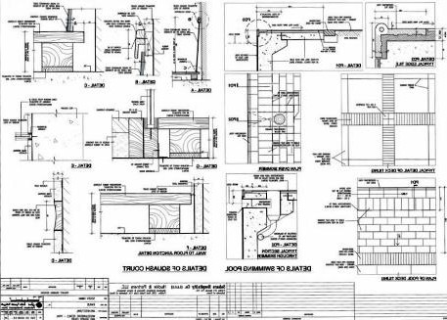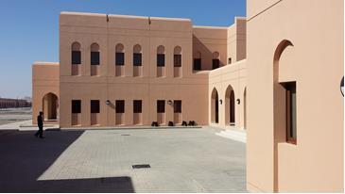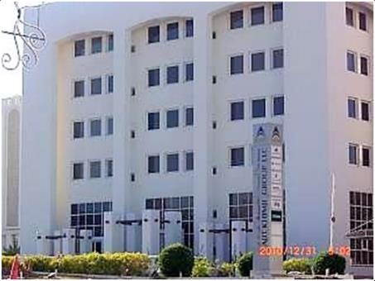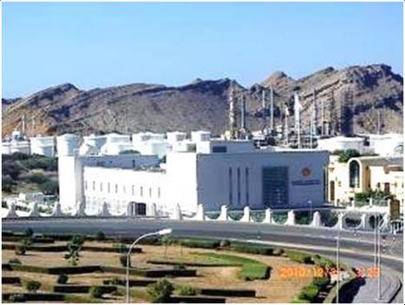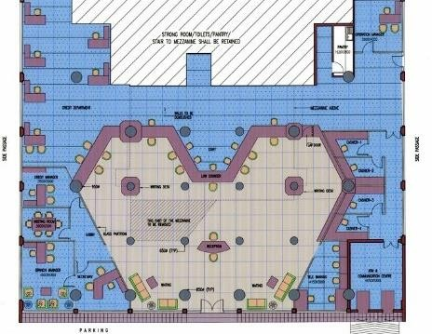Architect
Kadri Consultants

Muscat
January 2004 – July 2004

Projects

- Training Camp for the Royal Office at Halban Farmhouse at Seeb for Sheikh Saud Bahwan
- Truck Showroom and Workshop at Ghala for H.E.Mohammed Zubair
- Interior layout for BankMuscat at Al Khuwair

Nature of Work

I was in charge of a varied range of projects which included school buildings, steel industrial buildings, residential villas, farm houses, office buildings etc. My responsibilities included developing/assisting in conceptual design schemes, preparation of presentation drawings and development of working/tender drawings.

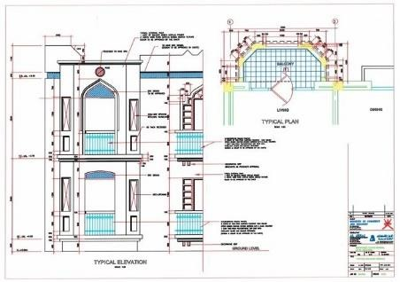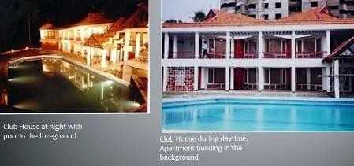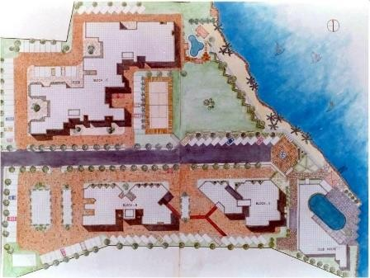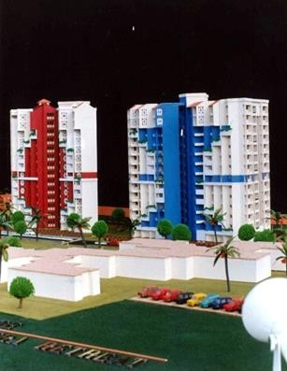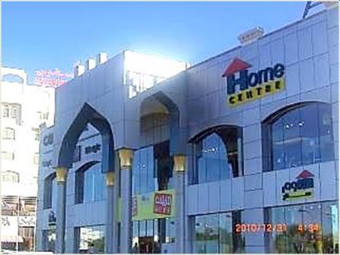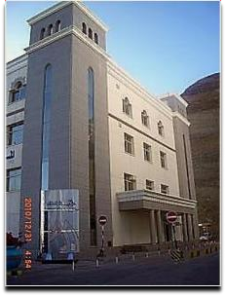Architect
Semac and Partners

Muscat
January 2003 –

September 2003

Architect

Al Abraj Consulting Engineering and Architects
Muscat
April 1998 – May 2001

Architect

Synthite Properties and Investments Pvt. Ltd
India
June-1994- June-1996

Nature of Work

I was involved in the development of large housing schemes, design schemes of staff accommodation buildings, residential villas and commercial buildings. My work included discussions with structural consultants and other service experts in preparation of working drawings.

Projects
- Commercial Complex,Al Khuwair(R.O. 2,000,000/USD 5.2m)
- Commercial Complex,Ruwi (R.O. 1,500,000/USD 3.9m)
- Commercial/ Residential building forDr. Fuad Jaffer (R.O.300,000/USD 780,000)
- Residential Apartment building forMr. Mohammed Jaffar(R.O. 75,000/USD 195,000)
- Youth Hostel at Al Ashkara forthe Ministry of Commerce & Industry
- Villa forMr. Toufiq Jawad (R.O. 130,000/USD 340,000)

Nature of Work

I was involved in major commercial buildings, apartment buildings, steel industrial buildings etc. My responsibilities included development of conceptual design schemes, development of proposals including working/tender drawings, all works associated with tendering, evaluation, liaising with officials of Municipality/Ministries/ROP for site related work/project management and inclusive of conducting site meetings, preparing minutes, assessing delay etc.

Nature of work

My work was on an apartment complex named the Riviera Retreat in Kochi. This was a waterfront development with natural views. I was in charge of the detailing the apartment complex comprising of 180 units with ancillary facilities like club house, swimming pool, play areas, boat jetty ,landscaping etc. My work included discussions with structural consultants and other service experts, preparation of working drawings, coordination of work between office and site etc. Minor non-structural revisions requested by clients were to be incorporated. The project duration was for three years.

Architect

M.M.Philip and Associates
India

September 1992-
June 1994
Nature of Work

The firm owned and run by the Chief Architect has two branches. I was in charge of the Kochi office and my work included architectural design of various projects -residences, apartment buildings, hostels, auditoriums, commercial complexes etc. I was also required to supervise the work of drafting staff, make site visits and attend meetings with clients. I was required to report to the Chief Architect who would have weekly visits to the office. My main task was to develop the designs and get approvals on detailing from Chief Architect before issuing it to site for construction.

EDUCATION

Masters in Urban Design

School of Planning and Architecture, India 1998

Bachelor of Architecture

Kerala University, India 1992
The duration of the course was one and a half years. This included subjects like urban planning, climate, design development, history of urban design etc. The final thesis was on revitalizing public spaces through mixed use.

The five year course was focused on learning architectural design skill development starting from small to large projects. The course structure included history, theory of design, civil engineering subjects and an internship for six months. The final thesis was the design of a community center.

CERTIFICATIONS & COURSES

LEED Green Associate since November 2015

In this program of study, the sustainable way of designing buildings was learnt. This included siting of a building considering all aspects of site constraints and strengths. The building was designed whilst taking into account the topography, vegetation, wind direction, sun path, water saving, energy saving, transportation, parking etc.
– under the global norms set by USGBC.

PUBLICATIONS

Mindful of Thoughts - Collection 1 (Fiction)

