DILSHAD

Contact

Email:

Dilshad-396771@gulfjobseeker.com

D.O.B:

16-07-1997

Languages

English– A1

Hindi – A2

Malayalam – A1

Summary
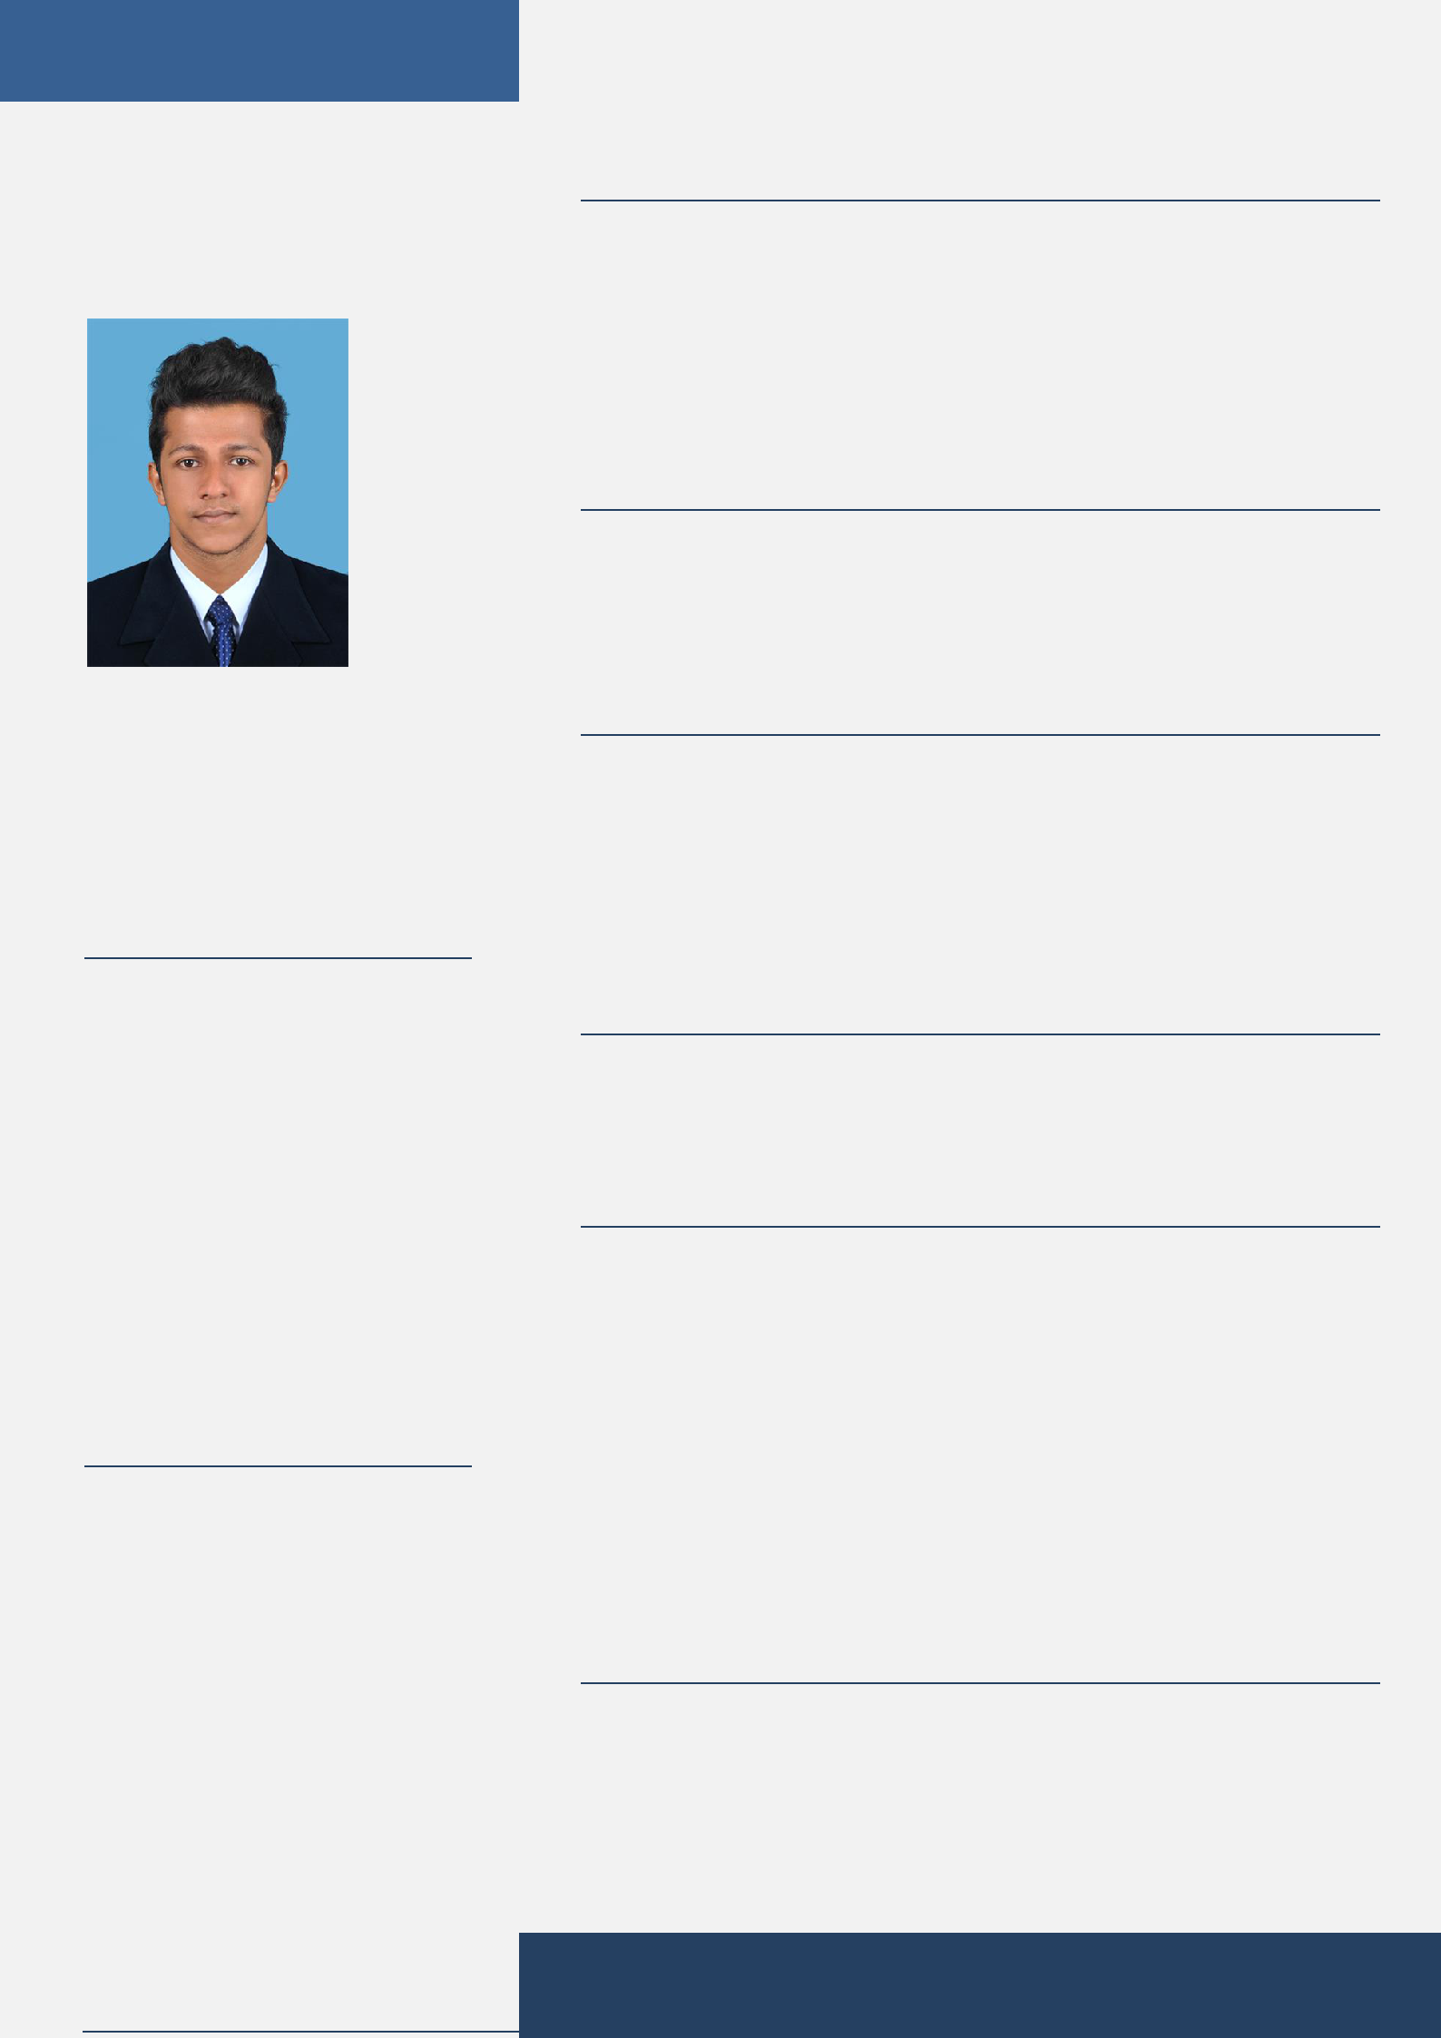

A highly skilled, talented and professional logistics supervisor with diverse experience in warehousing and distributing retail units for major retail food chains is looking for a challenging position as a logistic supervisor in an environment that will enhance my skills and experience in the mentioned field.

Skill Highlights

 | Marketing. |  | Sales management.
 | Operations. |  | Document Controlling.
 | Customer Relation. |  | Ware housing.

Experience

Logistics Executive- 09/2018 to 12/2019 Kerala, India

Education

- Bachelor of Business Administration (BBA) – 2015 to 2018
- Diploma in SHIPPING AND LOGISTICS- 2018 to 2019

STRENGTHS

- Good team player and service-oriented.

- Ability to understand complex service delivery issues.

- Problem-solving skills

- Ability to confidently manage and organize a team.

- Produced bills of lading and updated shipments status information

- Basic computer skills

- Knowledge of MS word

CERTIFICATIONS

- DIPLOMA IN SHIPPING AND LOGISTICS

- WAREHOUSE TRAINEE

