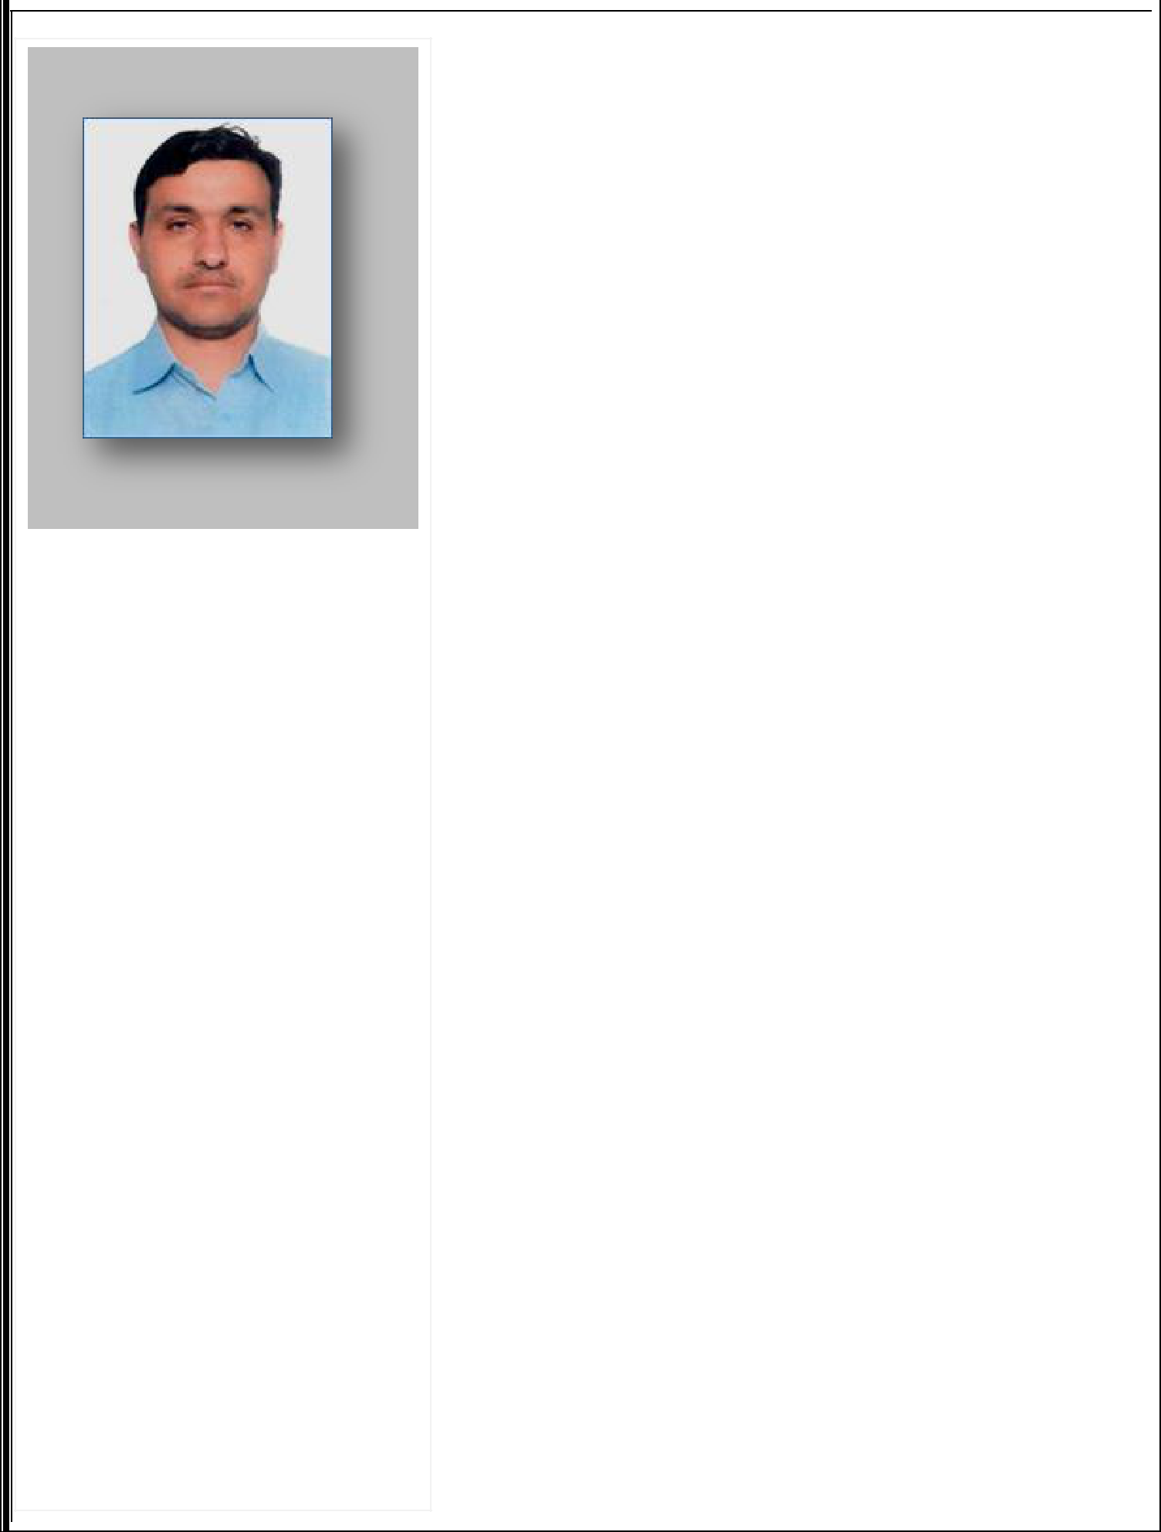

ZAHID

Email: zahid-396792@gulfjobseeker.com

PERSONAL DATA

Date of Birth |  | : 7th Feb 1982
Gender |  | : Male
Nationality |  | : Pakistani
Marital Status |  | : Married
Visa Status |  | : Employment
Present Address |  | : Dubai, UAE
LANGUAGES KNOWN
English

Urdu

Arabic

IT SKILLS
Well knowledge in:

Windows

Microsoft Office

Internet & Email

CURRICULUM VITAE

CAREER OBJECTIVES

To be associated with a progressive organization which can provide me with a dynamic work sphere to extract my inherent skills as a professional, use and develop my aptitude to further the organization’s objectives and also attain my career target in the progress.

EDUCATION QUALIFICATIONS

- SCM Certificate (Supply Chain Management) (Intro to Logistic and SCM) (Materials Management ) (Inventory Management) (Negotiating with the Suppliers) (International Trading) (Supply Chain) (Driver Quality and SCM).
- B.A (Bachelor of Arts)

PERSONAL STRENGTHS

- Good knowledge in Logistic Distribution.
- Have a good communication skills
- Can communication to people easily and a hardworking person
- Willing to treat everyone as an individual and a fast learner

- Knowledge of all Routes & Highways in All Emirates in UAE.

- Profound driving skills & able to work on a rotating shift.

- Customer services skills-top notch communication skills and professional work ethic.

LICENSE DETAILS

- License Status : Light Vehicle

- License Expiry : 25/03/2023

- Place of issue : Dubai

WORK EXPERIENCE DETAILS

Address : Dubai, UAE
Position : Messenger

Period : 1year 6 months.
Duties and Responsibilities:

# B/L collection # D/O collection # Export & Import # Customs # Inspection # Cheque Collection # Bank Payment # Official all Documents Collection.

Company: Dubai Taxi (RTA)

Address : Dubai, UAE
Position : Driver

Period : 7 years
Duties and Responsibilities:
- Professionally licensed commercial driver.

- Highly experienced on the job.
- Experience handling paperwork; preparing, handling and filing documentation.
- Physically fit; handled food products, construction materials, furniture and gym equipment.
- Good vision; I do wear anti-glare glasses for night driving.
- Excellent disposition; I enjoy working with and meeting people. .

- Punctual; I have never been late at work and have consistently met delivery schedules the past 7 years.

Company: Prime Limousien Company

Address : Dubai, UAE

Position : Sales Executive
Period : 2 years
Duties and Responsibilities:
- Launching and distributing several products

- Recruiting, interviewing and training several sales staff
- Boosting sales in my department every month

- Researching the market on a regular basis for related products
- Arranging several effective client demonstrations
- Liaising with the suppliers in order to make sure that existing orders increase

Company: All Trans Freight & Logistic

Address : Dubai, UAE
Position : Store Keeper

Period :1 year 6 months

Declaration

I hereby declare that all the above information is true to the best of my knowledge and beliefs. I am also assuring complete dedication hard work towards the organization if provided an opportunity.

Date :
Place: Dubai

Zahid

