RESUME
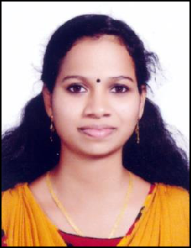

ARUNIMA

Email: arunima-396799@gulfjobseeker.com

Personal Details

Date of Birth | : | 12/03/1996
Sex | : | Female
Nationality | : | Indian
Marital Status | : | Married
Religion & Caste | : | Hindu, Ezhava
Language Known | : | Malayalam, English

Educational Qualification

Sl | Course | Board/University | Institution | Year of | Percentage
No |  |  |  | Pass | of Mark
.
1 | SSLC | Kerala State | GHSS | 2012 | 77%
 |  | Board | Kadakkal
2 | Plus Two | Board of Higher | GHSS | 2014 | 70%
 |  | Secondary | Kadakkal
 |  | Examination
 |  | Kerala
3 | BPA in Dance | Kerala University | Sree Swathy | 2017 | 78%
 |  |  | Thirunal Govt.
 |  |  | Music College
 |  |  | TVM
4 | MA in | Kerala University | Sree Swathy | 2019 | 80%
 | Keralanadanam |  | Thirunal Govt.
 |  |  | Music College
 |  |  | TVM

Passport Details

Date of Issue | :11/12/2019
Date of Expiry | :10/12/2029
Place of Issue | :Trivandrum

Declaration

I hereby declare that all the statements made in the application are true, complete and correct to the best of my knowledge and belief.

Place: Kadakkal

Date:

ARUNIMA

