CURRICULAM VITAE
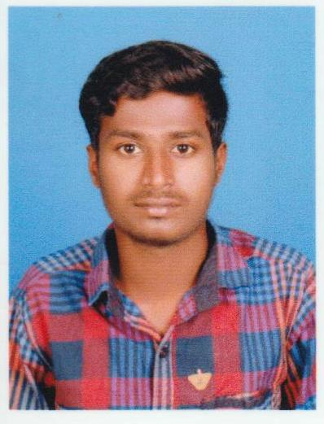  AJAY  Personal Data:  Date of Birth: July 16th 1996.  Sex : Male.  Nationality : Indian.  Marital Status: Single.  Languages: English, Hindi and Tamil.  Passport Details  Date of Issue : 02/08/2017  Date of Expiry : 01/08/2027  Visa Status: Visit 3Months  Date of Entry: 22/01/2020  Date of Expiry:28/04/2020 | Educational Qualification:  - Secured 86.0% in SSLC in A.C. Higher Sec SchoolPallathur in 2011.  - Secured 85.0% in HSC in A.C.HigherSec School Pallathur in 2013.  - Graduated in BE (CIVIL & STRUCTURAL) in Anna University Chennai  with 7.00(GGPA) in 2017.  Technical Skills:  - Completed AUTO CAD  - MS Office.  Employment History:  Company Name: Asthiwar Builders & Engineers– Chennai, India  Position : Site Engineer  Project :Grand Trinity [G+2], Residential Building [G+2]  Duration :June 2017 to November 2018  Jobs & Responsibility:  - To check Road alignment and leveling survey for water supply distribution network at site.  - Perform analysis and prepare design calculations and drawings.  - Direct Dealing with Clients and Government Officers  - Preparing bar bending Schedule.  - Supervision of all Earth works, Steel Works, Shuttering Works, Concrete works and Setting out works.  - Testing and Checking Reinforcements.  - Checking progress Bills and Reporting to the Project Manager.  - Training to project team regarding Technical Specification, Safety and Quality.  - Controlling and proper utilization of Transportation vehicle and materials etc.,

Company Name :P&C Projects (P) Ltd.,
Position : Site Engineer
Project Name : Cochin Cancer Research Centre, Kerala, India
Duration : November 2018 to Present

Jobs & Responsibility:

- Overall planning, Scheduling, Supervision, material control and assigning of construction work.
- Overall Monitoring.
- Cost control
- Getting approval from client.
- Coordinate with Clients and Consultants
- Preparing bar bending schedule.
- Controlling and proper utilization of Labor force and materials etc.,
- Preparation of Daily, Weekly & Monthly wages report for the entire site workers.
- Preparation of Daily Progress Report and submitting to project control office.
- Preparation of Method Statement for all construction activities.
- Getting work permit for all the construction activities.

CERTIFICATION

- Certificate of Completion on “LAND AND BUILDING SURVEYING USING TOTAL STATION”
Conducted during the year of 2015 Chennai.
- Certification of Participated in “BRIDGE DESIGN: workshop at National Level Technical, symposium of department civil engineering NIT Trichy-2016
- Certification of attending one day workshop on “PRE-FABRICATED STRUCTURE”
Organization by MJN Placement in Trichy-2016.

Personal Contact : ajay-396810@2freemail.com
Reference : Mr. Anup P Bhatia, HR Consultant, Gulfjobseeker.com 0504753686

Yours sincerely,

Place:
Date :

