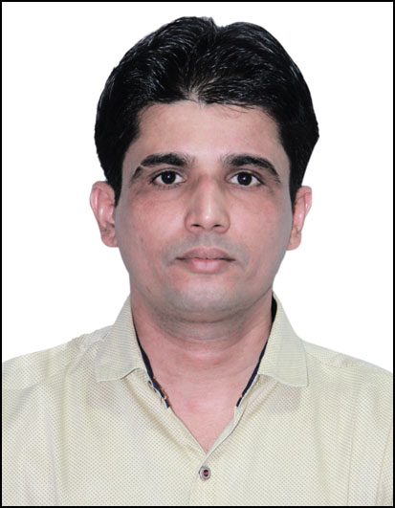
Vequar

Nationality : Indian
Personal Marital Status : Married
Information Date of Birth : 23rd September 1978
Passport Details
Date of Issue : 5-September-2018
Valid Untill : 4-September-2028

Visa Status On Visit Visa Till 2-April-2020

- Higher Secondary Education (Commerce).
Educational
Qualification

Professional
Qualification ➢“Computers Course Certification” from Unique Computer, Mumbai.

Familiar with windows, MS-DOS, MS-Office,
- Certified in Ms Word, Ms Excel, Ms Powerpoint, Ms
Access, Dbase III Plus.
- Familiar with Oracle-HRMS

Languages English, Hindi, Marathi & Urdu (Read, Write & Speak)

Fields of Experience MIS , Payroll, Office Administration & Electronic Document
Management Systems.

Other Skills ➢ Multi-Skilling Training Program Certificates :
- Various Oracle Certificates from Oracle University.

WORK EXPERIENCE

Worked at HDFC on third party payroll, as Region Coordinator/MIS Executive in Consumer Durable
Department w.e.f. 26th January 2019 to 18thMay 2019.

Assignment
➢ Provide Support to existing management Information System.
➢ Generate and Publish Sales and various management reports in accurate and timely manner.
➢ Publish daily reports of Sales Managers progress in line with their given target and commitment along with the performance percentage and projection.
➢ Generate both periodic and adhoc reports as needed.
➢ Analyze the daily, weekly and monthly reports in line with the respective department budget figures.
➢ Overall responsible for all MIS related reports.

Worked at Dabhol Shipyard with BHARATI DEFENCE AND INFRASTRUCTURE LIMITED
(Formerly BHARATI SHIPYARD LIMITED), as Senior Officer Administration Department w.e.f. 1st June
2015 to 16th August 2018.

Assignment
➢ Responsible to ensure the operational aspects of payroll MIS and processing and associated
activities, including salary disbursement, overpayment recovery, leave management.
➢ Reconciliation of payroll MIS and headcount on monthly basis.
➢ Supervision on handling database and file management (electronic as well as file form).
➢ Supervision on leave and attendance management MIS reports.
➢ Responsible for all administrative and general matters.

Worked at Doha Qatar with QATAR AIRWAYS (The World’s Five Star Airline), as Supervisor
(Payroll & Systems Admin.) w.e.f. 16-Dec-2004 till 14-May-2012 with multiple duties assignment.

➢ Over all Administration related assignment to complete day to day activities.
➢ Handling Company and its subsidiary Company monthly payroll and deal with finance department to transfer the salary / funds to the respective individual bank.
➢ Calculation of monthly overtime and other allowances statements of employees
➢ Overall supervision on payroll entries in oracle for QR and Amiri group including outstation posted staff. (Promotion, Demotion, Separation, New Joining & bank account updation etc.)
➢ Attending and solving the queries related to payroll.
➢ Coordinating HR payroll for monthly payroll processing as well as advising about stop payments and ceasing / releasing of salaries.
➢ Assisting in administration of vehicle fleet management for QR group and it’s other subsidiaries. Also verifying & creating requisition for the monthly vehicle invoice from the vendor.

Punj Lloyd Limited Dabhol Power Project, as Supervisor
(P & A /Document Control) from Sep. 2003 To Nov. 2004.

Tasks & Responsibilities :

➢ Organize and maintain the project document control system to strict document control standards and client requirements.
➢ Provide resources as required to Projects and ensuring a high quality of work performance from the Document Control Staff.
➢ Maintain the project filing system, perform archiving procedure during project close out.
➢  Implement QA functions such as non-technical checking, ensure that deliverables undergo the appropriate technical checking functions, and maintain accurate revision control.
➢  Allocating storage locations and generating corresponding control blocks for active documents in response to requests from active tasks.
➢  Audit control documents and reports.

Enron work Enron India Limited Promoted Dabhol Power Company.
History Worked as Human Resources Officer
As an Employee : From 14th June 1999 to 4th December 2001
As Consultant : From December 2001 to March 2002.

Duties & Responsibilities :

➢ Assisted in Recruitment quality engineers for India’s first LNG
terminal in record period of time.
➢ Assisted Head HR & Admin. In the revised compensation activity
of craftsmen in accordance with the market trends and statutory obligations.
➢ Assisted Head HR & Admin. In Transferring security force of 90 men & non exempt staff of 200 men to sister concern without any anticipated problems.
➢ Monitoring HR Information System and coordinating HR audit.
➢ Supervision on Drivers, Helpers & Pantry Services.
➢ Updating Leave records for payroll processing.
➢ Assisted in Termination 500 Employees under the company’s
severance plan without any anticipated problems.

Bechtel Work Bechtel India Ltd. Worked as Document Control Clerk/Assistant
History for Dabhol Power Plant Phase-I 2450 MW Power Project.

From 15th January 97 To 12th June 1999.
I was an active member of document control group responsible for the Electronic Document Management System.

Duties & Responsibilities :
➢ Creation of transmittals & routing of documents / drawings.
➢ Supporting the project team for bulk plots, copies, printouts
& scanning of documents / drawings.
➢ Providing Infoworks supports to the personnel working on the Project.
➢ Generating reports for keeping the project informed about the status
of various documents.

Previous Work 1) Accounts Assistant Cum Operator in Universal Sales Corporation, Mazgaon
History In Bombay from 18th August 1995 To 13th January 1997

Duties & Responsibilities :
➢ Maintaining of Journal Ledger, Purchase and Sales Register.
➢ Preparing of Invoice, Bills of exchange, Bank reconciliation statement.
➢ Maintaining Stock Register.
➢ Filing of Bills, Invoice and Letters.
➢ Co-ordinating with suppliers and clients relating to sales and Purchase, of the finished goods and raw materials.

2) Assistant Accountant in B.M. Enterprises from 18th August 1995 To 13th January 1997 (Part Time Job)
Duties & Responsibilities :
➢ Maintaining of Journal Ledger, Purchase and Sales Register.
➢ Preparing of Invoice, Bills of exchange, Bank reconciliation statement.
➢ Maintaining Stock Register.

Hobbies I love singing, listening to music & playing cricket.

Personal Contact : vequar-390893@2freemail.com
Reference : Mr. Anup P Bhatia, HR Consultant, Gulfjobseeker.com 0504753686

