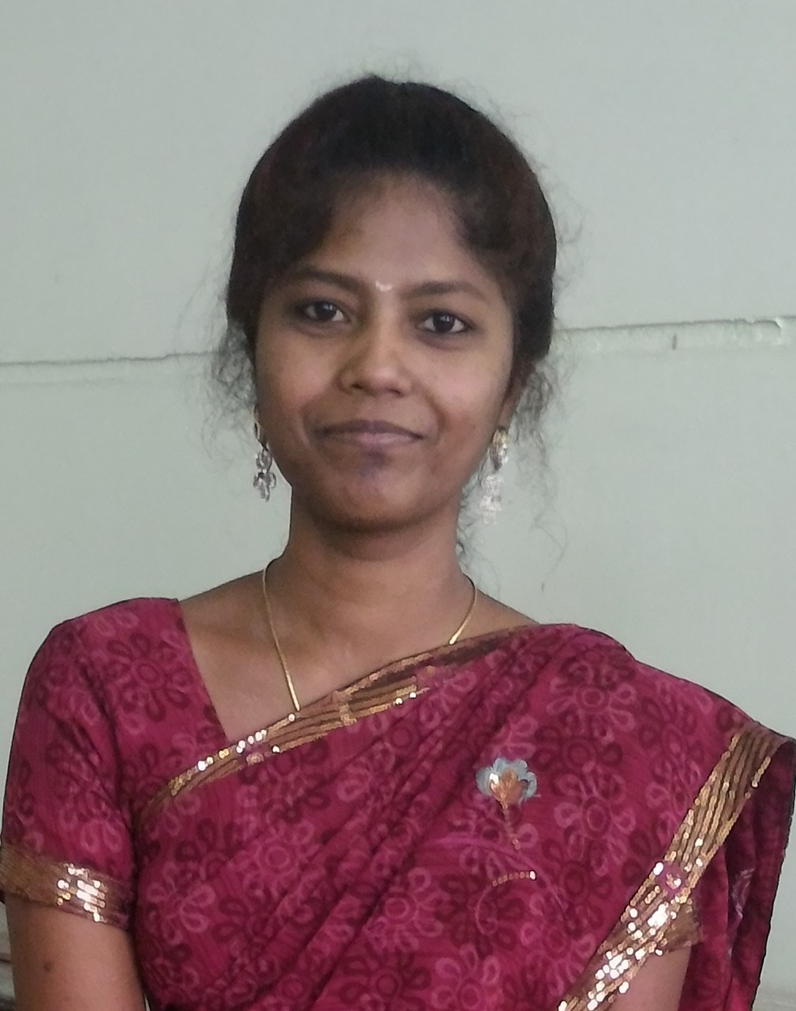 Dr. Kalpana

Doctoral Thesis
Title Investigation of Heat Transfer on Dusty Fluid Flows
Supervisor Dr. K. R. Madhura (Associate Professor)
University Visvesvaraya Technological University, Belagavi, Karnataka, India.

Date of Completion
8th Feb. 2020

Education
2007–2009 Master of Science (Mathematics), M.E.S. College of Arts, Science and Com- merce, Bangalore University, Bengaluru, Karnataka, Class – First Class.
2003–2006 Bachelor of Science (PME), Vivekananda College, Bangalore University, Bengaluru, Karnataka, Class – First Class.
Specialized in Physics, Mathematics & Electronics.

Teaching Experience
2019–till date Working as Assistant Professor in the Postgraduate Department of Mathematics at The National College from 18th Feb. 2019 - till date.
2012–2017 Worked as Assistant Professor in the Department of Mathematics at Sri Krishna Institute of Technology from 22nd Aug. 2012 - 30th Nov. 2017.
2011–2012 Worked as Assistant Professor in the Department of Mathematics at East West Institute of Technology from 27th Aug. 2011 - 23rd Aug. 2012.
2009–2011 Worked as Assistant Professor in the Department of Mathematics at Nadgir Institute of Engineering and Technology from 2nd Aug. 2009 - 23rd Aug. 2011.

Subjects Taught
Postgraduate ○ Continuum Mechanics, Magnetohydrodynamics, Graph Theory, Numerical Analysis, Topol- ogy, Linear Algebra, Scilab (for M.Sc-Mathematics)
- Bio-Statistics (for M.Sc-Nursing, M.Sc-Microbiology, M.Sc Biotechnology)
- Applied Mathematics I (for M.Tech.)

Undergraduate ○ Engineering Mathematics I, II, III & IV (for B.E.)
- Advanced Mathematics I & II (for B.E.)

Projects Guided for Master Degree
Postgraduate ○ Numerical stimulation on heat and mass transfer of MHD fluid flow under radiative effect
- Numerical computation of radiative MHD fluid flow between parallel plates through porous medium

Research Contributions

Published
9 C. P. Karthikeyan, G. Kalpana, V. Krishnamoorthy and Anand A. Samuel, Transient numerical analysis of thermophoresis and particle dynamics in a nanofluid - pool boiling conditions, Journal of Molecular Liquids, ISSN 0167 - 7322, Vol. 301, 2020, https://doi.org/10.1016/j.molliq.2020.112459.
Elsevier Publication, Scopus, IF: 4.561
8 G. Kalpana, K. R. Madhura and S. S. Iyengar, Numerical computation on Marangoni convective flow of two-phase MHD dusty nanofluid under Brownian motion and thermophoresis effects, Heat Transfer - Asian Research, ISSN 1523 - 1496, 2019, pp.1-25.
Wiley Publication, Scopus
7 G. Kalpana, K. R. Madhura, S. S. Iyengar and Uma S., Numerical investigation on convective flow of two-phase MHD dusty nanofluids over a wavy surface with Brownian motion and thermophoresis effects, International Journal of Applied and Computational Mathematics, ISSN 2349 - 5103, Vol.5, 2019, pp.62.
Springer Publication, Scopus
6 G. Kalpana, K. R. Madhura and Ramesh B. Kudenatti, Impact of temperature- dependant viscosity and thermal conductivity on MHD boundary layer flow of two- phase dusty fluid through permeable medium, Engineering Science and Technology, an International Journal, ISSN 2215-0986, Vol.22, 2019, pp.416-427.
Elsevier Publication, Scopus, IF: 0.765
5 G. Kalpana and K. R. Madhura, Computational study on heat transfer of MHD dusty fluid flow under variable viscosity and variable pressure down an inclined ir- regular porous channel, International Journal of Emerging Technology and Advanced Engineering, ISSN 2250-2459, Vol.7(11), 2017, pp. 358-369.
UGC Recognized, IF: 6.351
4 K. R. Madhura and G. Kalpana, A study on thermal diffusion and chemical reaction on pulsatile flow of a dusty fluid through an irregular channel in the presence of porous medium, International Journal of Advanced Trends in Engineering and Technology, ISSN (Online) 2456-4664, Vol.2(2), 2017, pp. 204-214.
UGC Recognized, Scopus, IF: 5.965

3 K. R. Madhura and G. Kalpana, Numerical scrutiny for thermal diffusion and chemical reaction on unsteady dusty visco elastic fluid flow in an irregular channel through porous medium, Global Journal of Engineering Research and Technology, ISSN 2249-3107, Vol.6(1), 2016, pp. 1-23.
2 K. R. Madhura and G. Kalpana, Study of thermal effect on unsteady flow of a visco-elastic fluid under pulsatile pressure gradient, International Journal of Applied Mathematical Sciences, ISSN 0973-0176, Vol.7(1), 2014, pp.15-32.
1 K. R. Madhura and G. Kalpana, Thermal effect on unsteady flow of a dusty visco-elastic fluid between two parallel plates under different pressure gradients, International Journal of Engineering and Technology, ISSN 2227-524X, Vol.2(2), 2013, pp.88-99.

Communicated
1 K. R. Madhura, Bibitha, G. Kalpana and S. S. Iyengar, Thermal performance of straight porous fin with temperature dependent thermal conductivity under mag- netic field and radiation effects .

Conferences, Symposium and Workshops

Presentations
11 Impact of temperature-dependant viscosity and thermal conductivity on MHD boundary layer flow of two-phase dusty fluid through permeable medium, One Day National Conference on "Emerging Trends in Applied Mathematics", 4th May 2019, S.J.B.I.T, Bengaluru, Karnataka.
10 Computational study on heat transfer of MHD dusty fluid flow under variable viscosity and variable pressure down an inclined irregular porous channel, One Day National Symposium on "Mathematics and its Applications", 27th Apr. 2019, Bangalore University (J.B. Campus), Bengaluru, Karnataka.
9 Numerical investigation on Marangoni convective flow of two-phase MHD dusty nanofluids under Brownian motion and thermophoresis effects, Two Days National Conference on "Recent Developments of Mathematics in Industrial Applications", 11th & 12th Apr. 2019, Kuvempu University, Shivamogga, Karnataka.
8 Numerical investigation on convective flow of two-phase MHD dusty nanofluids over a wavy surface with Brownian motion and thermophoresis effects, Two Days International Conference on "International Conference on Emerging Trends in Computational Fluid Dynamics", 27th & 28th Feb. 2019, Christ University, Bengaluru, Karnataka.
7 Computational study on heat transfer of MHD dusty fluid flow under variable viscosity and variable pressure down an inclined irregular porous channel, One Day National Conference on "Recent Trends and Explorations in Mathematics", 4th Oct. 2018, The National College, Bengaluru, Karnataka.
6 Analytical and computational simulation of thermal diffusion and chemical reaction on pulsatile flow of a dusty fluid through an irregular channel in the presence of porous medium, One Day National Conference on "An Insight into Analysis and Applications of Mathematics", 24th Aug. 2016, The National College, Bengaluru, Karnataka.

5 Numerical scrutiny for thermal diffusion and chemical reaction on unsteady dusty visco elastic fluid flow in an irregular channel through porous medium, Two Days International Conference on "Differential Geometry, Analysis and Fluid Mechanics", 4th & 5th Feb. 2016, Kuvempu University, Shivamogga, Karnataka.
4 Thermal effect on unsteady flow of a dusty visco-elastic fluid between two parallel plates under different pressure gradients, Two Days National Conference on "Emerging Trends in Fluid Mechanics", 14th & 15th Mar. 2014, Christ University, Bengaluru, Karnataka.
3 Study of thermal effect on unsteady flow of a visco-elastic fluid under pulsatile pressure gradient, One Day National Conference on "Emerging Trends in Applied Mathematics", Feb. 2014, M.E.S. College of Arts, Commerce and Science, Bengaluru, Karnataka.
2 Solution of boundary value problem using differential transform method, One Day National Conference on "Frontiers in Applied Mathematics", 9th & 10th Mar. 2012, M.E.S. College of Arts, Commerce and Science, Bengaluru, Karnataka.
1 Differential transform method, Two Days National Conference on "Emerging Trends in Information Technology and Mathematics", 3rd & 4th Nov. 2011, East West Institute of Technology, Bengaluru, Karnataka.

Participation
11 One day workshop on Scientific Data Analysis using ORIGIN PRO and MATHEMATICA, 2nd Jan. 2020, The National College, Bengaluru, Karnataka.
10 One day seminar on IPR for Spurring Innovation and Creativity, 28th Dec. 2019, The National College, Bengaluru, Karnataka.
9 One day International conference on Recent Advances in Interdisciplinary Mathematical Sciences, 6th Sep. 2019, Government Science College, Bengaluru, Karnataka.
8 One day workshop on Mathematical Practicals Usinf FOSS, 2nd Mar. 2019, Central College, Bengaluru, Karnataka.
7 One day National seminar on Insights of Science in Engineering Technology, 11th May 2017, Sri Krishna Institute of Technology, Bengaluru, Karnataka.
6 Three days National workshop on Research Methodologies & Latex, 21st - 23rd May 2015,
V.T.U. Regional Office, Bengaluru, Karnataka.
5 One day International symposium on Advances in Applied Mathematics, 18th Jan. 2014,
M.E.S. College of Arts, Commerce and Science, Bengaluru, Karnataka.
4 One day workshop on Scilab, 9th Apr. 2013, M.E.S. College of Arts, Commerce and Science, Bengaluru, Karnataka.
3 Two days National conference on Recent Developments of Numerical Methods in Various Engineering Applications, 24th & 25th May 2011, P.E.S. Institute of Technology, Bengaluru, Karnataka.
2 One day workshop on Emerging Fields of Applied Mathematics, 7th Mar. 2009, M.E.S. College of Arts, Commerce and Science, Bengaluru, Karnataka.
1 One day workshop on Specializations in Mathematics, 15th Mar. 2008, M.E.S. College of Arts, Commerce and Science, Bengaluru, Karnataka.

Computer Skills
Basic ms-office, latex
Programming matlab, mathematica, scilab, origin

Areas of Interest
- Fluid Mechanics
- Numerical Analysis
- Heat and Mass Transfer Investigation
- Nanofluids Model - Pure and Hybrid
- Heat Transfer through Fins

Statement of Research
My research work is focused on linear/nonlinear partial differential equations espe- cially those which models heat transfer effect. My doctorial work is to study the heat transfer effect on dusty fluid flows. Currently, the work has been extended to evaluate heat and mass transfer rate on dusty nanofluid flows on different nanopar- ticles. In addition, pure and hybrid nanoparticles are considered in the investigation. The heat transfer through fins with different geometries and materials have been examined. The mathematical models act as a strong tool to understand many complex systems. Hence, the problems considered in the research and the results discussed were expected to be applicable in realistic engineering problems.

Passport Details

Date of Issue 09th November 2011

Date of Expiry
08th November 2021

Personal Information

Date of Birth : 29th Nov. 1985
Personal Contact : kalpana-396897@2freemail.com
Reference : Mr. Anup P Bhatia, HR Consultant, Gulfjobseeker.com 0504753686

