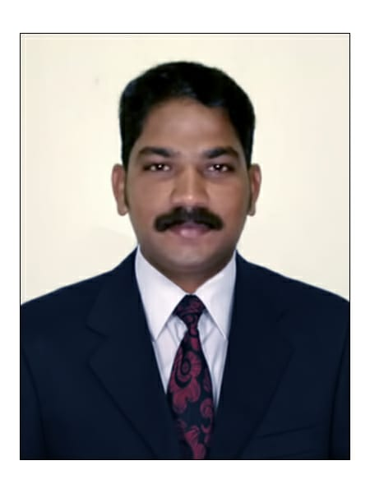

Vignesh
Email: vignesh-396919@gulfjobseeker.com
DUBAI-UnitedArabEmirates
PositionApplyingFor–CivilForeman

CareerObjective
ASuitablepositionwithanorganizationwhereIcanutilizethebestofmyskillsandabilitiesthatfittomyeducation,skillsandexperienceaplacewhereICanencourageandpermittedtobeanactiveparticipantaswellvitalcontributeondevelopmentofthecompany

ProfessionalSkills:
- VeryEnergeticresultorientedandorganized.
- Findingsolutionstoissuesandproblems
- Followallcompanypoliciesandprocedures.
- Alwayskeeponsmilingunderpressure.
- AbilitytoworklonghoursandUnderPressure.
- Pleasantpersonality,self–motivatedandhardworking.
- HighExperienceinWaterProofingWork including cementious, Membrane and Chemical.
- Having Experience in Rebar Works and Shuttering.
- Calculating quantity of material required in site.
- Studying shop Drawing and executing Work as per drawing.
- Maintaining landscaping works.
- Having experience in mechanical cladding and coping works.
- Reporting Site engineer.
- Having in Experience Guinite and Shotcreting work.
- Trained Confined Space Person.
- Operating Powertools.
- Handling materials in site.
- Reading Method Statement and Risk assessment.
- Tiling, paving Works.
- Coordinating with Other Working teams.

Educational&Qualification:
- HighSchoolCertificatefrom-(TamilNadu-INDIA)
- Higher(+2)EducationalCertificatefrom-(TamilNadu-INDIA)

AdditionalCertificate:
- ITI(Fitter)TrainingCertificatefrom-(TamilNadu-INDIA)02Years
- DiplomainComputerApplicationandOfficeManagementfrom“CCITrainingInstitute”-(TamilNadu-INDIA

ProfessionalExperience:

Position : CivilForeman
Duration : Oct,2014tillDate
Location : Dubai-UAE

Company : KUMARACONSTRICTIONCOMPANY
Position : Supervisor&Maintenance
Duration : 03Years
Location : TamilNadu-INDIA
Scopeofwork:
Having Good experience in following Works.
- WaterFeature
- Lake and water garden
- ReplacementandMaintenancework
- RebarWork
- ShutteringWork
- Interlockwork
- AlltypeofSwimmingPoolCivilWork
- HardLandscapingwork
- Civil Construction Works
DUTIES&RESPONSIBILITIES
- KnowledgeofBuildingCodeandHighQualityBuildingStandards
- KnowledgeofWorksaferequirements
- Strongcommunicationskills
- Proactiveandpositiveattitude
- Superiororganizationalandtimemanagementskills
- Detailorientedandabilitytomulti-task
- Workwiththesuperintendentandthesub-tradestoexecutedailyworkplans
- Assistthesuperintendentwithmanagingandschedulingofsubcontractors,suppliers,andemployees
- Layoutsiteworkbasedonreviewofdrawingsandspecifications
- Createpunchlists;directandoverseethecompletionofthepunchlists
- Maintainsafeworkingpracticesandconditionsatalltimes
- Excellentcriticalthinkingandproblem-solvingabilityo Handlingallthecashtransactionofanorganizationo FinallyIalwaysgivebestservicewithmyteam.

PersonalDetails:

o | Name : | VIGNESH
o | Nationality : | Indian
oo | PlaceofBirth :  DateofBirth : | TamilNadu-INDIA  25/07/1990
o | Religion : | Hindu
o | Gender : | Male
o | MaritalStatus : | Single

Language Known:

o | English : | (Basic) Speaking,Reading&Writing
o | Hindi : | Speaking
o | Tamil : | Speaking,Reading&Writing
o | Malayalam : | (Basic)Speaking

Declaration:
Iherebycertifythattheaboveinformationaretrueandcorrectaccordingtothebestofmyknowledge&MyExperience

Vignesh

