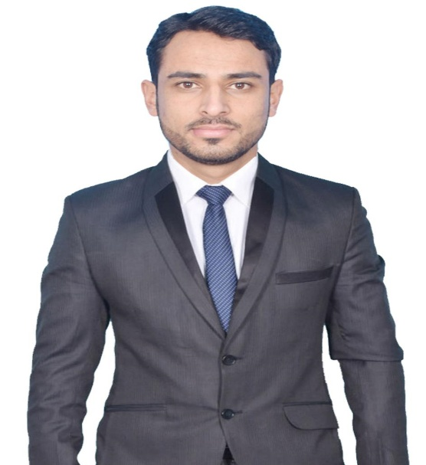
CURRICULUMVITAE
Sheikh
Email I’d : sheikh-397012@gulfjobseeker.com
Career Objectives
Looking for a job, which can be a learning experience for me and where I can contribute in the growth of organization. Striving to become part of a team which will provide the right atmosphere to utilize my skills and help to achieve the objectives of the organization.
Academic Qualification
- 10thfrom JKBOSE
- 12th in commerce
- B. Com Graduate from Mewar University(Chittorgarh Rajasthan)

Experience
Axis securities (June 2017 – March 2019)

- In June 2017 joined the organization as Sales Executive in the department of Merchant Acquiring
- Providing real time solution to issue

(April 2019 till date)

- Currently working as Executive operation in Axis bank branch banking

Technical Qualification
- One year Diploma in computer basics
- Tally 9.2

Critical Skills
- Analytical Skill
- Good Communication Skill

Languages
- English, Urdu, Kashmiri, Hindi

Personal Details
Name :Sheikh
Religion :Muslim
D. O. B : 27-11-1992
Gender :Male
Marital Status :Single
Nationality :Indian

DECLARATION
I here by declared that all the information provided is true to the best of my knowledge.
Sheikh

