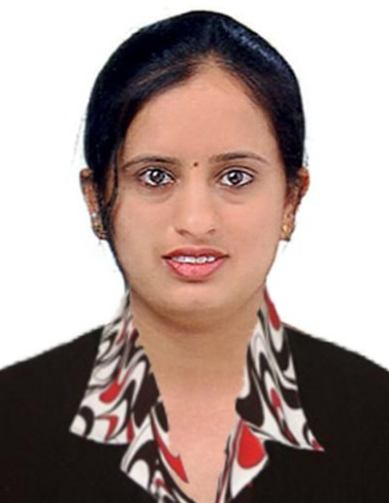
CURRICULUM VITAE

Asha

E-mail: asha-397027@gulfjobseeker.com
Visa Status:Visit Visa

OBJECTIVES:

An ambitious and optimistic executive with proven abilities in Customer and Operational efficiency. A professional looking forward to a global vision, which encourages innovativeness and offers an opportunity to use my knowledge and skills to learn and develop professionally.

ACADEMIC QUALIFICATION:

- Diploma (Chemical Engg.) 2009 – 2012 Karnataka (Govt) Polytechnic Mangalore

- S.S.L.C
UshataiGogte Girls High School, Belgaum. 2007 - 2008

TECHNICAL QUALIFICATION:

- Basic Computer knowledge with sound knowledge in Microsoft Word and Excel
- Email Communication, Marketing Automation & Data Visualization.
- Excellent skills in development of Power Point presentations with experience in delivering paper presentations & training programs.
- Complete AutoCAD.

PROFESSIONAL EXPERIENCE :

Lab Technician
February 2018 – November 2018
- Collect and test water and sewage samples.
- Monitor operating conditions, meters and gauges.
- Inspect equipment in regular basis.
- Ensure up-to-date maintenance of both computerized and manual filing system
- record meter and gauge readings and operational data
- Ensure safety standards are met
- Managing outsource Employees
- Reporting Plant Manager.

Junior Engineer - Operations& Process Control
JSW Steel Ltd. January - 2015 - September 2017.

- Reporting to the Plant Manager
- Managing outsourced employees
- Responsible for controlling process parameters effecting coke quality and power generation
- Production and Raw Materials planning for achieving annual production targets
- Active coordination with power plant officials for optimizing low rate and temperature with unfortunate fluctuations in production targets
- Participating Quality Circle teams in various projects
- Worked as Shift in charge, Co-coordinating shift activities to achieve production targets ensuring safety and with innovative & effective time management skills
- Conducting Training programs & interactive sessions with outsourced employees for effective communication &self development

Lab Instructor – August 2013 - January - 2015
Dr M S Sheshgiri College of Engg& Tech, Belgaum, Karnataka

- Maintenance of existing laboratory experiments and the apparatus associated with them, including computer-aided design exercise
- Class preparation and training of teaching assistants overseeing students performing the experiments and exercises

SKILLS:

- Highly motivated.
- Team player.
- Multi-tasking expert.
- Work without much supervision.

ACHIEVEMENTS :

- Rewarded for an “Innovative suggestion and Implementation”

- Successful retention of business from dis-satisfied customers.

PERSONAL DETAILS:

Date of birth : 29-09-1992

Gender : Female

Marital status : Married

Nationality : Indian

DECLARATION:

I hereby declare that the above mentioned information are true and correct to the best of knowledge and belief.

Asha

Date:
Place: Abu Dhabi.

