PERSONAL DETAILS

D.O.B:01 Dec 1989
Nationality: Indian
Religion: Hindu

Languages Known:
- English
- Tamil
- Malayalam
- Hindi
Extra-Curricular Activities:
- Reading Books
- Listening Music
- Gardening
- Knowledge Surfing

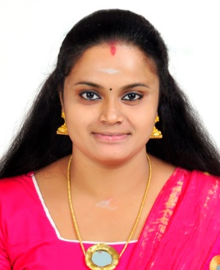
DHANYA
Email: dhanya-397041@gulfjobseeker.com
CAREER OBJECTIVE:
Seeking a position as an English Teacher by utilizing exceptional English Language knowledge and class room management abilities to provide a conducive learning environment
WORK EXPERIENCE:
- Working as an English Teacher from July2018
- Worked as an English Teacher in S.N. Central School Mavelikara
From May 2016 to March 2017.
EDUCATIONAL QUALIFICATION:
2018 IGNOU Delhi
M.A English (pursuing).
2014-2016 J.B.M.C.T.E,Kayamkulam, Kerala
B.Ed. English
2011-2013 Bharathiyar University
MBA Human Resource
2007-2010 D.B. Pampa College
Parumala, Kerala
B.A English
2005-2007 Board of Higher Secondary Examination
Govt. G.H.S.S, kayamkulam, Kerala
Plus Two
2005NSS High School, Kurathikadu Kerala
10th(SSLC)
PERSONAL SKILLS
- Quick Learner
- Flexible And Adaptive
- Able To Grasp New Ideas
DECLARATION:
I hereby declare that, the particulars of information andfacts stated here in above
are true, correct and complete to the best of myknowledge and belief.

Place: Kanjirappally

Date: Dhanya

