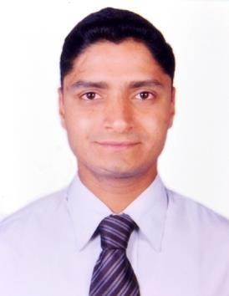

MANJUNATH

FOREX OPERATIONS MANAGEMENT PROFESSIONAL
Offering 10 Years of experience

Core Competencies
Forex Operations
Western Union Transactions
Training Customer Relationship Management
Accounting
Coordination
Strong Interpersonal Skills Effective Communication Skills

PROFESSIONAL EXPERIENCE

Organization : SYNERGY RELATIONSHIP MANAGEMENT

SERVICES (DST for HSBC BANK)
Designation : Team Leader
Duration : 2006 July to 2008 November Nature of Job : Handling a team of 8 members
Taking approvals from Credit Officer – Branch PL & Team cases
- Conduction of promotional activities on monthly basis.
- Generating quality leads and distribution to the branches.

Organization : TEAMLEASE SOLUTIONS

(DST for THOMAS COOK)
Bangalore International Airport Ltd.,
Designation : Counter Cashier
Duration : 3 Feb 2009 to 2009 July

Organization : VKC CREDIT AND FOREX SERVICES (P) Ltd
Designation : Executive Customer Service Duration : Nov 2009 to Mar 2012
Nature of Job : Preparing and sending daily FC holding position reports.
Promotions of various products Like Travel Insurance, Air tickets and calling cards.
Maintain all registers, records &amp; documentation as
. Per guidelines.
Maintain all cash and bank transactions on daily basis. Scheduling foreign exchange delivery to corporate

Organization : ESSEL FOREX LTD – ZEE GROUP Designation : Senior Executive Customer Service & Sale Duration : Mar 2013 to Nov 2018
Nature of Job : Developing FX business – Retail / Corporate/Channel
Bank Marketing and Corporate Sales
Conduction of promotional activities on monthly basis. Generating quality leads and distribution to the Branches. Issuing of Foreign Currency Drafts/Activation &amp;
Reloading of Pre-paid FC cards.

ACADEMIC & PROFESSIONAL CREDENTIALS
- Bachelor of Commerce

PERSONAL DETAILS:
Date of Birth : 20-05-1982
Marital Status : Married
Languages Known : English, Kannada and Hindi.
Personal Contact : manjunath-397051@2freemail.com
Reference : Mr. Anup P Bhatia, HR Consultant, Gulfjobseeker.com 0504753686

I hereby declare that above furnished information is true to the best of my knowledge.

Place: Dubai

References: Available on request. (MANJUNATH)

