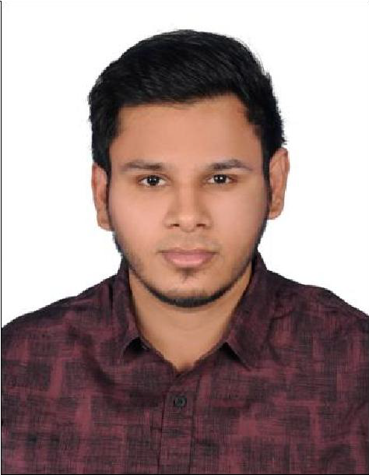
ASIF
Contact
Email:
Asif-397078@gulfjobseeker.com

Marital Status
Unmarried

Nationality
Indian

Visa Status
On Visit visa

PROFESSIONAL SUMMARY
Mechanical Engineering professional with two years of experience gained with in India. I am looking for an opportunity to work, where I can utilize my skill and knowledge to grow up for both myself and company.
I’m an effective team player who has excellent interpersonal and communication skills, has respect and loyalty among others and has professional attitude to achieve success within the targets.

KEY SKILLS
- Complex Problem solver
- Service focused
- Project management

EDUCATION QUALIFICATION
Bachelor of Engineering in Mechanical engineering
2013 -2017 in Syed Ammal Engineering College, Ramanathapuram.

NEBOSH IGC, International General certificate ( ON GOING).

PROFESSIONAL EXPERIENCE
PRODUCTION ENGINEER - 03/2017 to 09/2018 HYLITE INDUSTRIES, Chennai.
- Investigate and analyze problems that saves money, time,and
materials.
- Design and develop new systems and equipment to ensure manufacturing is efficient and effective.
- Provide engineering support for production and maintenance activities to ensure maximum production.
- Develop process improvements to effectively utilize equipment and materials to maximize production.

MECHANICAL ENGINEER - 09/2018 to 12/2019
Chennai
- Reviewing Drawing and Involve in procurement.
- Site Supervision.
- Coordinate with main Contractor and sub-Contractor.
- Prepare periodical Management Reports accurately for all projects to provide timely feedback to Management for monitoring the progress of Quantity Surveying activities .
- Interface / liaise with Project Department, Consultants and client.

CERTIFICATION

- I had attended one day national level workshop on "Optimization Techniques for Applications" organized by department of mechanicalengineering.
- I had won First prize in project expo conducted at Syed Ammal Engineering College on march2016.
- I had won First prize in water rocketry conducted at Syed Ammal Engineering College on march 2014.

INPLANT TRAINING

Integral Coach Factory (ICF), Chennai

COMPUTER LITERACY

- MS Word, MS Excel

LANGUAGES

- Fluent in Speaking, Reading & Writing in English & Tamil

DECLARATION

I hereby declare that the above written particulars are true to the best of my knowledge and belief.
ASIF
Strengths
- Good communication skills
- Eagerness to work as a team
- Good documentation work
- Projects Presentations
- Capable to handle the client pressure in any situation.

