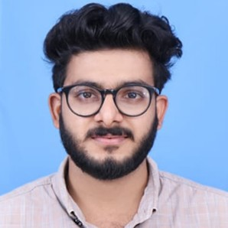
RAMSHEED
B.Tech. (civil engineering)

CAREER OBJECTIVE

Hardworking Civil Engineer with Bachelor’s degree and excellent creative thinking; seeking an opportunity to work with an established organization.

EXPERIENCE

Fastline Projects PVT.LTD
Assistant site supervisor

EDUCATION
November 2018 - November 2019

CADD centre training services
Professional in Architectural Design(6month)

2018

Visvesvaraya Technological University
B.E/ B.Tech(civil) 58
2018

Shivapuram Higher Secondary School
Plus two 60
2013

Mattannur Higher Secondary school
10th 60
2011

TECHNICAL SKILLS

Well verse with Cad revit 3D max
Good knowledge of basic computers, MS Oﬃce and internet Good problem solving skills
Knowledge of core subjects

PROJECTS

Identiﬁcation of black spots 1 month
Identiﬁcation of black spots is the procedure to locate those spots in the road network that are particularly dangerous, that is, the black spots. Diagnosis is the process to study what are the problems, the accident contributing factors and the deﬁciencies for each of the identiﬁed black spots.

FIELDS OF INTERESTS

Designing and drawing Experimental analysis Prestressed concrete Surveying
Construction management Site supervising

PERSONAL PROFILE

Date of Birth : 28/11/1995
Marital Status : Single
Nationality : Indian
Known Languages : English, Hindi, Malayalam, Tamil

Personal Contact : ramsheed-397079@2freemail.com
Reference : Mr. Anup P Bhatia, HR Consultant, Gulfjobseeker.com 0504753686

DECLARATION
I hereby declare that all the details furnished above are true to the best of my knowledge and belief.

Date : 05/01/2020
Ramsheed
Place : Dubai

