CURRICULUM VITAE
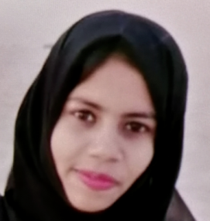
SANA
Email Id: - sana-397097@gulfjobseeker.com

Career Objective:

- To be a part of an Organization where process of learning never ends and my imagination takes wing to unexpected heights.
Educational Qualifications:-

Qualification | Board/University | Year of passing | %
BTECH Computer Science Engineering (CSE) | Jawaharlal Nehru Technological University (JNTU) | Pursuing Final Yr. | -
Intermediate (10+2) | Telangana State Board of Intermediate Education | 2016 | 61.3%
S.S.C | Board of Secondary | 2013 | 50%

Computer Skills:

- Ms Office 2010(Word,Excel,Power Point)
- E-Mail & Internet Tools.

Personality traits:

- Team Worker, Self-Confident, Very adaptable and friendly.
- Keen to learn new technologies and work on it.

Personal Profile:
Name : SANA
Date of Birth :15th May 1999
Nationality : Indian
Language Known : English, Hindi & Urdu.
Declaration:

I hereby declare that the information gives herewith is correct to my knowledge and I will responsible for any discrepancy.

Date:
Place: UAE (SANA)

