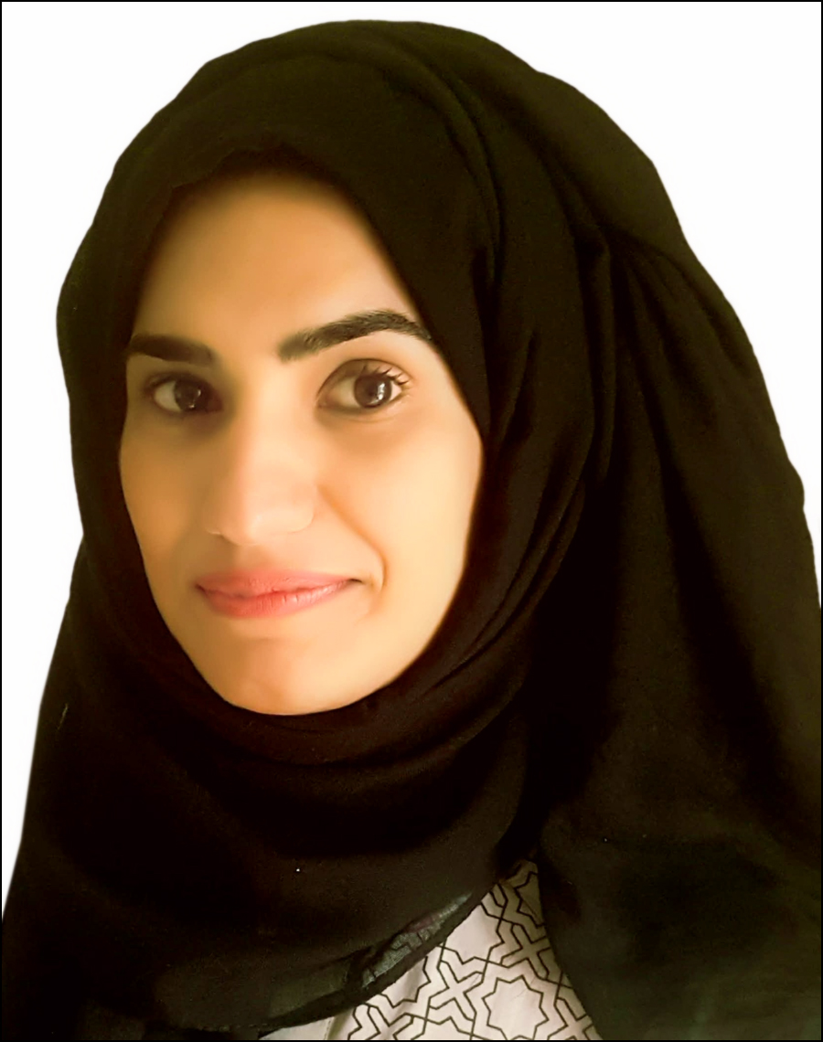

**Saba**

***Science Teacher Specialized in Chemistry***

+9665014069

[Saba-397111@gulfjobseeker.com](mailto:Saba-397111@gulfjobseeker.com)





January 10, 1992



Uhdhfhhhfjhjhhhhh Spouse Visa

**Profile**

* Dedicated, passionate and responsible individual with expertise in Teaching Chemistry and other science subjects at secondary to undergraduate level.
* Proficient and competent professional adept at delivering lectures, preparing reports & grading projects; holds staunch ability in implementing 21st century teaching techniques and planning subject based projects, building course material and lessons effectively.

|  |  |  |
| --- | --- | --- |
| **CORE STRENGTHS & ENABLING SKILLS** | | |
| * Research and Development * Creative Lesson Planning * Excellent communication skills | * laboratory Experimentation * Student’s Evaluation * Proficient in Classroom Technology | * EndNote, ChemDraw& Origin * Microsoft Office package * Teaching Expert | |

**PROFESSIONAL EXPERIENCE**

* **December 2017 – May 2019 Visiting Lecturer Chemistry**
* Successfully taught 15 credit hours per week and increased learning outcomes by 50%.
* Assessed and marked250+ students’ progress throughout the semester in multiple courses.
* Effectively improved practical skills of students in chemistry by conducting laboratory experiments**.**
* **May 2017-December 2017Science Teacher at Fatima Zahra Girls Degree College KotliAjk, Pakistan**
* Prepared 100+ students for examination by delivering lessons and study plans for science subjects, Met parents and school officials; maintained discipline in the classroom and organized co-curricular activities.
* **April 2016 – April 2017 Internee at Mirpur University of Science and Technology (MUST), Mirpur**

**AJK, Pakistan**

* Assisted faculty members in performing laboratory experimentation, teaching chemistry courses and conducting examinations at graduate & undergraduate level.

Kotli, Mirpur, Azad Kashmir

**PROFESSIONAL QUALIFICATION**

* **2019 B.ed (1.5years)**

Allama Iqbal International open University Islamabad Pakistan.

* **2017 M.Phil. (Chemistry)**

Mirpur University of Science & Technology (MUST), Mirpur AJK, Pakistan

* **2014 M.Sc.( Chemistry)**

Mirpur University of Science & Technology (MUST), Mirpur AJK, Pakistan

* **2012 B.Sc. ( Botany, Zoology, Chemistry)**

Government Post Graduate College for Girls UAJK , AJK , Pakistan 





**PROFESSIONAL TRAININGS, COURSES & CERTIFICATIONS**

* Certificate in being ***“Organizer in MUST Olympiad”***by MUST Mirpur, AJK (2017)
* Certificate in***“Participation in PIEAS Research Summit”*** by PIEAS Islamabad (2016)
* Certificate in***“Participation in International Conference of New Trends in Chemistry”***by Allama Iqbal Open University Islamabad(2016)
* Certificate in***“Participation in Declamation Contest”*** by MUST Mirpur, AJK (2014)
* Certificate in***“Participation in Essay writing contest”*** by The Caring Society Pakistan(2014)
* Certificate in ***“Participation in Divisional Speech competition Mirpur”*** by UAJK, AJK (2011)
* Certificate in***“Participation in District Speech competition Kotli”*** by UAJK, AJK (2011)



**INSTRUMENTAL HANDLING**

UV-VIS absorption spectrophotometer, FT-IR spectrophotometer, Cyclic Voltametry, HPLC



**Languages**

Proficient in English, Native Urdu, Arabic Basic



